AC Component Identification
Meets NATEF Task: (None specified)

Name _______________________________ Date ___________ Time on Task __________

Make/Model/Year _________________ VIN ________________ Evaluation: 4 3 2 1

_____ 1. Locate the air-conditioning system label. Describe the location.
______________________________________________________________
_____ 2. According to the label, what type of refrigerant is used in the vehicle?
_____ HFC-134a (R-134a or SUVA®)
_____ CFC-12 (R-12 or Freon®)
_____ 3. According to the label, what is the capacity of the system?
_____ ounces
_____ 4. Describe the location of the compressor _________________________________
______________________________________________________________
_____ 5. Describe the location of the condenser __________________________________
______________________________________________________________
_____ 6. Describe the location of the evaporator __________________________________
______________________________________________________________
_____ 7. Describe the location of the accumulator or receiver-drier ___________________
______________________________________________________________
_____ 8. Does the system use an expansion valve? _____ Yes _____ No
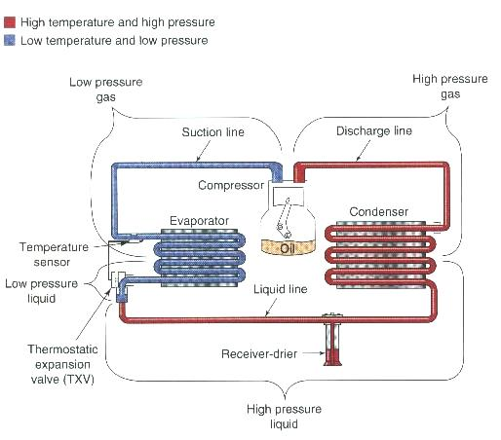
_____ 9. Does the system use an orifice tube? _____ Yes _____ No
