Identify Piston and Bearing Wear Patterns
Meets ASE Task: (A9-C-12) Identify piston, rod, and main bearing wear patterns; determine needed repairs.

Name _______________________________ Date ___________ Time on Task __________

Make/Model/Year _________________ VIN ________________ Evaluation: 4 3 2 1

_____ 1. Check service information for the specifications and procedures to follow when
diagnosing piston, rod, and main bearing wear patterns. Describe the specified
procedures. _______________________________________________________ _________________________________________________________________
_________________________________________________________________
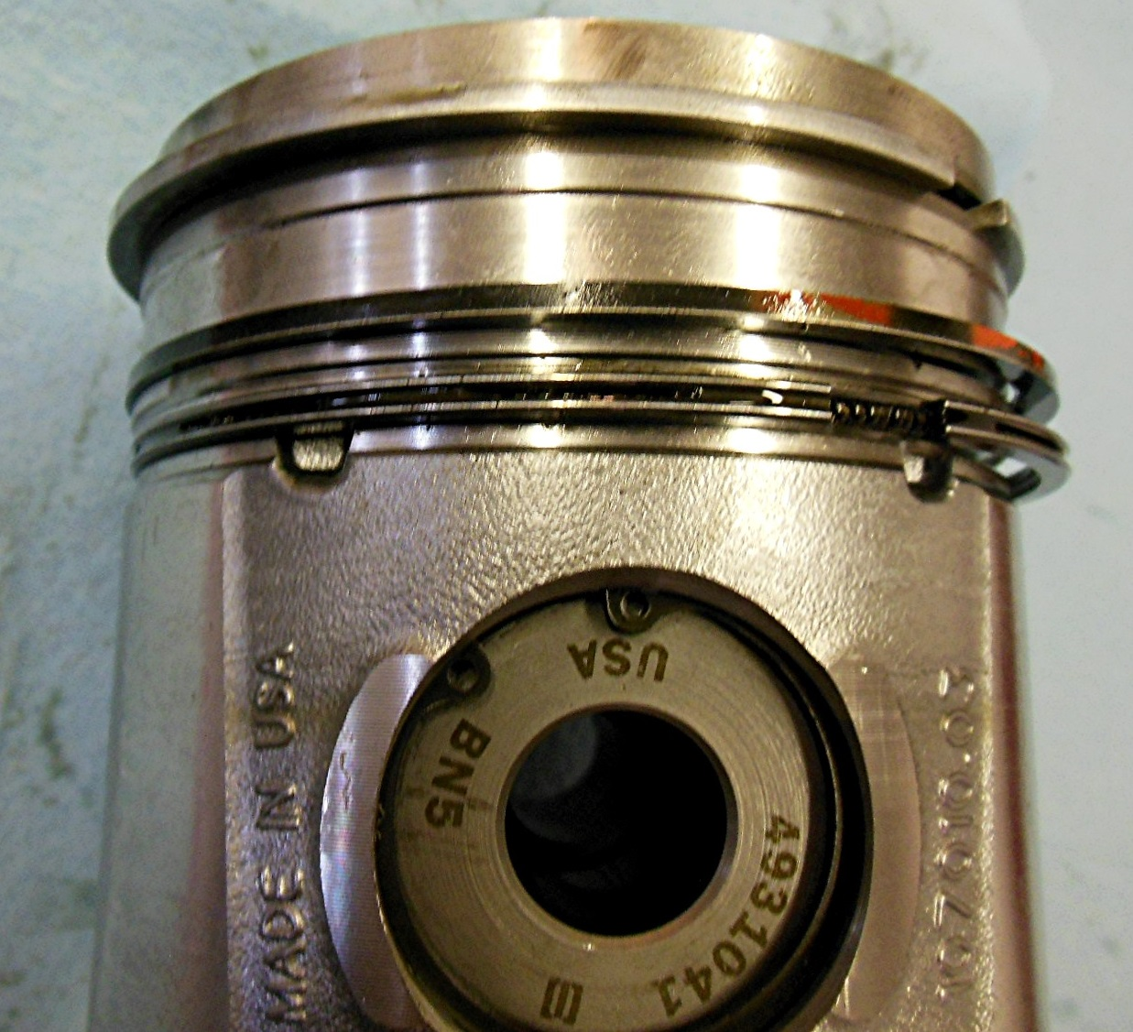
_________________________________________________________________
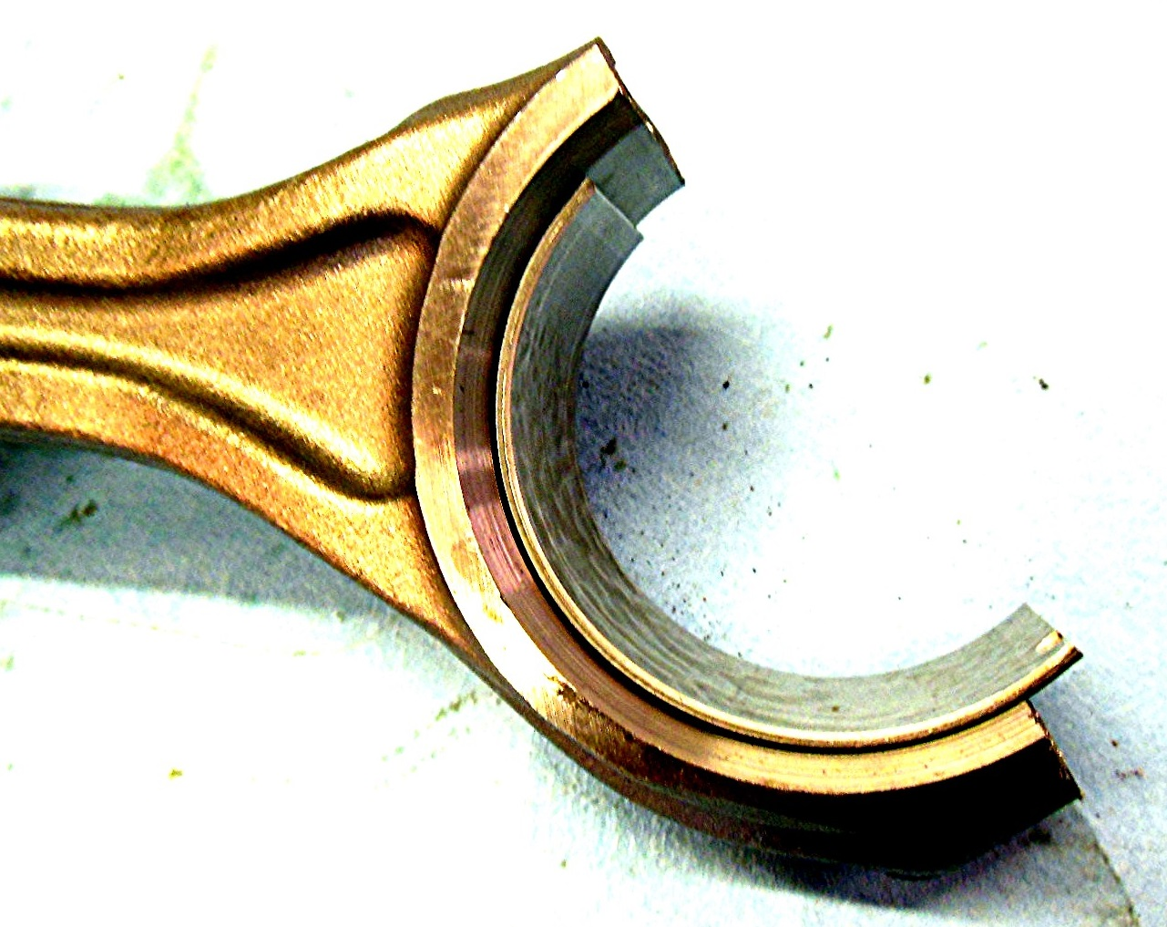

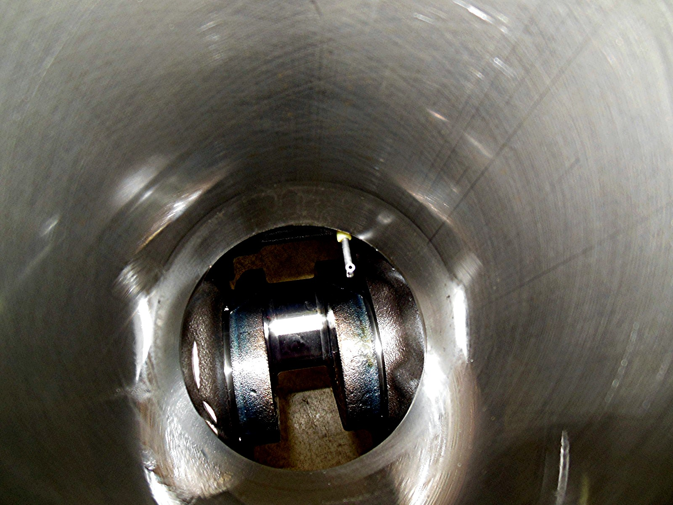

_____ 2. Based on the inspection, what is the needed action? ___________________________
_________________________________________________________________
_________________________________________________________________

