Install Lash Adjusters
Meets ASE Task: (A9-B-9) Inspect, install, and adjust cam followers, lash adjusters and retainers; adjust valve clearance if applicable.

Name _______________________________ Date ___________ Time on Task __________

Make/Model/Year _________________ VIN ________________ Evaluation: 4 3 2 1

_____ 1. Check service information for the specified procedure to follow when assembling and
adjusting the valve train. What is the specified procedure? _____________________
_________________________________________________________________
_________________________________________________________________
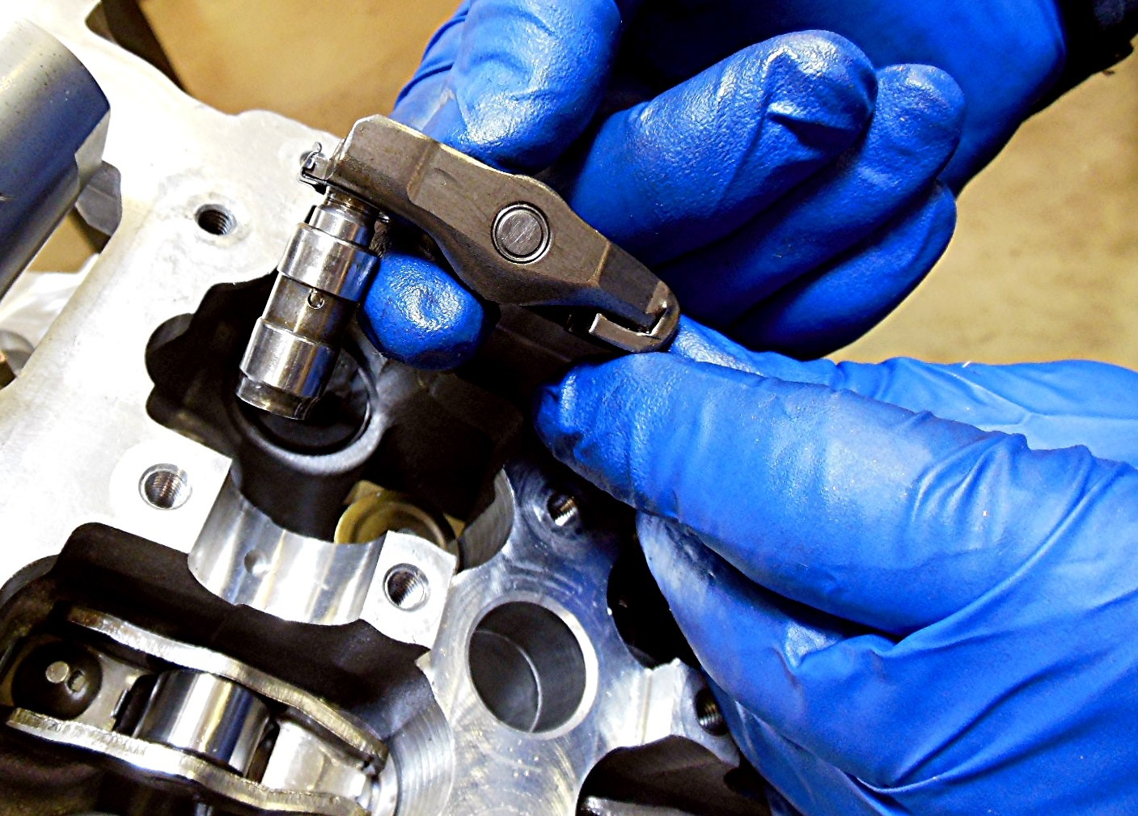

_____ 2. What is the specified valve clearance and how is it adjusted? __________________
________________________________________________________________



