Engine Oil and Lubrication System Inspection

Meets ASE Task: (A9-A-15) Check the lubrication system; determine the needed repairs

Name _______________________________ Date ___________ Time on Task __________

Make/Model/Year _________________ VIN ________________ Evaluation: 4 3 2 1

_____ 1. Check the oil level and condition. Describe the results. ________________________
_________________________________________________________________
_________________________________________________________________
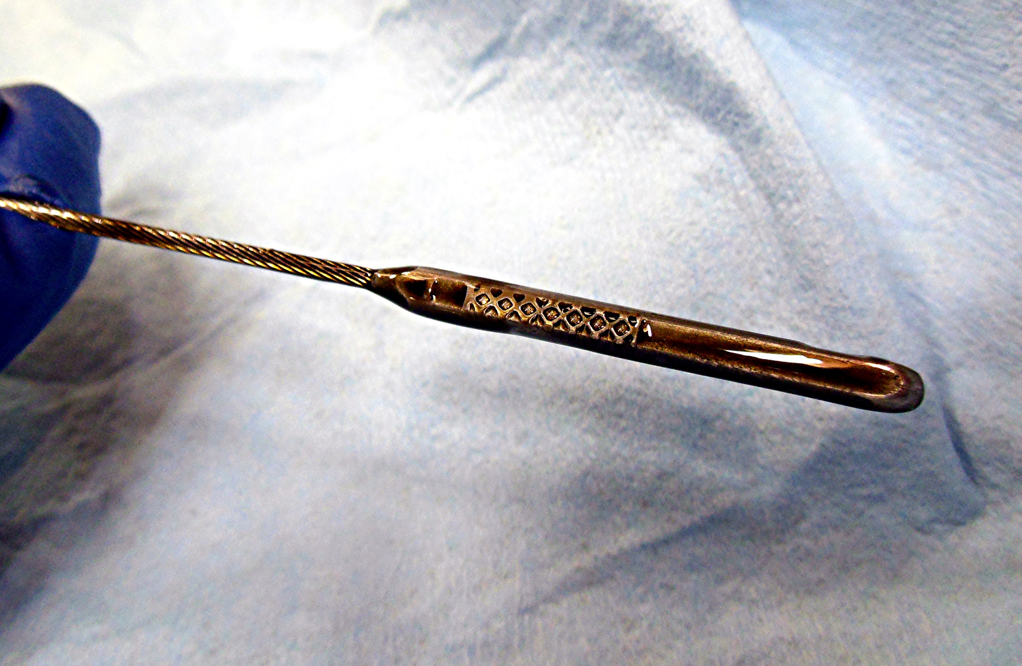

_____ 2. Check service information for the specified oil pressure. _____________________
_____ 3. Measure the oil pressure ___________ ____ OK ____ NOT OK
_____ 4. Obtain an oil sample and have it analyzed. Describe the oil analysis test results.
________________________________________________________________
________________________________________________________________
________________________________________________________________
________________________________________________________________
_____ 5. Based inspection of the lubrication system, what are the needed repairs? _________
________________________________________________________________
________________________________________________________________

