Traction Control Identification
Meets NATEF Task: (A5-G-9) Identify traction/vehicle stability control system components.
(P-3)

Name _______________________________ Date ___________ Time on Task __________

Make/Model/Year _________________ VIN ________________ Evaluation: 4 3 2 1

_____ 1. Check service information for what type and components are used in the traction
control/vehicle stability control system (check all that apply).

___ A. Rear-wheel only antilock braking system
___ B. A four-wheel (three channel, three wheel speed sensors) ABS
___ C. Four-wheel (four channel, four wheel speed sensors) ABS
___ D. Electronic throttle control (ETC) system
___ E. Electronic stability control dash-mounted switch
___ F. Electric power steering system (EPS)
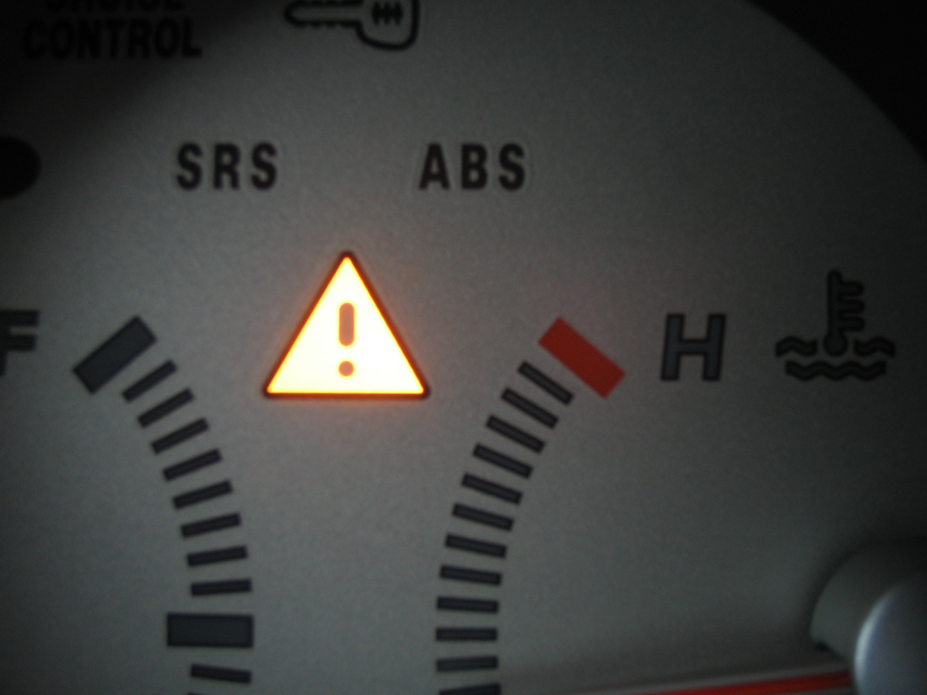

_____ 2. Describe the location of the following components:

Antilock braking system hydraulic control unit __________________________
Antilock braking system electronic control unit __________________________
Wheel speed sensors _______________________________________________
Stability control system dash switch (if equipped) ________________________

