Machining a Brake Drum

Meets NATEF Task: (A5-C-3) Refinish brake drum; measure final drum diameter. (P-1)

Name _______________________________ Date ___________ Time on Task __________

Make/Model/Year _________________ VIN ________________ Evaluation: 4 3 2 1

_____ 1. Measure the drum and double check that the brake drum can be safely machined.

- Maximum allowable inside diameter = ________
- Actual measurement of the drum = _____ left = _______ right = _______

OK to machine _______ discard ________

_____ 2. Select the proper tapered centering cone and face supporting plate.
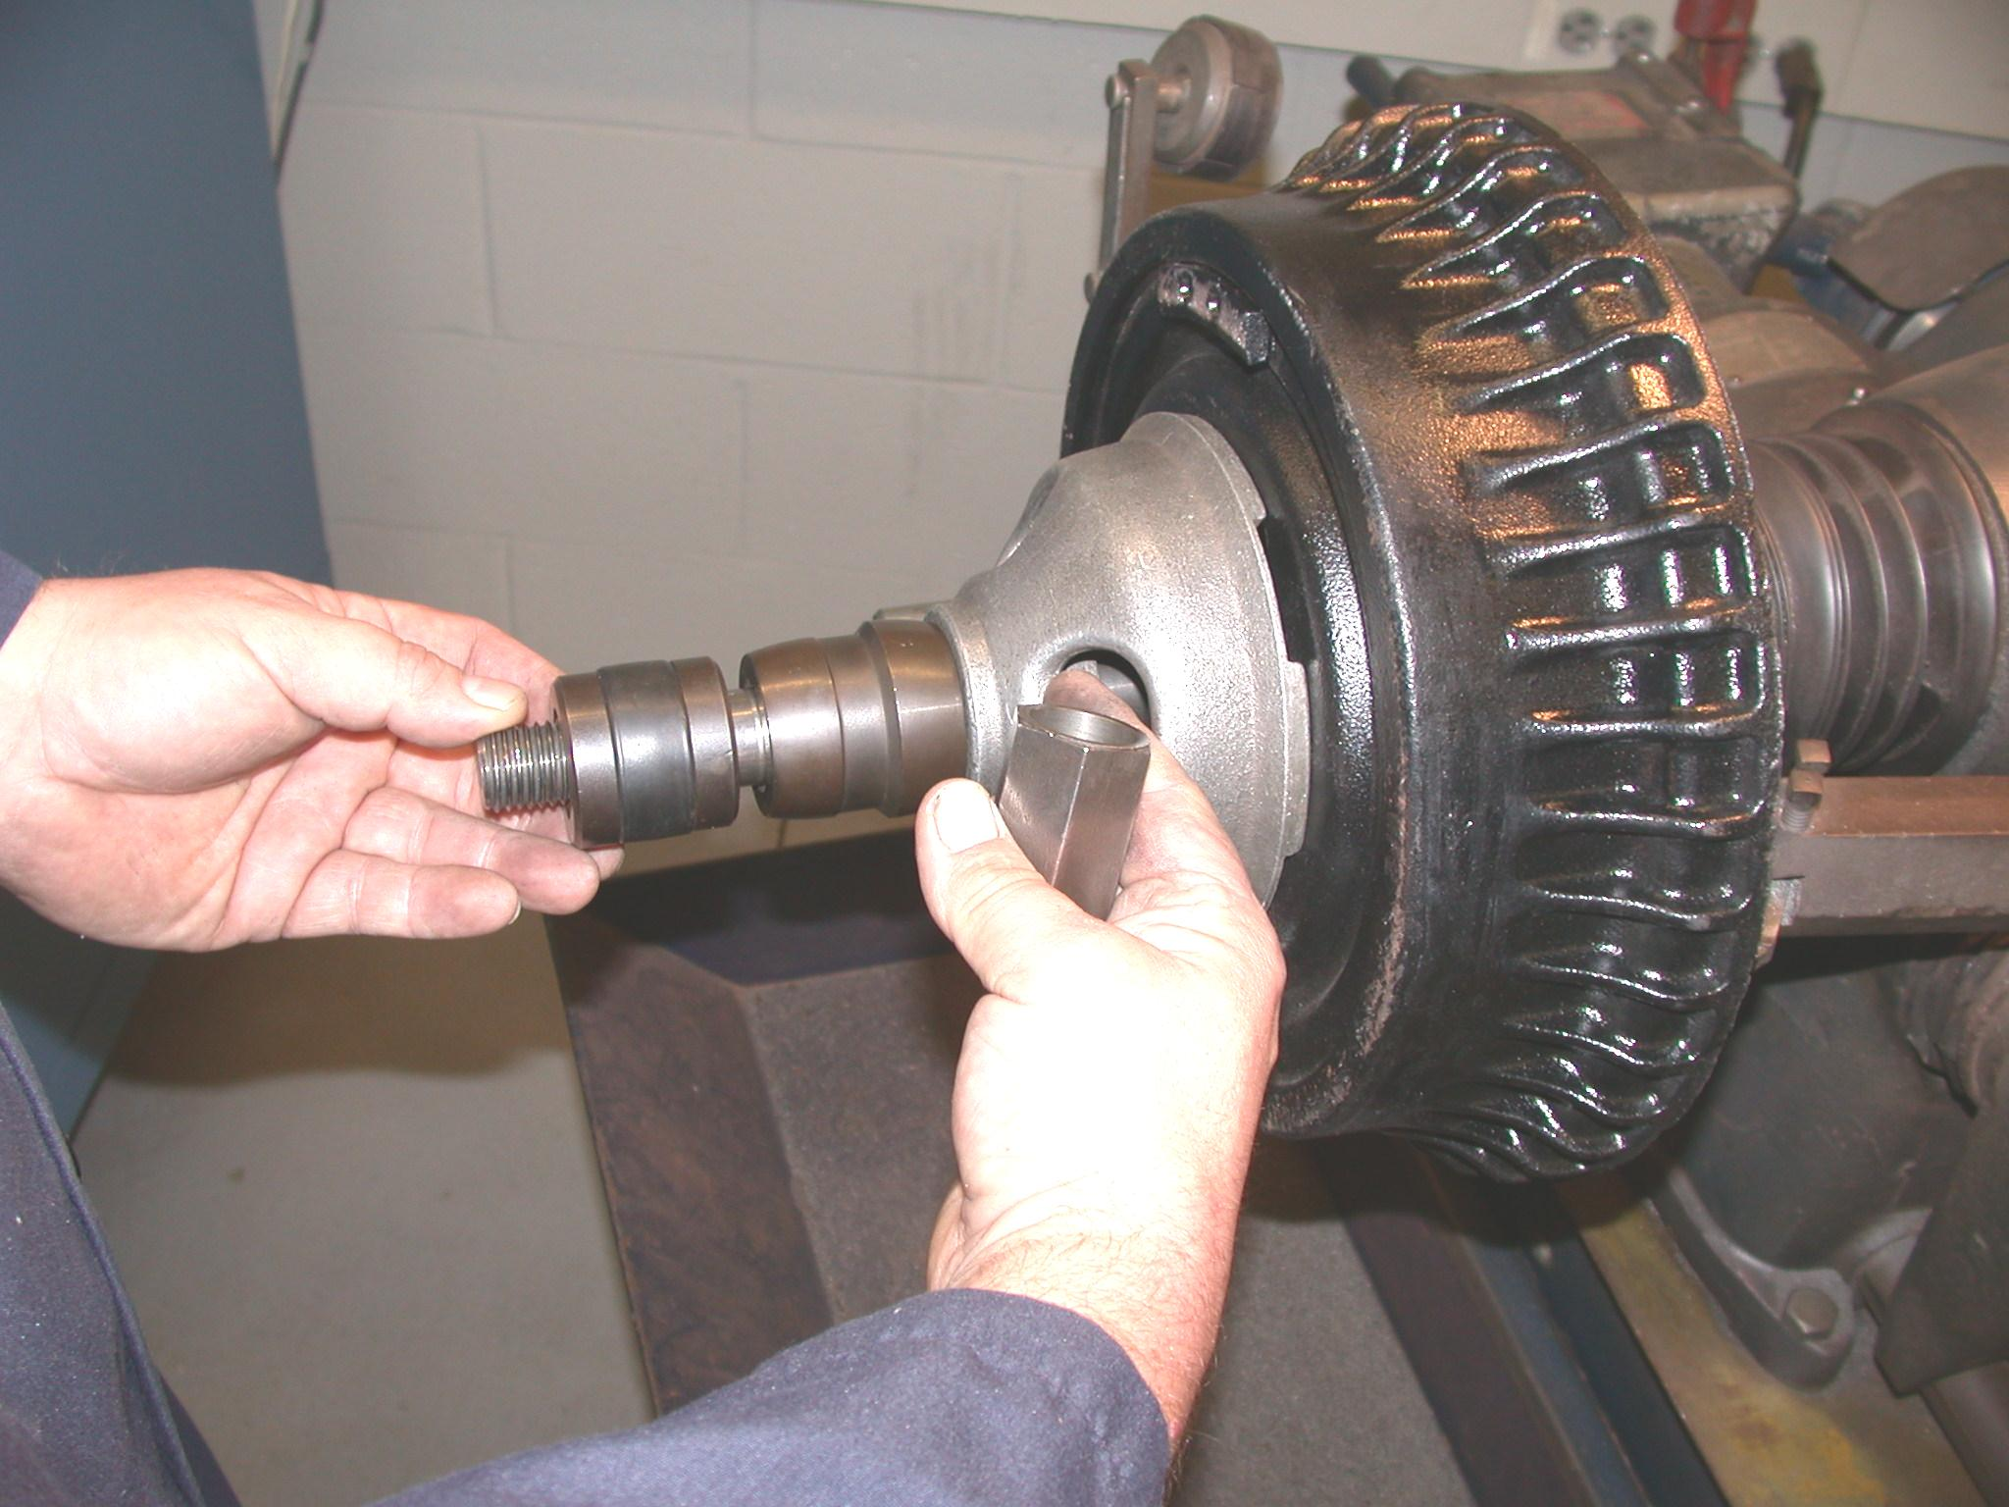
_____ 3. Install a self-aligning spacer (SAS) and tighten the spindle nut.

_____ 4. Perform a scratch cut.

_____ 5. Stop the lathe, loosen the spindle nut, and rotate the brake
drum 180° (one-half turn) and retighten the spindle nut.

_____ 6. Perform a second scratch cut.

- If the second cut is in the same location, proceed with machining.
- If the second cut is on the opposite side of the drum, clean or repair the lathe before machining.

_____ 7. Install a silencer band (vibration damper).

_____ 8. Machine the drum.

_____ 9. The measurement of the drum after machining = _________.

Does this allow 0.030” or more for wear?

Yes ____ (install on the vehicle) No ____ (replace the drum)

