Front Disc Brake Inspection
Meets NATEF Task: (A5-D-2) Remove caliper assembly, inspect for leaks and damage to caliper housing; determine necessary action. (P-1)

Name _______________________________ Date ___________ Time on Task __________

Make/Model/Year _________________ VIN ________________ Evaluation: 4 3 2 1

_____ 1. Hoist the vehicle safely and remove the front wheels.

_____ 2. Loosen the bleeder valve and push the caliper piston into the caliper.

_____ 3. Remove the caliper and pads.

_____ 4. Check the front disc pad condition (the thickness of the friction material should
be thicker than the metal part of the pads), and the thickness should be equal on
both sides of the rotor.

OK ____ NOT OK ____ Describe any faults _______________________

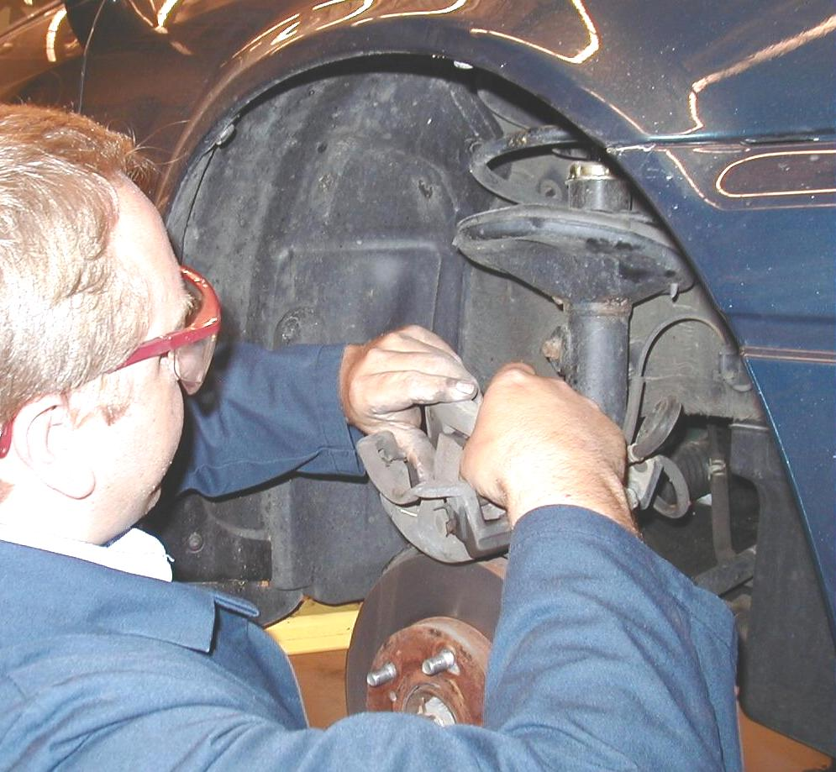
_____ 5. Check the caliper mountings for damage or wear.

_____ 6. Check for brake fluid leaks and cracked flex hoses.

OK ____ NOT OK ____

_____ 7. Based on the inspection results, what is the
necessary action?

__________________________________________________________________

__________________________________________________________________

__________________________________________________________________

