Vehicle Hoisting

Meets NATEF Task: None Specified

Name _______________________________ Date ___________ Time on Task __________

Make/Model/Year _________________ VIN ________________ Evaluation: 4 3 2 1

Getting Ready to Hoist the Vehicle
_____ 1. Drive the vehicle into position to be hoisted (lifted) being certain to center the vehicle
in the stall.

_____ 2. Pull the vehicle forward until the front tire rests on the tire pad (if equipped).

NOTE: Some long vehicles may have to be positioned forward of the pad and some short vehicles may have to be positioned behind the pad.

_____ 3. Place the gear selector into the park position (if the vehicle has an automatic
transmission/transaxle) or in neutral (if the vehicle has a manual
transmission/transaxle) and firmly apply the parking brake.

_____ 4. Position the arms and hoist pads under the frame or pinch weld areas of the body.
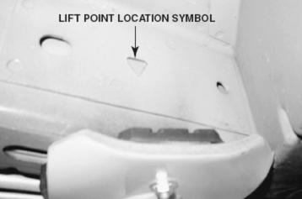

Hoisting the Vehicle
_____ 5. Slowly raise the vehicle about one foot (30 cm) off the
ground and check the stability of the vehicle by
attempting to move the vehicle on the lift. Reposition
pads if needed.

NOTE: Best working conditions are at chest or elbow level.

_____ 6. Be sure the safety latches have engaged before
working under the vehicle.

Lowering the Vehicle
_____ 7. To lower the vehicle, raise the hoist slightly, then release the safety latches.

_____ 8. Lower the vehicle using the proper operating and safety release levers.

CAUTION: Do not look away while lowering the vehicle. One side of the vehicle could become stuck or something (or someone) could get under the vehicle.

_____ 9. After lowering the hoist arms all the way to the floor, move the arms so that they will
not be hit when the vehicle is driven out of the stall.

