Safety Check

Meets NATEF Task: None Specified

Name _______________________________ Date ___________ Time on Task __________

Make/Model/Year _________________ VIN ________________ Evaluation: 4 3 2 1

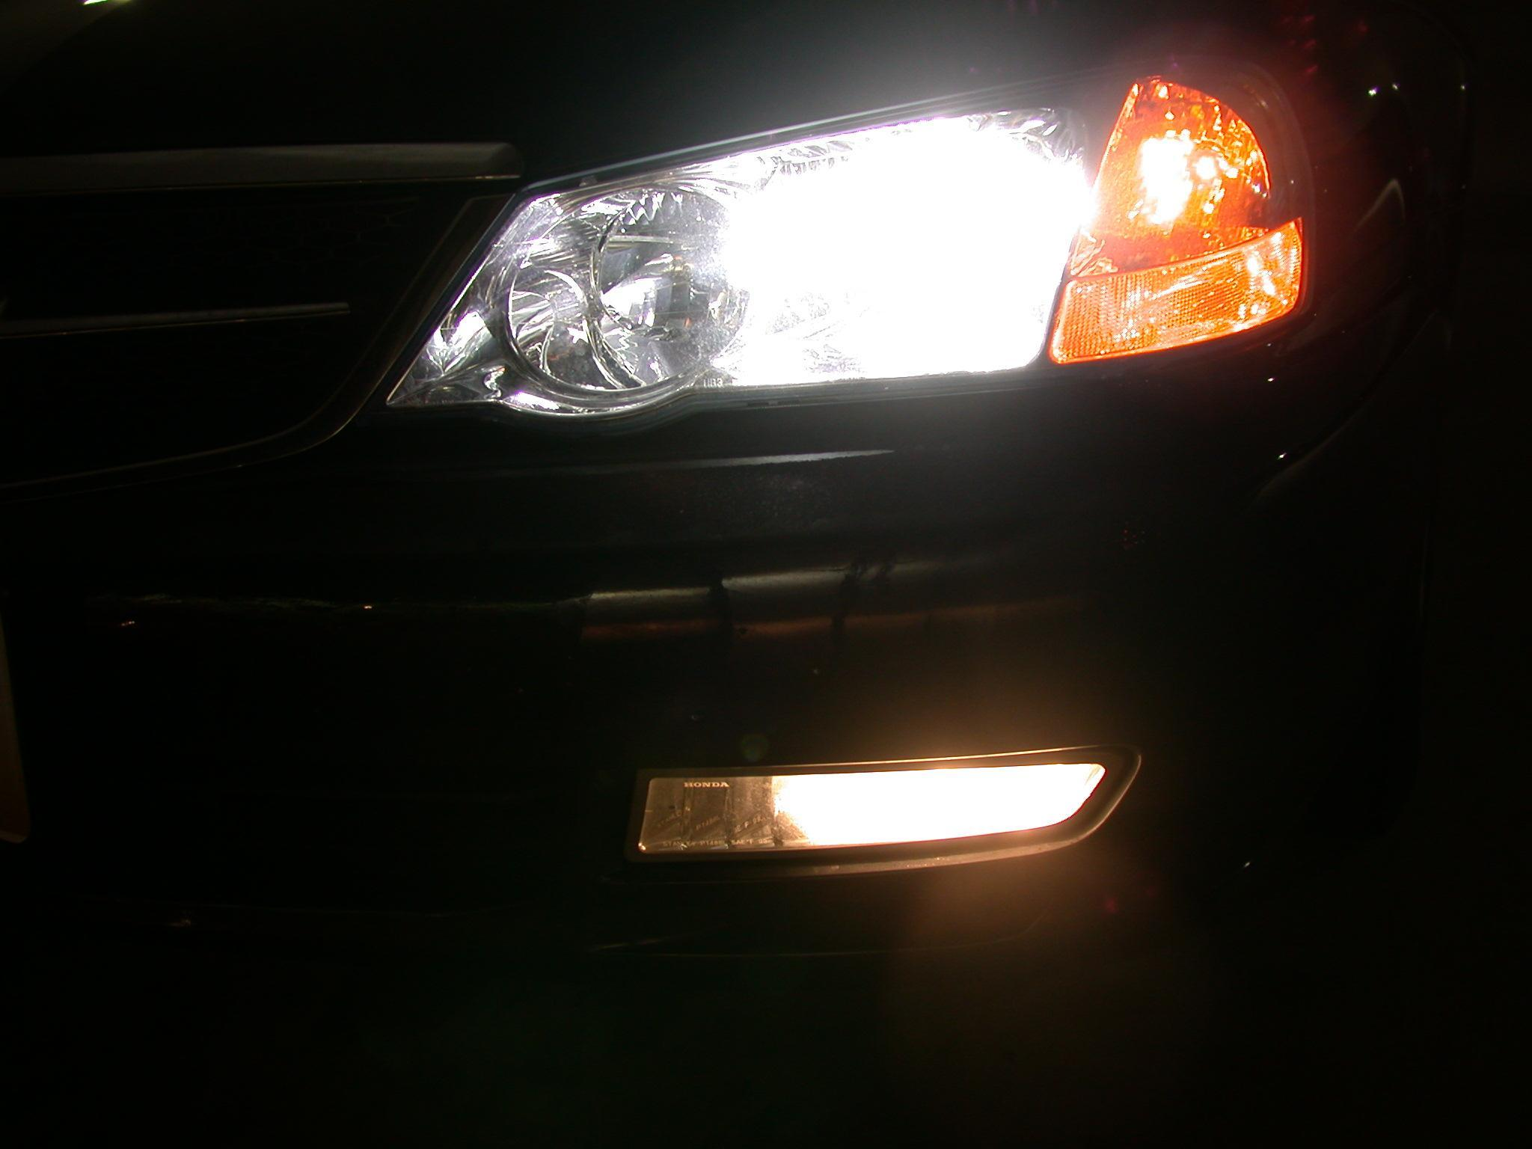
_____ 1. Check the headlights (brights and dim).

_____ 2. Check the taillights.

_____ 3. Check the side marker lights.

_____ 4. Check the license plate light.

_____ 5. Check the brake lights.

_____ 6. Check the turn signals.

_____ 7. Check the back-up lights with the ignition switch "on" (engine "off") and the gear
selector in reverse.

_____ 8. Check the windshield wipers (all speeds) and wiper blades.

_____ 9. Check the heater-defroster fan (all speeds).

_____ 10. Check the condition of the tires (must have at least 2/32" of tread) and the tire
pressure. Do not forget to check the spare tire!

_____ 11. Check for looseness in the steering wheel (less than 2" of play).

_____ 12. Check the 4-way emergency flashers.

_____ 13. Check the horn.

_____ 14. Listen for exhaust system leaks.

_____ 15. Check the parking brake (maximum 8-10 "clicks" and should "hold" in drive).

