A5 BRAKES 6th Edition

Chapter 7 Brake Fluid & Lines

Opening Your Class
KEY ELEMENT | EXAMPLES
Introduce Content | This course or class covers operation and service of Automotive Brakes. It correlates material to task lists specified by ASE and NATEF.
Motivate Learners | Explain how the knowledge of how something works translates into the ability to use that knowledge to figure why the engine does not work correctly and how this saves diagnosis time, which translates into more money.
State the learning objectives for the chapter or course you are about to cover and explain this is what they should be able to do as a result of attending this session or class. | Explain the chapter learning objectives to the students.  1. Discuss the purpose and function of brake fluids.  2. Describe brake service procedures and precautions.  3. Discuss the types of rubber that are used in brake system components.  4. Discuss the use of brake lines.
Establish the Mood or Climate | Provide a WELCOME, Avoid put downs and bad jokes.
Complete Essentials | Restrooms, breaks, registration, tests, etc.
Clarify and Establish Knowledge Base | Do a round robin of the class by going around the room and having each student give their backgrounds, years of experience, family, hobbies, career goals, or anything they want to share.

ICONS | Ch07 BRAKE FLUID & LINES
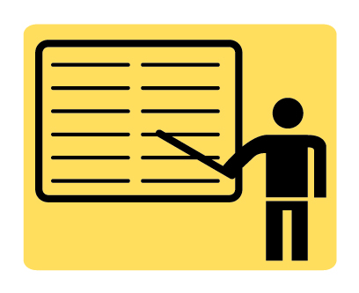 | 1. SLIDE 1 CH07 BRAKE FLUID & LINES  2. SLIDES 2-3 EXPLAIN OBJECTIVES
 | Check for ADDITIONAL VIDEOS & ANIMATIONS @ http://www.jameshalderman.com/  WEB SITE IS CONSTANTLY UPDATED
4. SLIDES 4-5 EXPLAIN Brake Fluid
6. SLIDE 6 EXPLAIN Figure 7-1 Brake fluid can absorb moisture from the air even through plastic, so many experts recommend that brake fluid be purchased in metal containers, if possible.
7. SLIDE 7 EXPLAIN Figure 7-2 Brake fluid absorbs moisture from the air at the rate of about 2% per year. As the brake fluid absorbs water, its boiling temperature decreases.
 | DISCUSSION: ask students to talk about types of brake fluids and their chemical characteristics. What must all brake fluids have in common? Ask students to discuss brake fluid specifications. What do sae dot specification standards signify? (have students refer to federal motor vehicle standard 116 covering all fluids for use in hydraulic brake systems of motor vehicles, brake fluid containers, and brake fluid labeling issue
 | 8. SLIDE 8 EXPLAIN Figure 7-3 DOT 5 brake fluid is used mostly in motorcycles because if spilled, it will not hurt painted surfaces.
VIDEO: Brake Fluid Recommendations
www.myautomotivelab.com http://media.pearsoncmg.com/ph/chet/chet_mylabs/akamai/template/video640x480.php?title=Brake%20Fluids&clip=pandc/chet/2012/automotive/A5-F6.mov&caption=chet/chet_mylabs/akamai/2012/automotive/xml/A5-F6.adb.xml
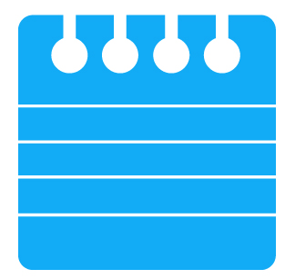 | 9. SLIDE 9 EXPLAIN FIGURE 7-4 Both rubber sealing cups were exactly same size. Cup on left was exposed to mineral oil. Notice how the seal greatly expanded.  10. SLIDE 10 EXPLAIN Brake Fluid: Brake Fluid Inspection and Testing
 | DISCUSSION: ask students to discuss performance characteristics and uses of DOT 3 brake fluid. Why is it the most commonly used brake fluid? Why is it important to keep DOT 3 brake fluid in a sealed container? Ask students to talk about performance characteristics and uses of DOT 4 brake fluid? What differentiates it from DOT 3 brake fluid, and why does it cost more? Why is it important to change brake fluid on a vehicle equipped with abs every 30,000 miles (48,000 km)? Ask students to discuss performance characteristics and uses of DOT 5.1 brake fluid. What types of vehicles might use DOT 5.1 fluid?
 | DISCUSSION: Ask students to talk about why they should never use mineral oil in a brake system designed for DOT brake fluids. Ask students to discuss characteristics & uses of DOT 5 brake fluid. What are advantages of silicone-based brake fluids? What are disadvantages?
11. SLIDE 11 EXPLAIN Figure 7-5 If brake fluid is black in color, it should be replaced.
12. SLIDE 12 EXPLAIN Figure 7-6 (a) brake fluid test strip is being used to test the condition of the brake fluid.
12. SLIDE 12 EXPLAIN Figure 7-6 (b) The color of test strip is then compared with a chart on package, which indicates the condition and if fluid should be replaced.
13. SLIDE 13 EXPLAIN Figure 7-7 electronic tester that measures boiling temperature of the brake fluid is useful to help determine if the brake fluid needs to be replaced.
 | DEMONSTRATION: Show students how to use brake fluid test strip. Show how to use brake fluid tester & discuss results.
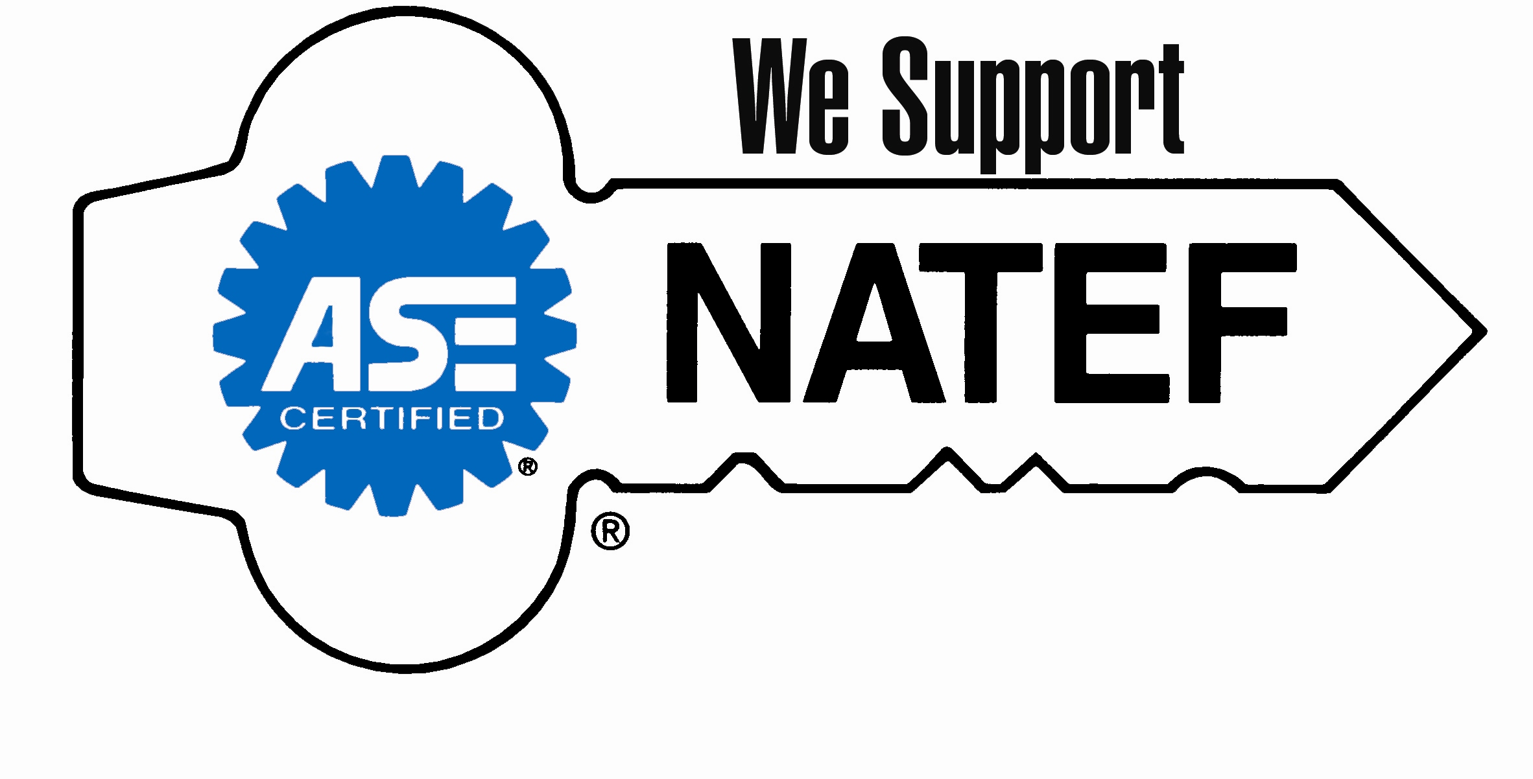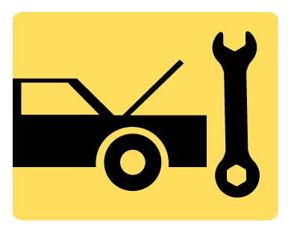 | ON-VEHICLE NATEF TASK Brake fluid usage and test for contamination
 | 14. SLIDES 14-17 EXPLAIN Brake Fluid Service Procedures and Precautions
 | DISCUSSION: Ask students to discuss brake fluid servicing procedures. What precautions should they take to prevent contamination of brake fluid?
 | If possible, store brake fluid in a moisture-free area, such as an old refrigerator.
18. SLIDE 18 EXPLAIN Figure 7-8 The master cylinder piston seals are usually constructed from EPDM rubber, and the diaphragm of the vacuum power brake booster is usually made from SBR.
19. SLIDE 19 EXPLAIN Figure 7-9 Cross-sectional view of a typical drum brake wheel cylinder. Most wheel cylinder boots and cups are either SBR or EPDM rubber.
20. SLIDE 20 EXPLAIN Figure 7-10 Exploded view of a typical disc brake caliper. Both the caliper seal and dust boot are constructed of EPDM rubber.
 | DEMONSTRATION: Show students the EPDM rubber parts found in master cylinder, drum brake wheel cylinder, and disc brake caliper and discuss the effect of brake fluid on these components.
 | DISCUSSION: Ask students to talk about the rubber components found in braking systems, including the master cylinder and disc and drum brake assemblies. How might these be affected by prolonged exposure to brake fluid?
21. SLIDES 21-23 EXPLAIN Brake Lines
24. SLIDE 24 EXPLAIN Figure 7-11 Steel brake tubing is double-walled for strength and plated for corrosion resistance.
25. SLIDE 25 EXPLAIN Brake Lines

 | 26. SLIDE 26 EXPLAIN Figure 7-12 & EXPLAIN Figure 7-13 ISO fitting, also called a bubble or ball-type flare.
27. SLIDE 27 EXPLAIN FIGURE 7–14 Double flaring the end of a brake line. (a) Clamp the line at the correct height above the surface of the clamping tool using the shoulder of the insert as a gauge. (b) The insert is pressed into the end of the tubing. This creates the first bend..
28. SLIDE 28 EXPLAIN FIGURE 7–14 (CONTINUED) (c) Remove the insert and use the pointed tool to complete the overlap double flare. (d) The completed operation as it appears while still in the clamp.
 | DEMONSTRATION: Show students the double-walled steel brake lines connecting the master cylinder to each brake, and discuss how their construction is designed to carry brake fluid while providing maximum durability
 | DEMONSTRATION: Show double-flare & ISO brake line ends, & talk about their purpose & function. Ask students to talk about why replacement brake lines must be same diameter as originals. Show how to flare end of brake line by using double-lap flare fitting
 | After cutting or flaring brake lines, use dry shop air to blow out contaminates.
 | HANDS-ON TASK: Have students double-lap flare a brake line. Use a small diameter line first than a larger diameter so they can see the difference
 | 29. SLIDE 29 EXPLAIN Figure 7-15 Making an ISO flare requires a special tool. (a) Use the gauge, which is part of the tool, to position the brake line at the specified distance from the base of the tool. (b) The ISO forming tool will create the perfect "bubble" or ISO flare.
 | DEMONSTRATION: Show students how to flare the end of a brake line by using an ISO fitting
 | HANDS-ON TASK: Have students ISO flare a brake line. Use a small diameter line first than a larger diameter so they can see the difference.
30. SLIDE 30 EXPLAIN Figure 7-16 Whenever disconnecting or tightening a brake line, always use the correct size flare-nut wrench. A flare-nut wrench is also called a tube-nut wrench or a line wrench.
31. SLIDE 31 EXPLAIN Figure 7-17 The coils in the brake line help prevent cracks caused by vibration.
32. SLIDE 32 EXPLAIN Figure 7-18 Armored brake line is usually used in the location where the line may be exposed to rock or road debris damage. Even armored brake line can leak and a visual inspection is an important part of any brake service.
33. SLIDE 33 EXPLAIN FIGURE 7–19 A tube bender being used to bend a brake line.
34. SLIDE 34 EXPLAIN Figure 7-20 Flexible brake hoses are used between the frame or body of the vehicle and the wheel brakes. Because of suspension and/or steering movement, these flexible brake lines must be strong enough to handle high brake fluid pressures, yet remain flexible. Note that this flexible brake hose is further protected against road debris with a plastic conduit covering.
35. SLIDE 35 EXPLAIN Figure 7-21 (a) Typical flexible brake hose showing the multiple layers of rubber and fabric. (b) Inside diameter (ID) printed on hose (3 mm).
36. SLIDE 36 EXPLAIN Figure 7-22 Typical flexible brake hose faults. Many faults cannot be seen, yet can cause brakes to remain applied after brake pedal is released.
37. SLIDE 37 EXPLAIN Figure 7-23 Flexible brake hose should be carefully inspected for cuts or other damage, especially near sections where brake hose is attached to vehicle. Notice crack & cut hose next to mounting bracket
38. SLIDES 38-40 EXPLAIN SUMMARY
Show VIDEO: REPLACING BRAKE LINES
www.myautomotivelab.com http://media.pearsoncmg.com/ph/chet/chet_mylabs/akamai/template/video640x480.php?title=SDouble-Flare%20and%20ISO%20Flare&clip=pandc/chet/2012/automotive/Clip2.mov&caption=chet/chet_mylabs/akamai/2012/automotive/xml/Clip2.adb.xml
ANIMATION: LEAK IN HYDRUALIC SYSTEM
www.myautomotivelab.com http://media.pearsoncmg.com/ph/chet/chet_myautomotivelab_2/Brakes/auto_animations/ch05_fig05_12/index.html
Show ANIMATION: BRAKE HOSE FAULTS
www.myautomotivelab.com http://media.pearsoncmg.com/ph/chet/chet_myautomotivelab_2/Brakes/auto_animations/ch07_fig07_23/index.html
 | ON-VEHICLE NATEF TASK Brake hose and line inspection and replacement

