Torque Converter Lock-Up Test
Meets NATEF Task: (A2-A-9) Perform lock-up converter tests; determine necessary action.
(P-3)

Name _______________________________ Date ___________ Time on Task __________

Make/Model/Year _________________ VIN ________________ Evaluation: 4 3 2 1

_____ 1. Check service information and determine the specified tests to be performed to check the
operation of the lock-up torque converter. Describe the tests. _____________________
____________________________________________________________________
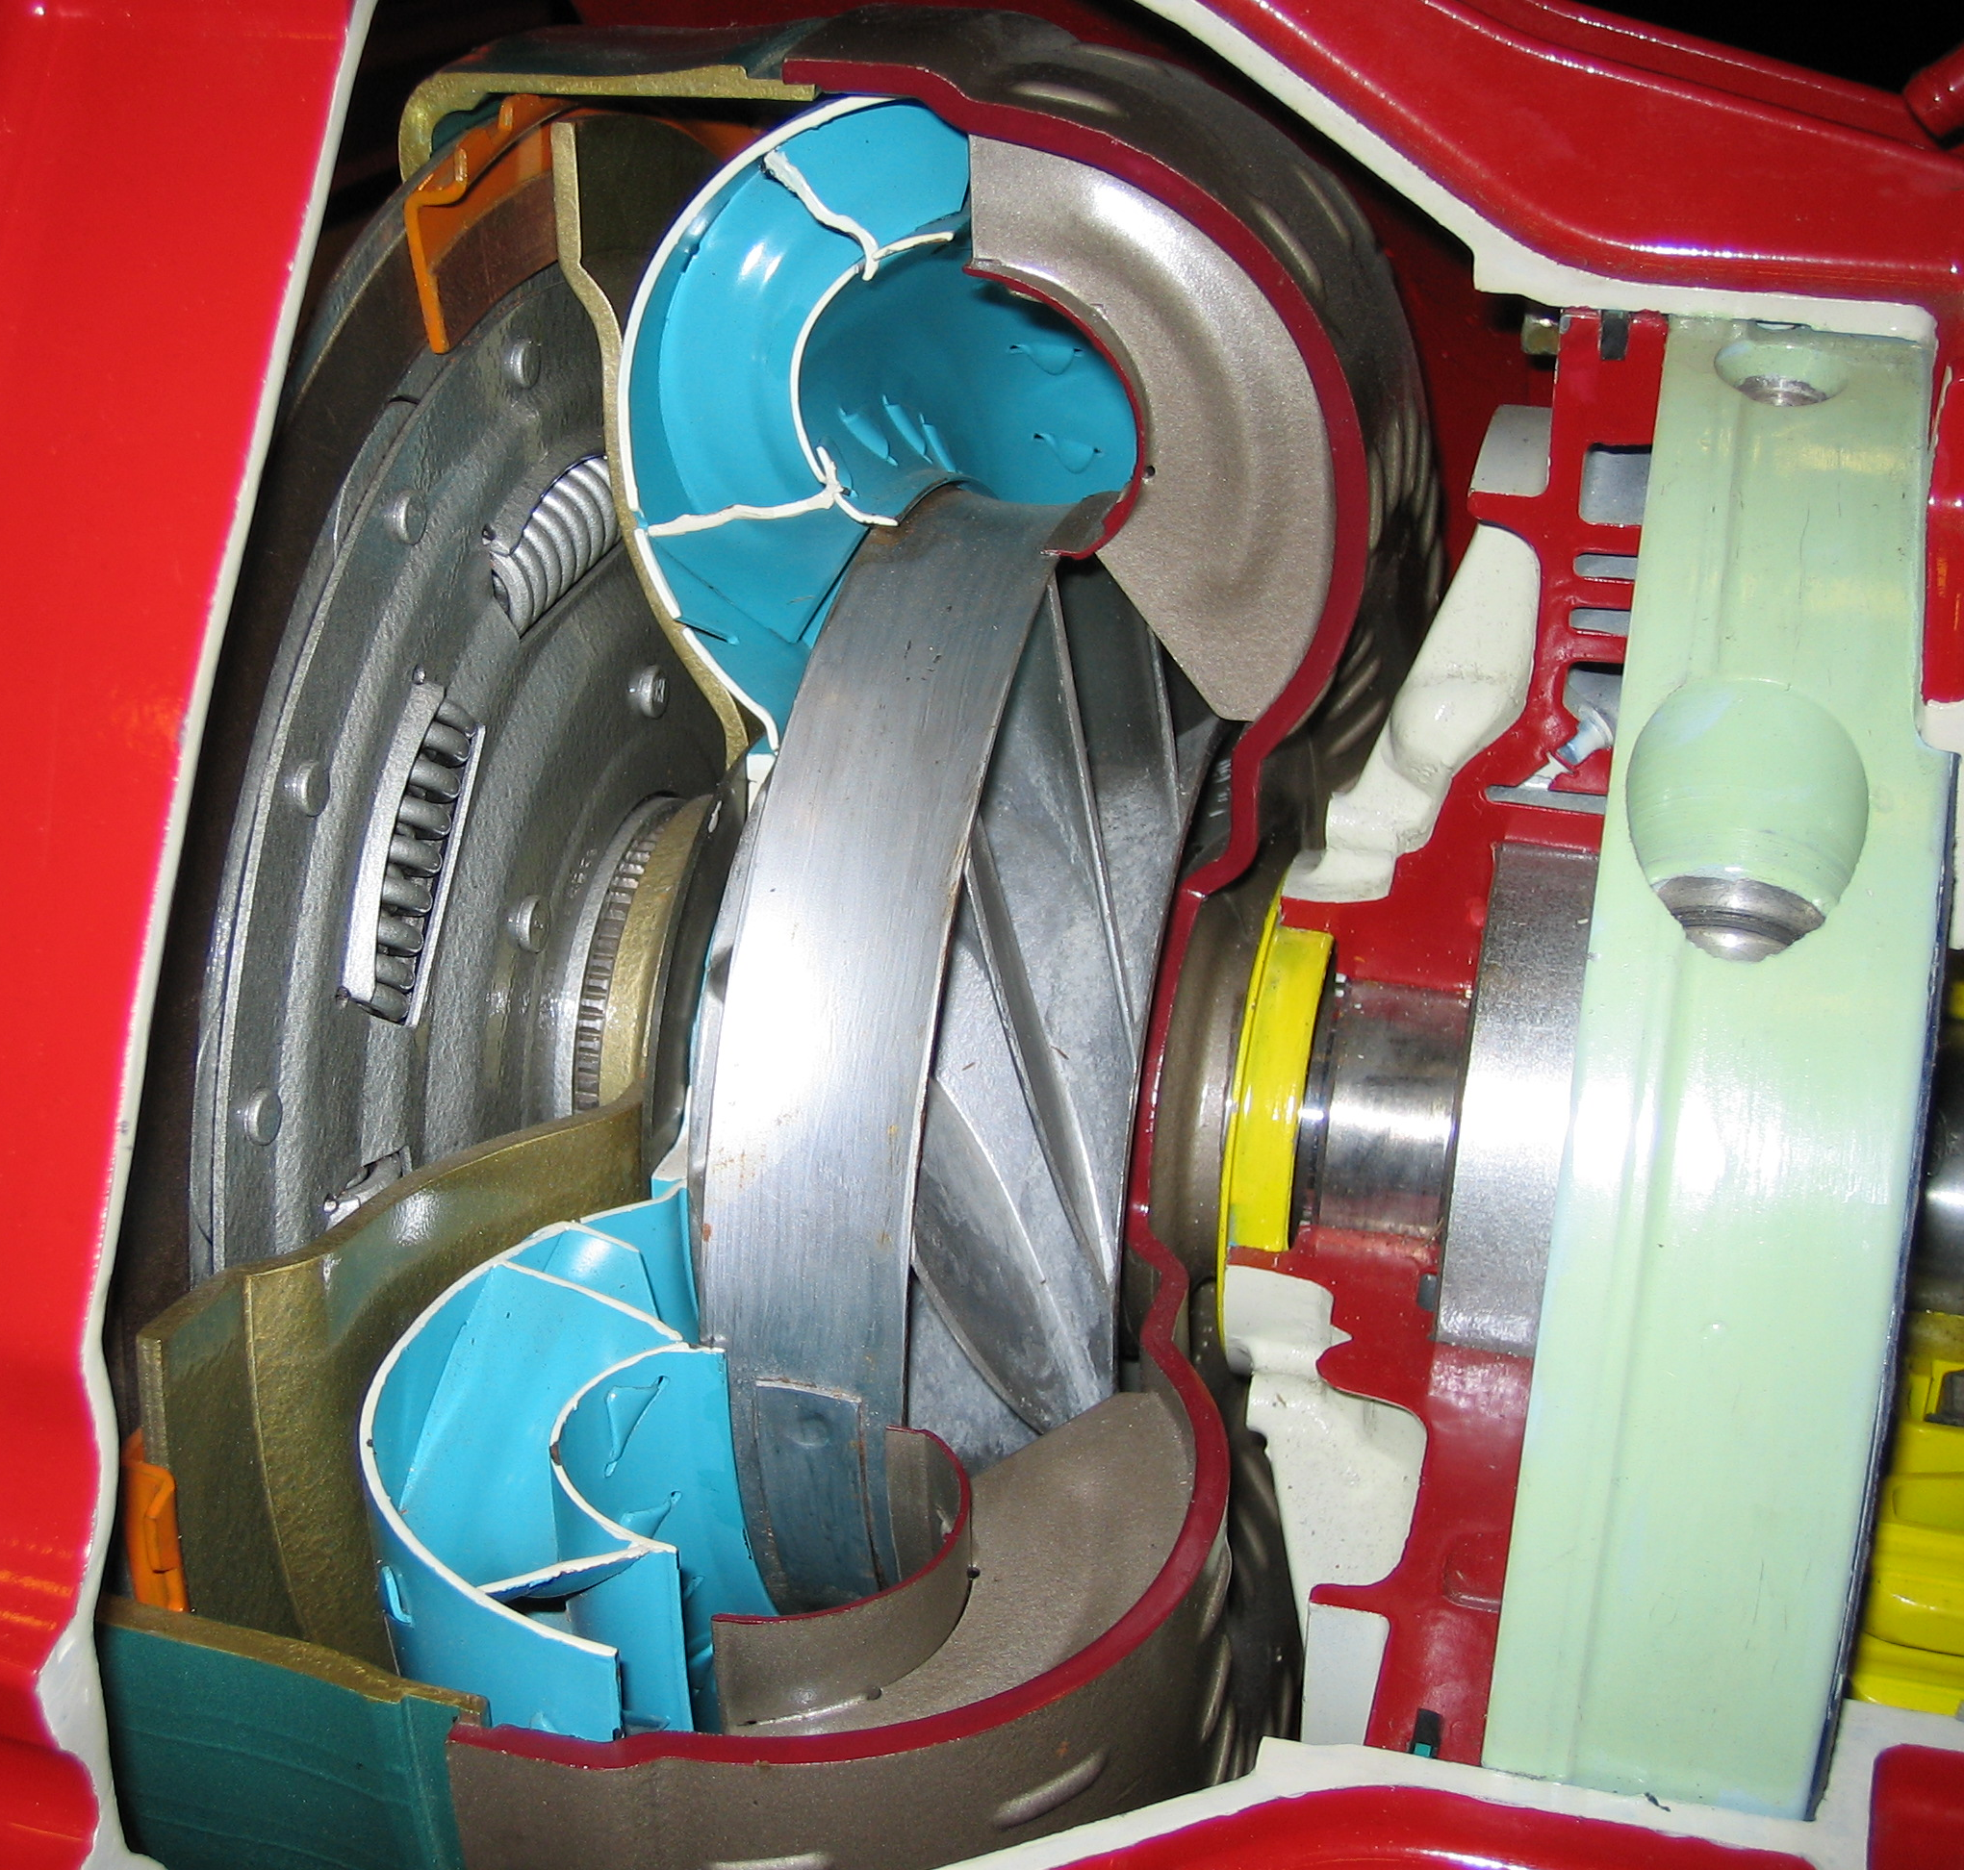
____________________________________________________________________

_____ 2. List all specified tools and equipment needed (check all that apply).
____ Scan tool
____ DMM
____ Pressure gauge
____ Other (describe) ______________________________________________
_____ 3. Based on the test results, what is the necessary action? __________________________
___________________________________________________________________
__________________________________________________________________

