Transaxle Final Drive Inspection
Meets NATEF Task: (A2-C-18) Inspect, repair, or replace transaxle final drive components.
(P-2)

Name _______________________________ Date ___________ Time on Task __________

Make/Model/Year _________________ VIN ________________ Evaluation: 4 3 2 1

_____ 1. Check service information and determine the specified procedures to follow when
inspecting the final drive assembly of an automatic transaxle. Describe the specified
procedures. _____________________________________________________________
____________________________________________________________________
____________________________________________________________________
____________________________________________________________________
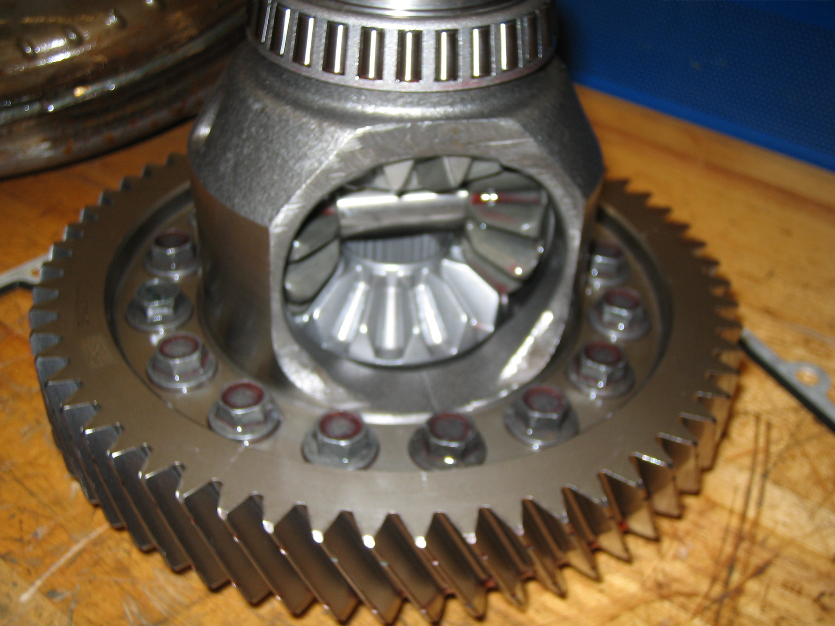

_____ 2. Based on the inspection results and the recommendations of service information, what is
the necessary action? _____________________________________________________
____________________________________________________________________
____________________________________________________________________

