Inspect and Adjust Linkages

Meets NATEF Task: (A2-B-1 and A2-B-3) Inspect and adjust linkages and cables. (P-1)

Name _______________________________ Date ___________ Time on Task __________

Make/Model/Year _________________ VIN ________________ Evaluation: 4 3 2 1

_____ 1. Check service information for the specified method to follow to adjust linkages and
cables. Describe the recommended procedure. __________________________________
____________________________________________________________________
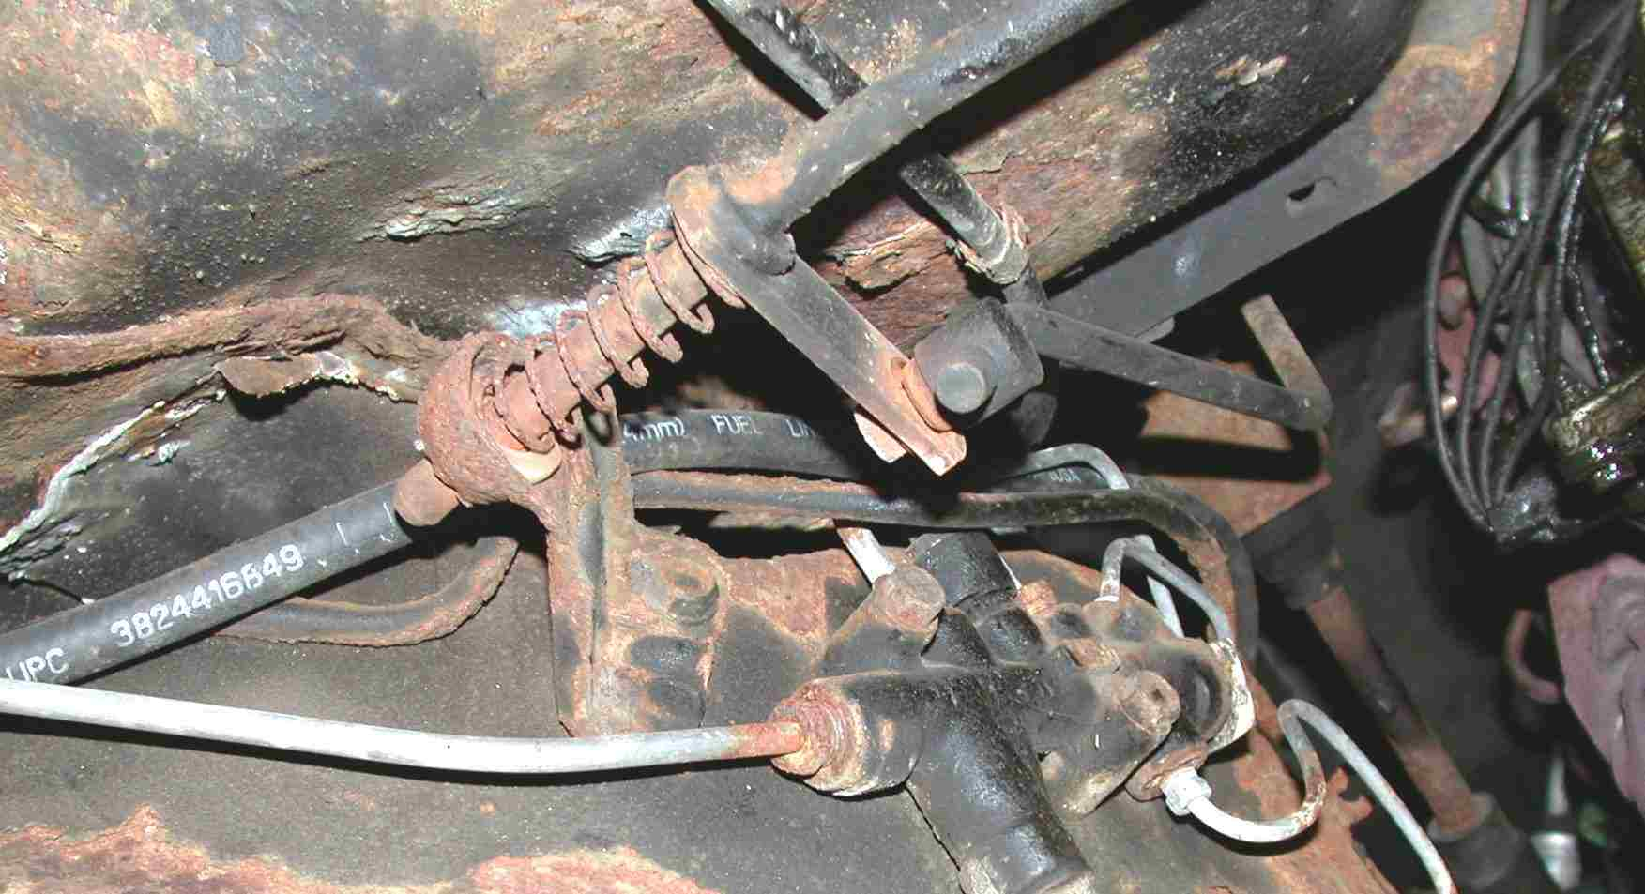
____________________________________________________________________

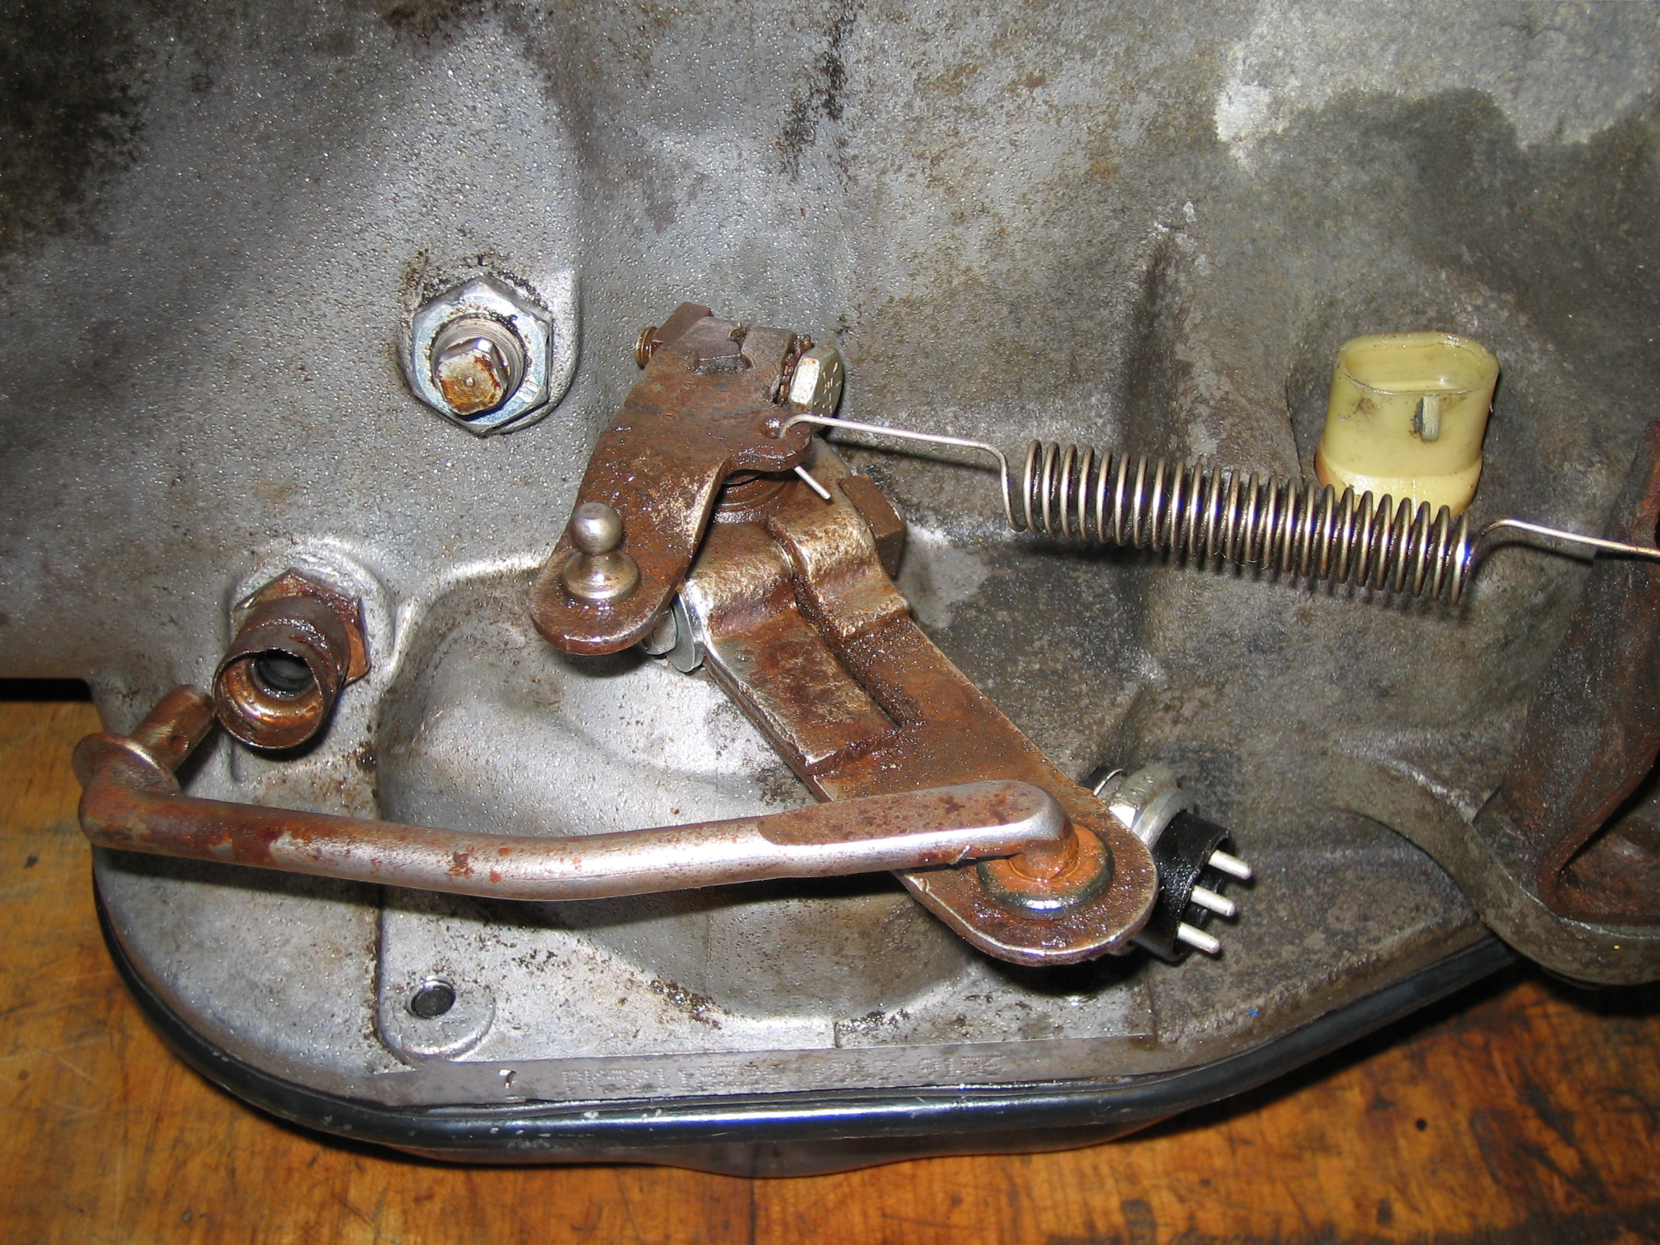
_____ 2. Describe the results of the inspection.
____________________________
____________________________
____________________________
_____ 3. Was a linkage adjustment needed?
Yes ____ No ____
If yes (describe) ______________
____________________________
____________________________

