Check Fluid Level
Meets NATEF Task: (A2-A-4 and A2-A-5) Check fluid level in a transmission or a transaxle with or without a dipstick. (P-1)

Name _______________________________ Date ___________ Time on Task __________

Make/Model/Year _________________ VIN ________________ Evaluation: 4 3 2 1

_____ 1. Check service information for the specified procedure to follow when checking the
transmission fluid level. Describe specified procedure.
With a dipstick: ____________________________________________________
____________________________________________________________
Without a dipstick: __________________________________________________
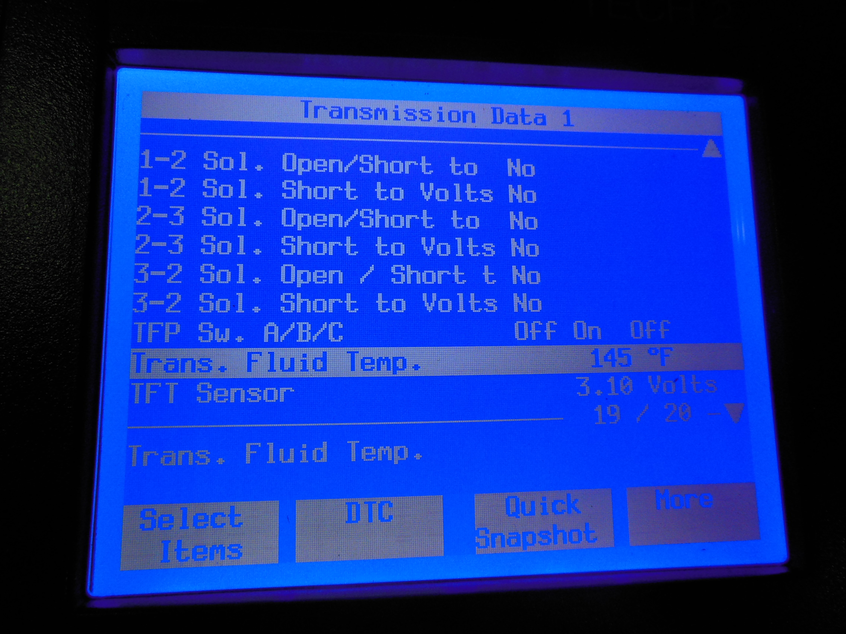
____________________________________________________________

_____ 2. What tools or equipment is needed to check the fluid level on a vehicle that does not
have a dipstick? Check all that apply.
___ Shop cloth ___ Special tool (describe) _______
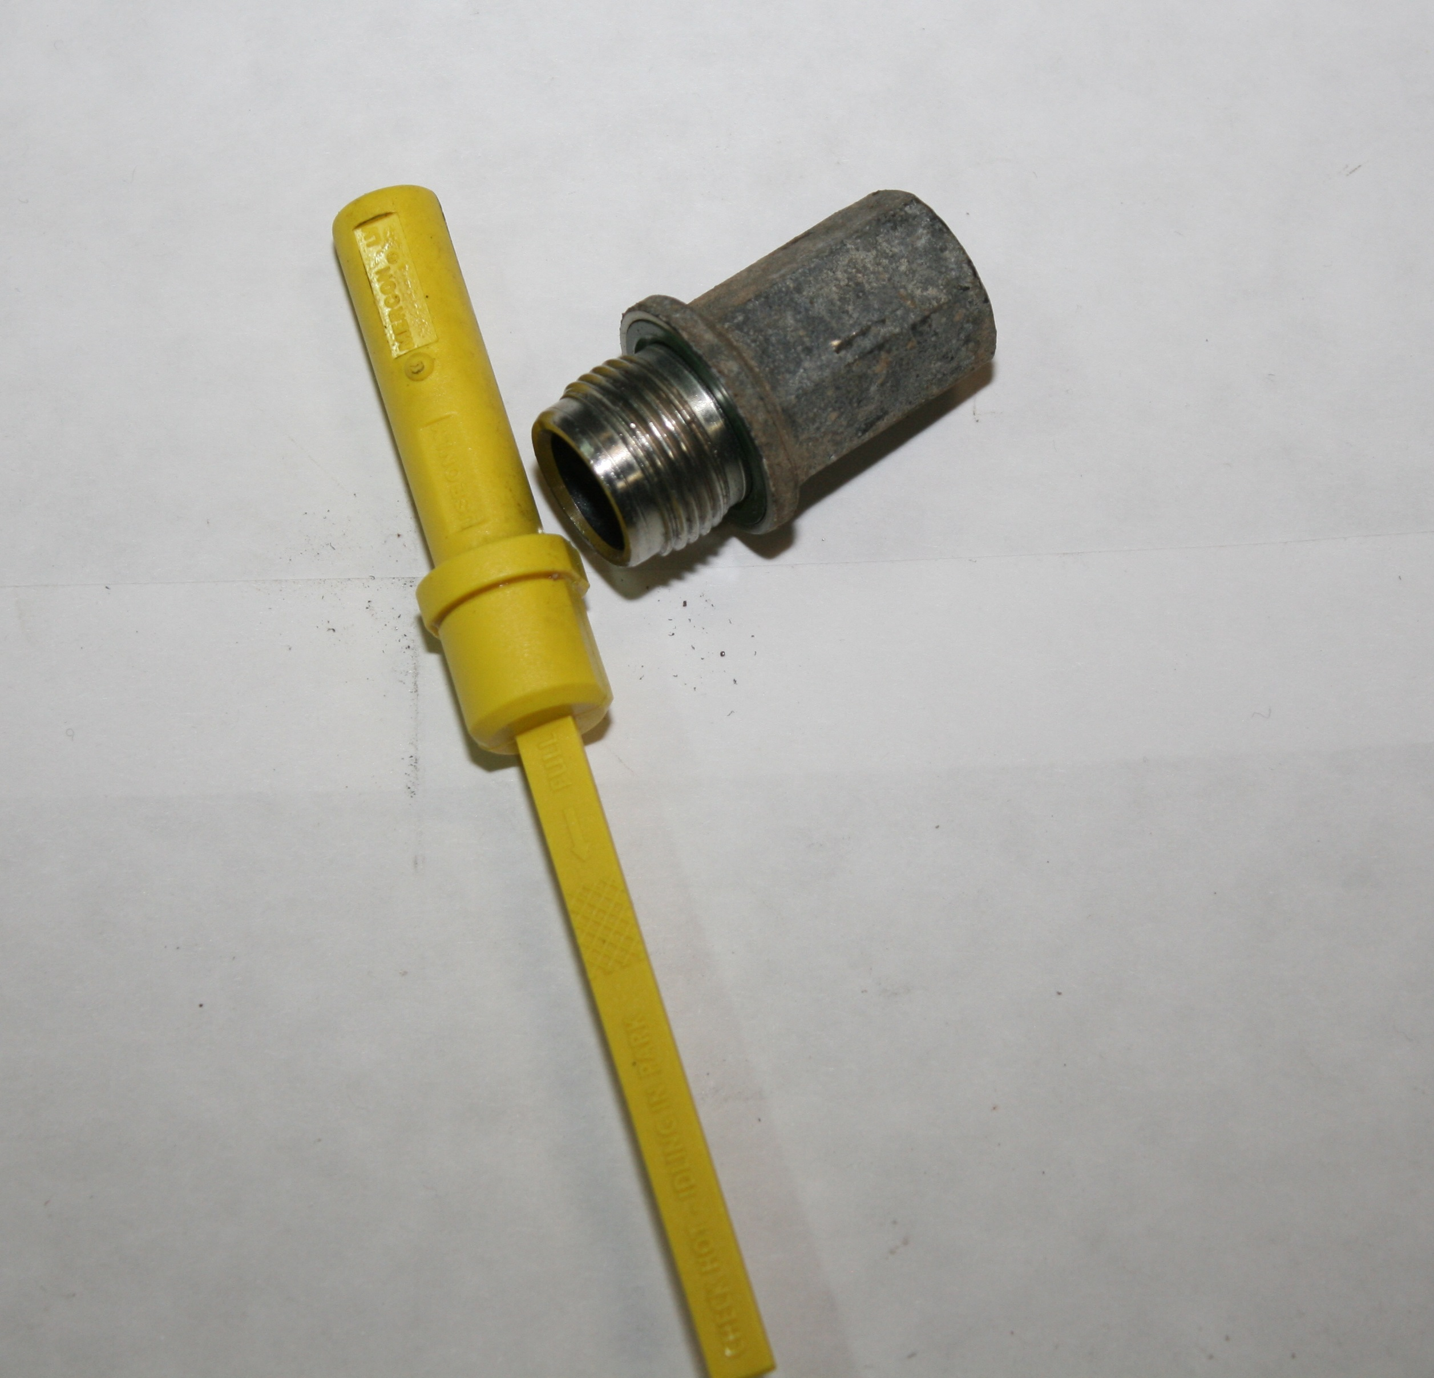
___ Scan tool _______________________
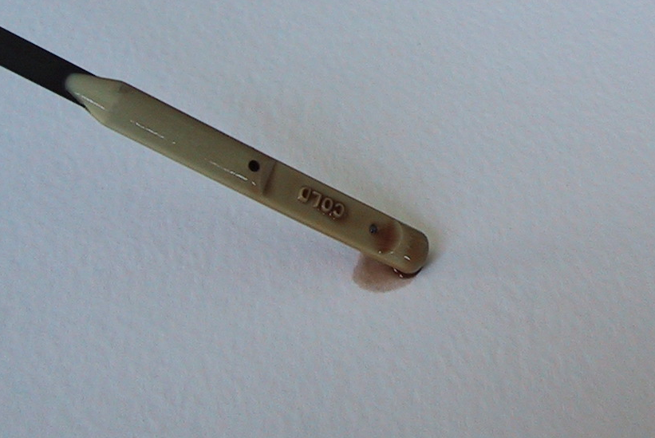
___ Wrenches/hand tools

