Battery Electrical Drain Test
Meets NATEF Task: (A6-A-14) Measure and diagnose the cause(s) of excessive parasitic draw; determine necessary action. (P-1)

Name _______________________________ Date ___________ Time on Task __________

Make/Model/Year _________________ VIN ________________ Evaluation: 4 3 2 1

A battery electrical drain test should be performed if a battery is dead (discharged) to determine if a battery electrical drain was the cause of the dead battery.

_____ 1. Perform a visual inspection and check if the following are turned on:

A. The glove box light (instrument panel compartment light)
B. The interior light switch
C. Vanity mirror(s) light
D. Trunk light (look for discoloration indicating that the bulb may have been
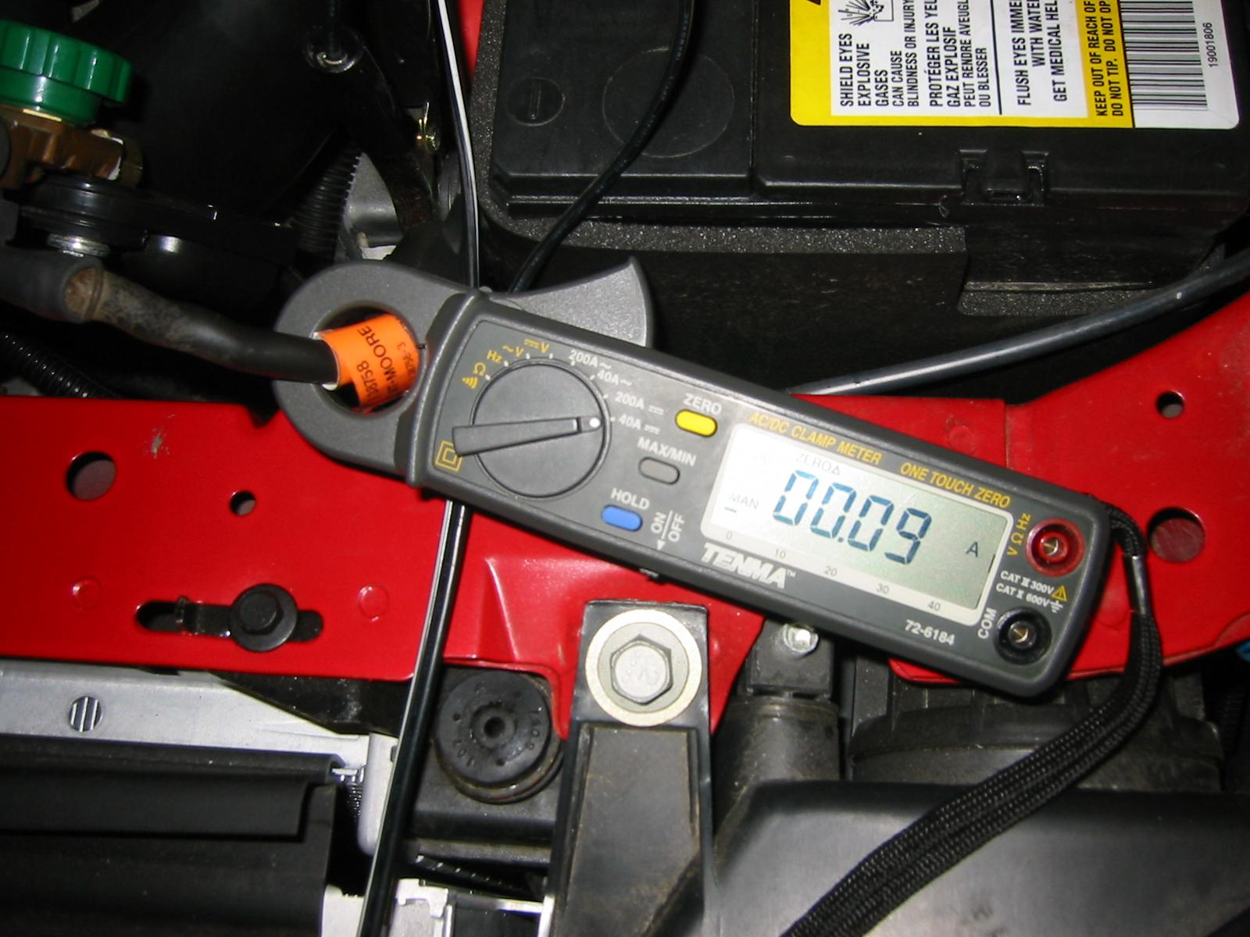
on for a long time

_____ 2. Turn the ignition and all accessories off. Close
all doors and the trunk. Disconnect
the under the hood lamp if equipped.

_____ 3. Disconnect the negative (-) battery cable.

_____ 4. Select DC amperes on a digital multimeter.

_____ 5. Connect the black meter lead to the negative terminal of the battery.

_____ 6. Connect the red meter lead to the disconnected cable end and read the ammeter
following the manufacturer’s module time out specifications and procedures.

______ amps of battery electrical drain [should be less than 0.05A (50 mA)]
OK _____ NOT OK _____

_____ 7. Reconnect the battery, reset the radio presets, and set the time on the vehicle clock.

HINT: If possible, use a clip-on type digital multimeter or an amp probe to measure the battery drain. Using this equipment prevents the need to disconnect the battery cable and then have to reset the radio and the clock.

_____ 8. Based on the test results, what is the necessary action? ________________________

___________________________________________________________________

