Fuel Composition Tester
Meets NATEF Task: (A8-D-2) Check fuel for contaminants and quality; determine necessary action. (P-2)

Name _______________________________ Date ___________ Time on Task __________

Make/Model/Year _________________ VIN ________________ Evaluation: 4 3 2 1

A fuel composition tester is used to determine the percentage of alcohol in a gasoline sample.

_____ 1. Check service information for the specified method of taking a fuel sample from the
vehicle.

__________________________________________________________________

__________________________________________________________________

_____ 2. Follow the instructions of the tester to determine the alcohol content of the gasoline.
The normal procedure for one type of tester states:

a. Connect a DMM and set to read AC Hertz. Verify the proper tool and meter
hookup by checking the air frequency (normally between 35 and 48 Hertz).

b. Pour the sample gasoline into the testing cell of the tool.

c. Record the AC frequency of the sample and subtract 50. The number that
results is the percentage of alcohol.

_____ 3. What is the air frequency? __________________

_____ 4. What is the frequency of the gasoline sample? __________________

_____ 5. Subtract 50 from the number in #4. What is the alcohol content of the gasoline
sample?
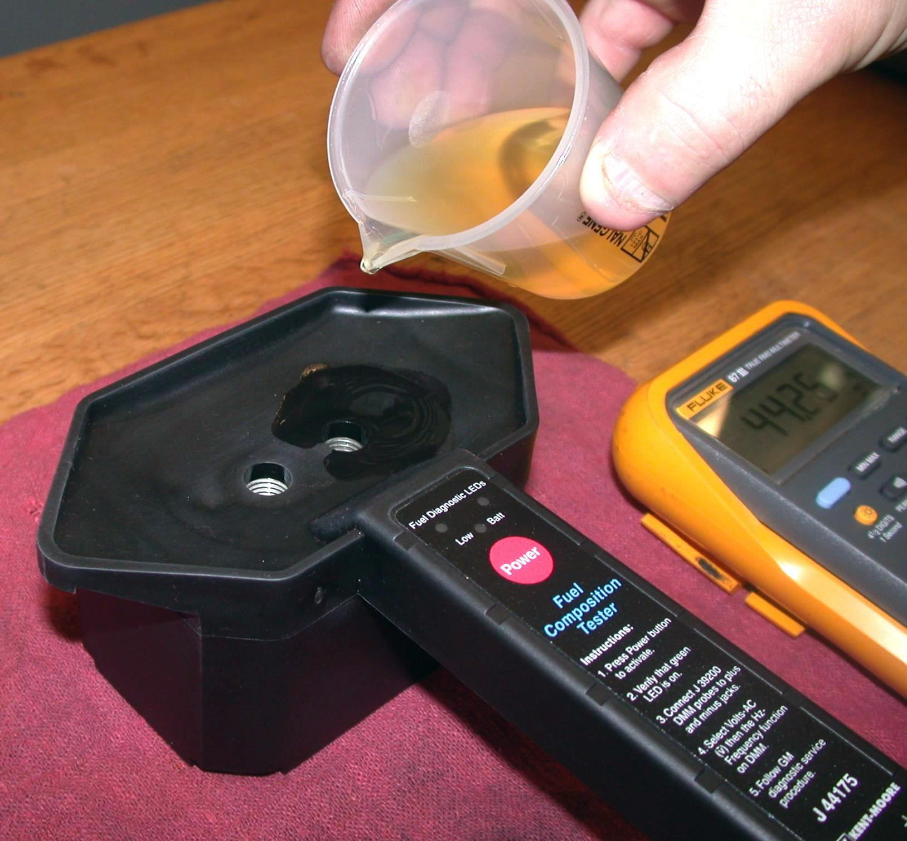
_____________________

_____ 6. Based on this test, what action is necessary?

___________________________________

___________________________________

