Catalytic Converter Test
Meets NATEF Task: (A8-E-9) Inspect and test catalytic converter efficiency.
(P-2)

Name _______________________________ Date ___________ Time on Task __________

Make/Model/Year _________________ VIN ________________ Evaluation: 4 3 2 1

_____ 1. Check service information for the recommended test to perform on the catalytic
converter.

__________________________________________________________________

__________________________________________________________________
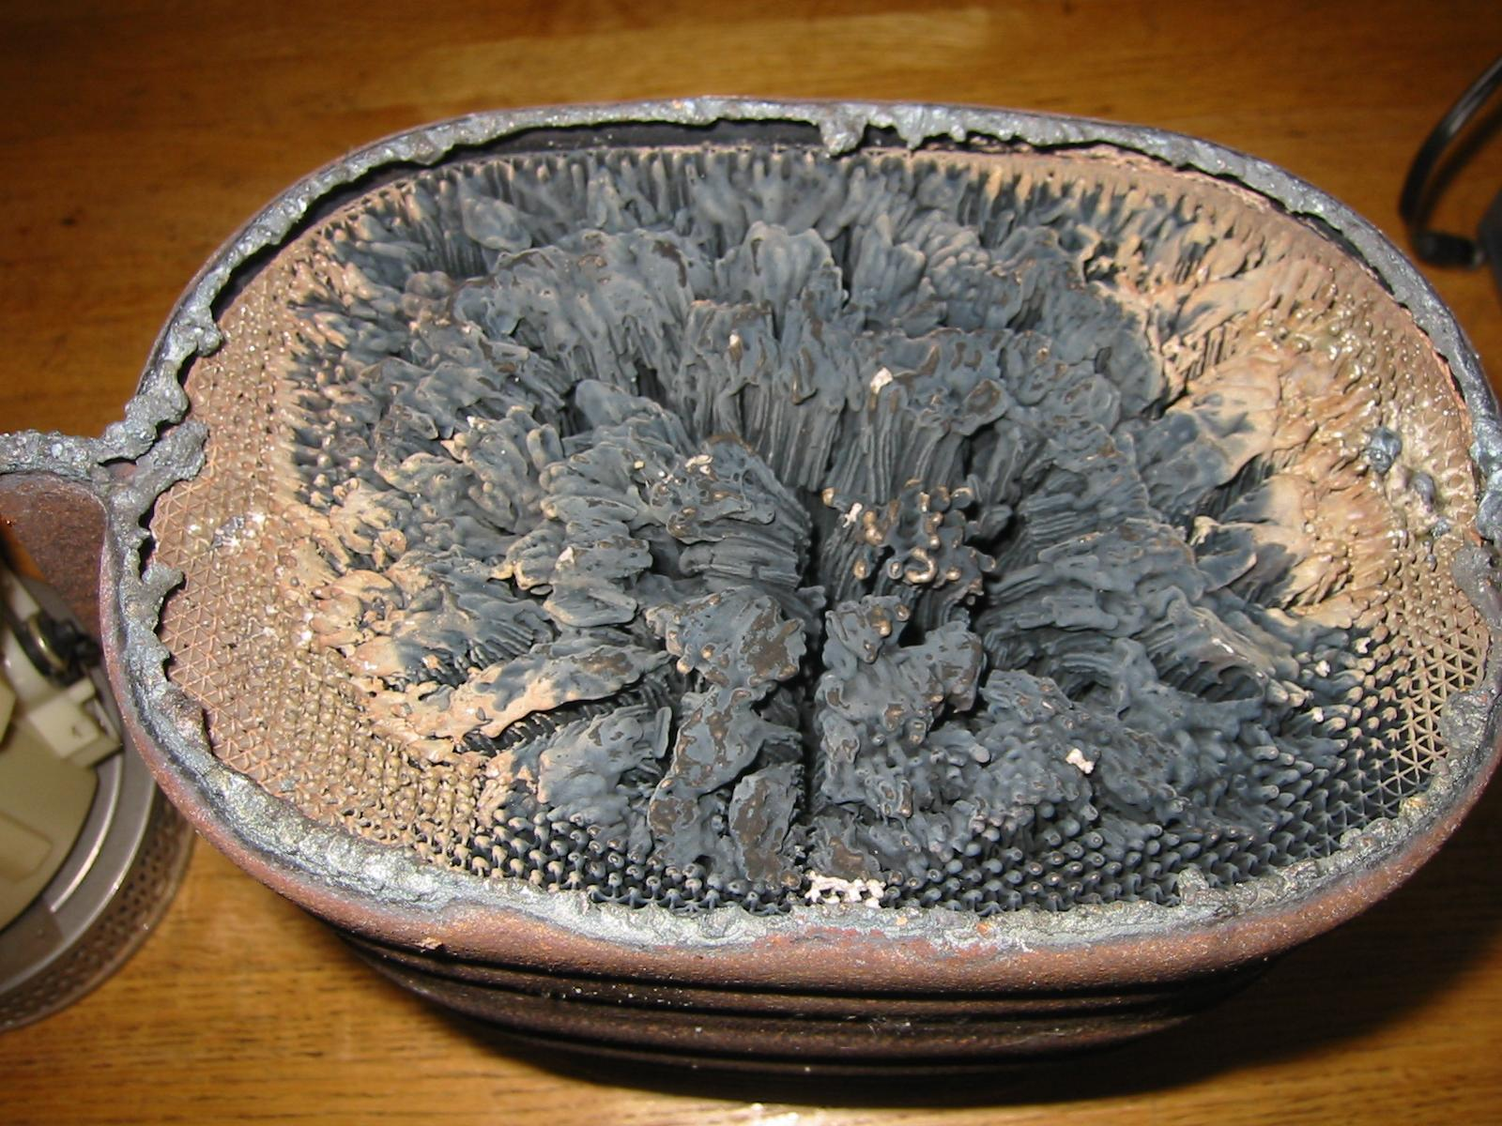
_____ 2. The recommended test(s) include the
following. Check all that apply.

____ Check for loose substrate (rattle
noise)

____ Check temperature differences

____ Use propane

____ Use an exhaust gas analyzer

____ Other (describe) _____________________________________________

_____ 3. Which tests were performed and what were the results?

a. _______________________ Result: ________________________________

b. _______________________ Result: ________________________________

c. _______________________ Result: ________________________________

_____ 4. Based on the tests and inspection of the catalytic converter, what is the necessary
action?

__________________________________________________________________

__________________________________________________________________

