PCV System Test
Meets NATEF Task: (A8-E-2) Inspect, test and service positive crankcase ventilation (PCV) filter/breather cap, valve, tubes, orifices, and hoses; perform necessary action. (P-2)

Name _______________________________ Date ___________ Time on Task __________

Make/Model/Year _________________ VIN ________________ Evaluation: 4 3 2 1

The purpose of the "positive crankcase ventilation" (PCV) system is to use engine intake manifold vacuum to draw crankcase vapors that occur due to blow-by past the piston rings into the engine to be burned.

NOTE: If there is gasoline in the engine oil, gasoline vapors will be drawn into the engine and
the intake charge will be richer. Therefore, if black exhaust smoke or a rich condition is
being diagnosed, check the crankcase for the presence of gasoline.

A good PCV system should draw fresh air into the engine through a filter usually located in the air cleaner or on the valve (cam) cover. This filtered air then is mixed with the blow-by gases in the crankcase and through a PCV valve which regulates the flow into the engine.

PCV Valve Operation:

a. Idle = high vacuum = PCV valve almost closed by high vacuum.

b. At cruise = 10-15 in. Hg. = PCV valve is opened to allow the crankcase gases to be
drawn into the engine (vacuum and internal spring are almost balanced).

c. At wide open throttle (WOT) low vacuum = PCV valve is fully opened by internal
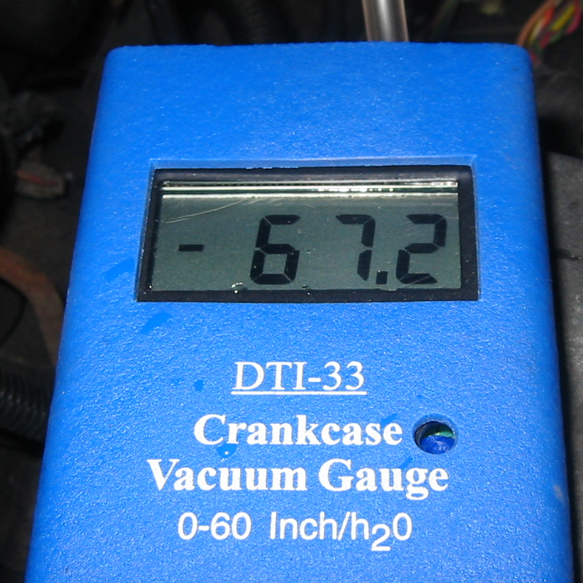
spring permitting maximum flow.

Testing the System:

_____ 1. Start the engine and allow it to idle.

_____ 2. Remove the oil fill cap.

_____ 3. Place a piece of paper or a 3" x 5" card over the filler. (The PCV system is
functioning correctly if the paper is held down tight onto the filler by vacuum in the
crankcase).

_____ 4. Seal off the oil fill opening and measure the crankcase vacuum at the dipstick tube
= ________ (should be about 0.5 in. Hg. or 7 in. or more of water if using a water
manometer).
OK _____ NOT OK _____

