Injector Balance Testing
Meets NATEF Task: (A8-D-7) Diagnose hot or cold no-starting, hard starting, poor driveability, and etc.; determine necessary action; determine necessary action. (P-2)

Name _______________________________ Date ___________ Time on Task __________

Make/Model/Year _________________ VIN ________________ Evaluation: 4 3 2 1

(Ohmmeter Method)
_____ 1. Check service information for the specified injector resistance. __________________

_____ 2. Measure the resistance of all injectors with a digital ohmmeter.
NOTE: For best performance and idle quality, all injectors should measure within
0.3 to 0.4 ohms of each other.

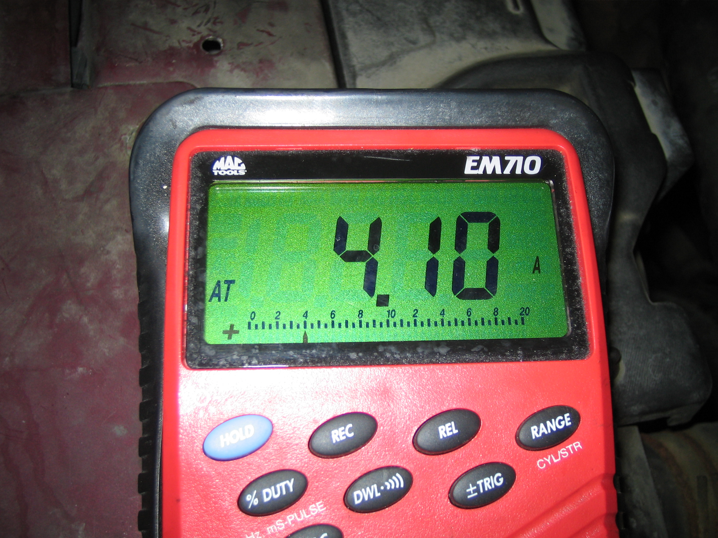
Injector resistance:
Resistance Resistance
1. __________ 5. __________
2. __________ 6. __________
3. __________ 7. __________
4. __________ 8. __________

Highest resistance = ____ ohms.
Lowest resistance = ____ ohms.
Difference = ____ ohms (should be less than 0.4 ohms).
OK______ NOT OK______

