IAC Scan Tool Diagnosis
Meets NATEF Task: (A8-B-8) Perform active tests of actuators using a scan tool; determine necessary action. (P-3)

Name _______________________________ Date ___________ Time on Task __________

Make/Model/Year _________________ VIN ________________ Evaluation: 4 3 2 1

_____ 1. Check service information for the specified IAC position as displayed on a scan tool.

__________________________________________________________________

__________________________________________________________________

_____ 2. Check service information for the units used to express the position of the IAC.
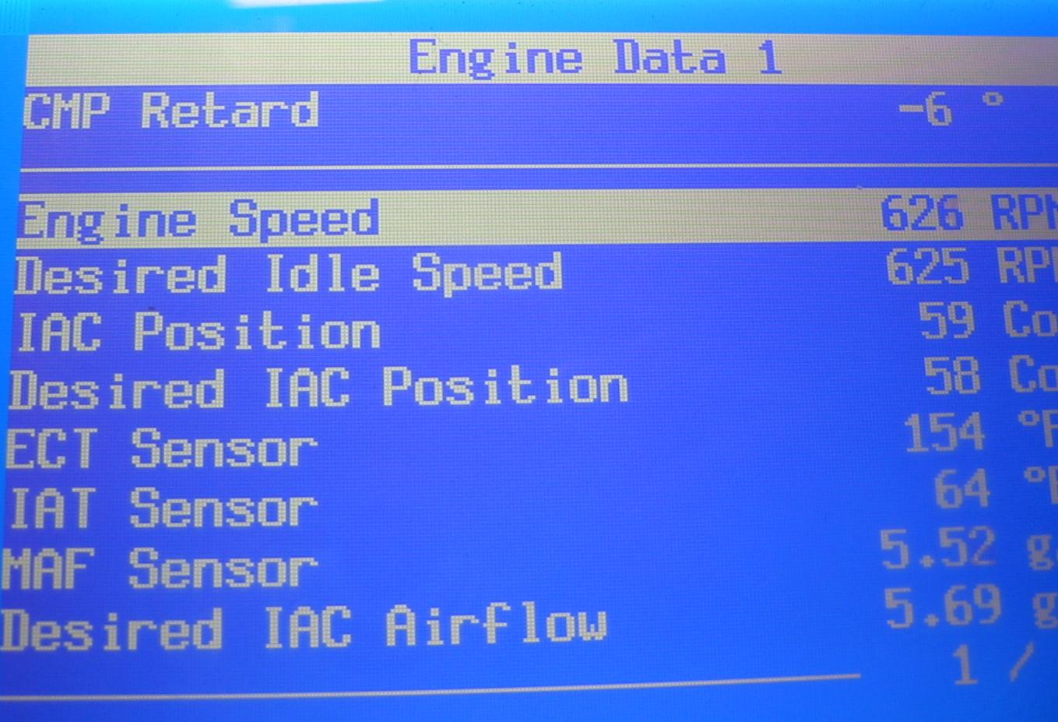
_____ Counts

_____ Percentage (%)

_____ Milliamperes (mA)

_____ Other (describe) ______________________________________________

_____ 3. What is the IAC position on a fully warmed engine without any accessories on?

__________________________________________________________________

_____ 4. Create a vacuum leak. How does the IAC react?

____ IAC position decreased (usually for speed density-equipped engines)

____ IAC position increases (usually for engines equipped with a MAF sensor)

_____ 5. Based on the test results, what is the necessary action? ________________________

_________________________________________________________________

