Diesel Exhaust Fluid

Meets NATEF Task: (A8-D-12) Check and refill diesel exhaust fluid. (P-3)

Name _______________________________ Date ___________ Time on Task __________

Make/Model/Year _________________ VIN ________________ Evaluation: 4 3 2 1

_____ 1. Check service information for the location of the diesel exhaust fluid fill port.
Describe the location. __________________________________________________
_________________________________________________________________
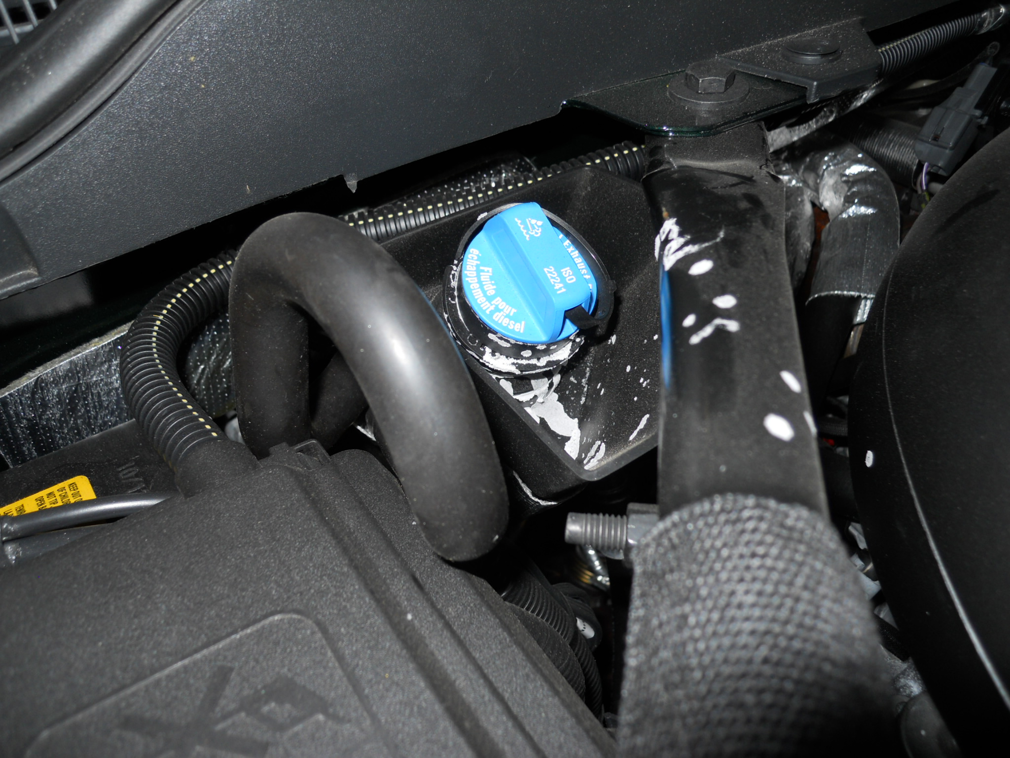

_____ 2. Check service information and determine the capacity of the DEF storage container.
DEF storage container capacity = __________________________

_____ 3. Check local parts stores and determine the current price for DEF. Record your
findings:
Store A = __________________
Store B = __________________
Store C = __________________

