Gasoline Engine Identification
Meets NATEF Task: (A8-A-2) Locate and interpret vehicle and major component identification information. (P-1)

Name _______________________________ Date ___________ Time on Task __________

Make/Model/Year _________________ VIN ________________ Evaluation: 4 3 2 1

_____ 1. Number of cylinders = ________ Arrangement of cylinders = _________________
_____ 2. Number and arrangement of camshafts = ___________________________________
_____ 3. Bore = ________ Stroke = _______ Cu. in. = ______ cc = ______ Liters = ______
_____ 4. Rated HP = ________ @ RPM _______
_____ 5. Rated torque = _________ @ RPM _______
_____ 6. Compression ratio = _______________
_____ 7. Recommended octane of gasoline required = ______________________
_____ 8. The block is constructed of: ____ cast iron _____ aluminum

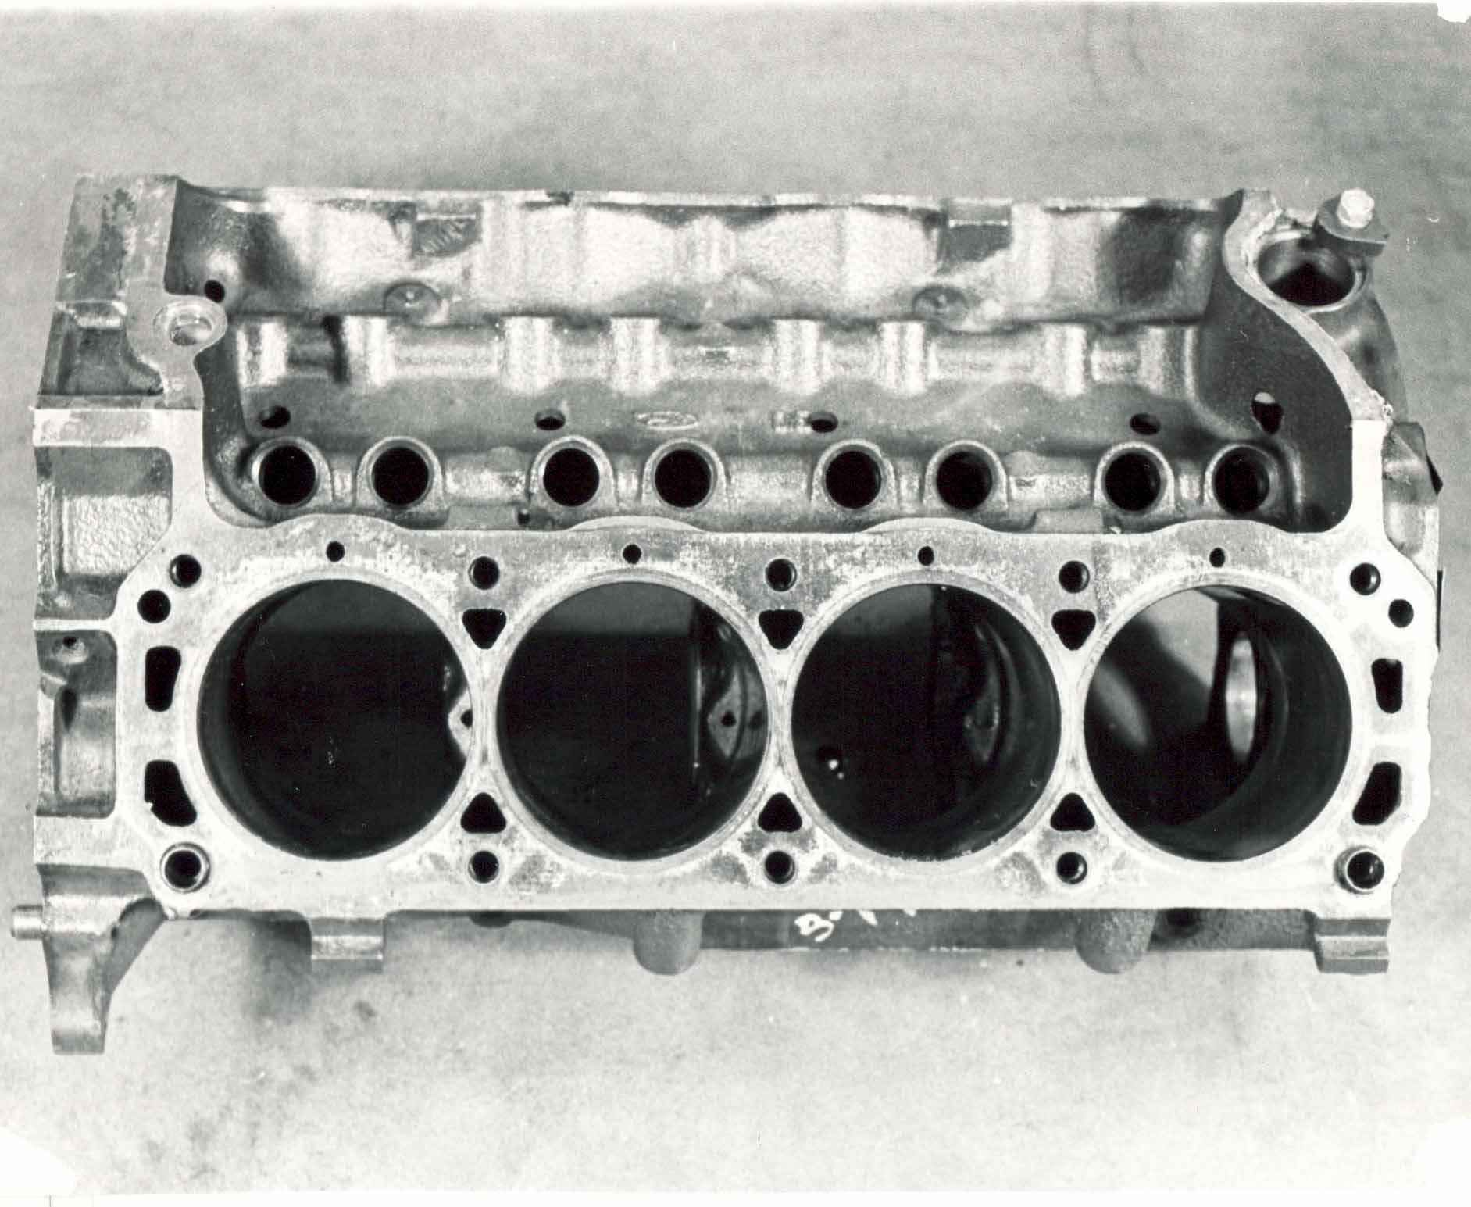

_____ 9. Cylinder head(s) is constructed of: ____ cast iron _____ aluminum
_____ 10. Intake manifold is: _____ one piece _____ two pieces (upper and lower) and is
constructed of: ____ cast iron _____ aluminum _____ composite
_____ 11. Casting numbers on the block ________________ Cylinder head(s) ____________
Crankshaft ___________________

