MAF Sensor Diagnosis
Meets ASE Task: (A8-B-7) P-2 Inspect and test sensors, actuators, and circuits using a graphing multimeter (GMM)/digital storage oscilloscope (DSO); perform necessary action.

Name _______________________________ Date ___________ Time on Task __________

Make/Model/Year _________________ VIN ________________ Evaluation: 4 3 2 1

A "Mass Air Flow" sensor produces a variable output depending on the MASS of the air flow through the sensor. A faulty MAF can cause driveability problems and stalling. A good MAF sensor should produce a signal that increases with engine speed.

_____ 1. Check service information for the specified procedure to follow to test the MAF
sensor.

__________________________________________________________________

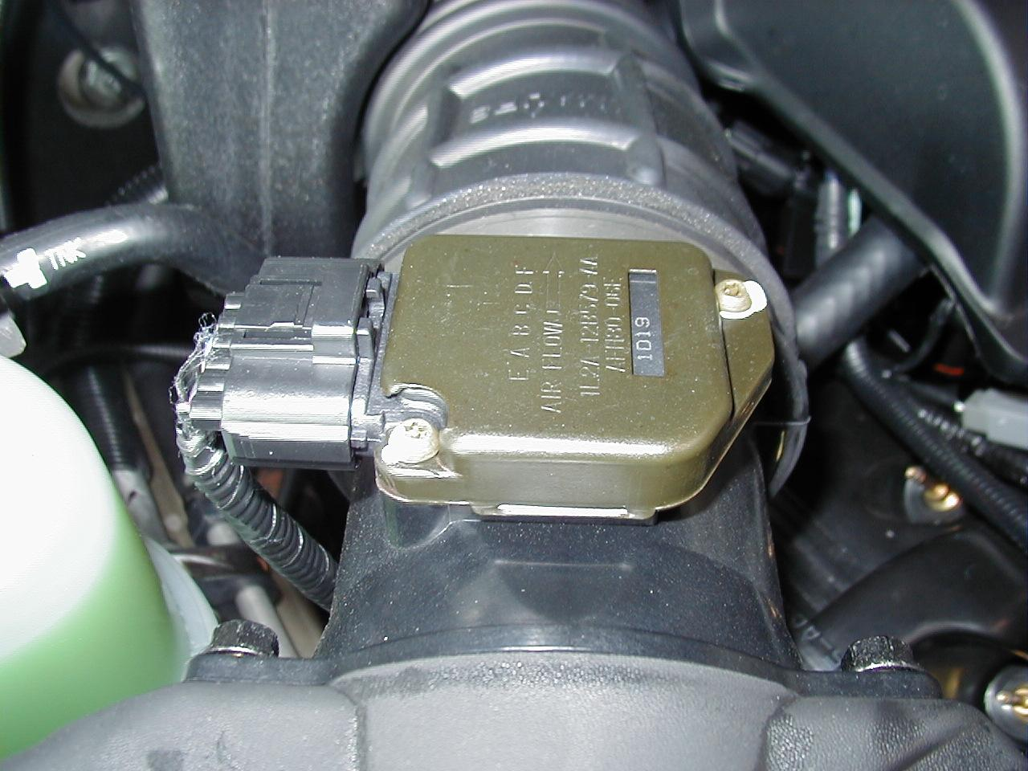
_____ 2. Use a meter or scope with a frequency counter to record
frequency or voltage at idle and at WOT (short bursts).

at idle = ____________ at WOT = _____________

_____ 3. Use a scan tool and record grams per second.

at idle = ____________ at WOT = _____________

A good MAF should read:

- greater than 100 grams per second (scan tool diagnosis)
- higher than 7000 Hertz (7 KHz) (digital MAF)
- higher than 4 volts (analog MAF)

_____ 4. If the MAF sensor reading does not exceed these values, the sensing wire may be
contaminated or the sensor itself is defective.

_____ 5. Based on the test results, what is the necessary action? ________________________

_________________________________________________________________

_________________________________________________________________

