Temperature Sensor Scan Tool Diagnosis
Meets ASE Task: (A8-B-7) P-2 Inspect and test sensors, actuators, and circuits using a graphing multimeter (GMM)/digital storage oscilloscope (DSO); perform necessary action.

Name _______________________________ Date ___________ Time on Task __________

Make/Model/Year _________________ VIN ________________ Evaluation: 4 3 2 1

_____ 1. Check service information for the recommended method for checking temperature
sensors using a scan tool.

__________________________________________________________________

__________________________________________________________________

_____ 2. List all of the temperature sensors that are on the vehicle. Check all that apply.

_____ ECT (describe location) ________________________________________

_____ IAT (describe location) _________________________________________

_____ TFT (describe location) _________________________________________

_____ Other (describe) ______________________________________________
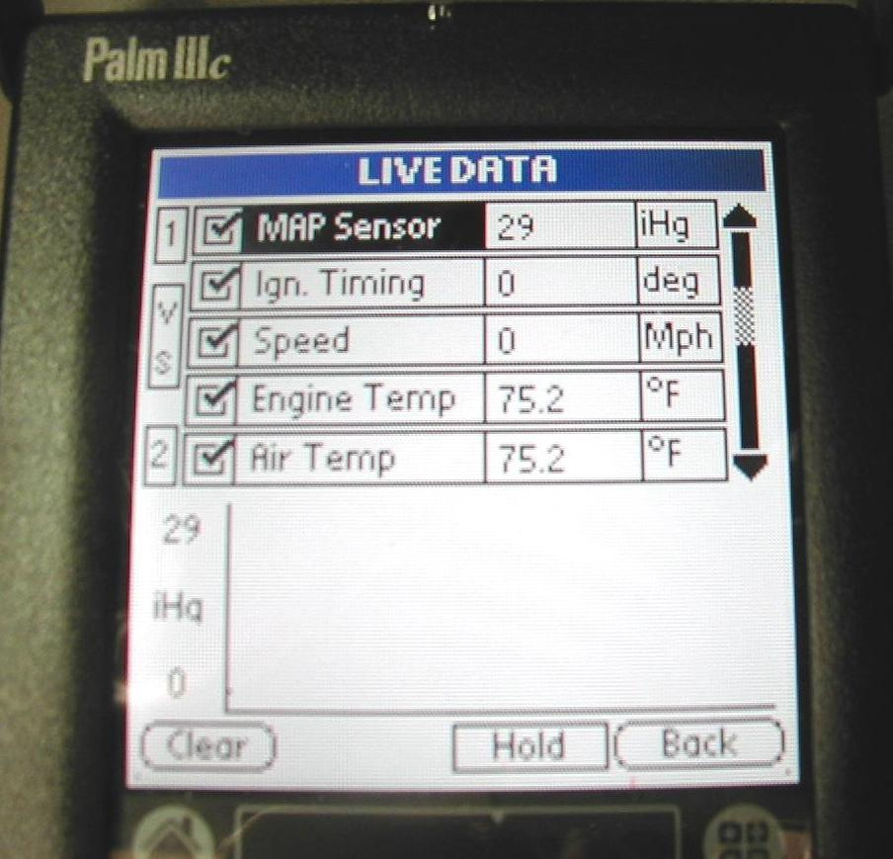
_____ 3. On a vehicle that has not been operated for several hours,
use a scan tool and list the temperature displayed for
various temperature sensors.

ECT = _______

IAT = ________

TFT = ________

Other (describe) = ____________________________

_____________________________________

_____ 4. Based on the test results, what is the necessary action? _________________________

__________________________________________________________________

