Spark Plugs Inspection
Meets ASE Task: (A8-C-4) P-1 Inspect and test ignition primary and secondary circuit wiring and solid state components; test ignition coil(s); perform necessary action.

Name _______________________________ Date ___________ Time on Task __________

Make/Model/Year _________________ VIN ________________ Evaluation: 4 3 2 1

_____ 1. Check service information and determine the correct plug code and gap for your
vehicle using a spark plug application guide.

Engine: # Cylinders_____ VIN# ____________________
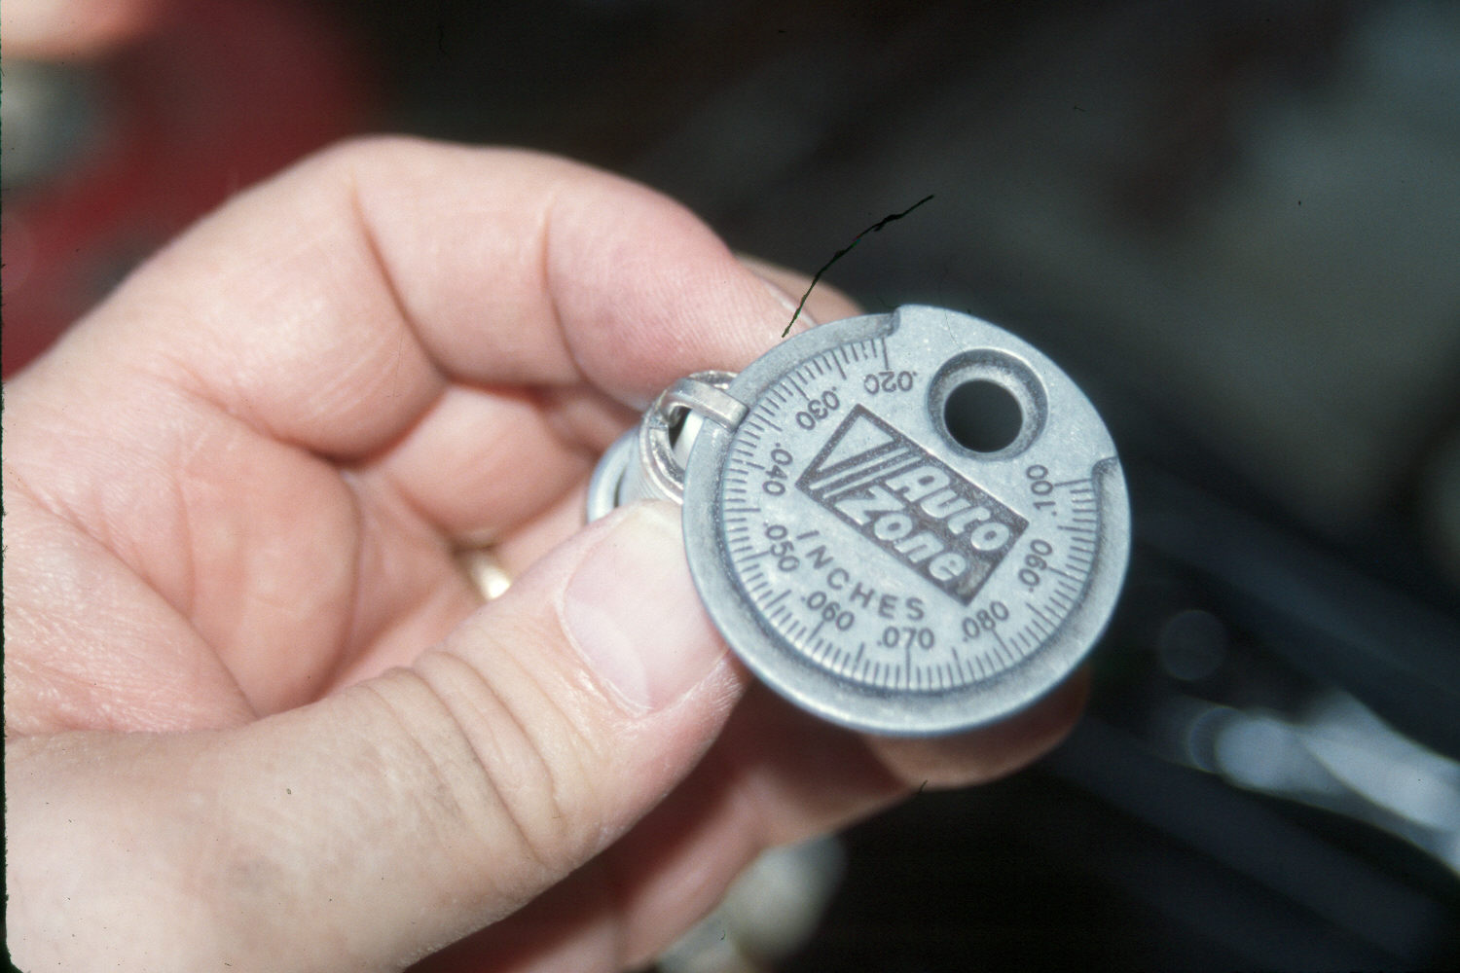
Brand __________ Code # __________ Gap __________

_____ 2. Remove and label all the spark plug wires.

_____ 3. Determine the condition and gap of all spark plugs:

Condition Gap
1. ______________________________________ _______
2. ______________________________________ _______
3. ______________________________________ _______
4. ______________________________________ _______
5. ______________________________________ _______
6. ______________________________________ _______
7. ______________________________________ _______
8. ______________________________________ _______

_____ 4. Reinstall the spark plug (start by hand).

_____ 5. Use a torque wrench and torque the spark plugs to the proper torque.

Specified torque = ______________

_____ 6. Start the engine. Check for possible rough running caused by crossed or loose spark
plug wires.

OK _____ NOT OK _____

_____ 7. Based on the inspection of the spark plugs, what is the necessary action? __________

__________________________________________________________________

