Alternative Fuel Power and Economy Specifications
Meets ASE Task: (A8-A-2) P-1
Research applicable vehicle and service information.

Name _______________________________ Date ___________ Time on Task __________

Make/Model/Year _________________ VIN ________________ Evaluation: 4 3 2 1

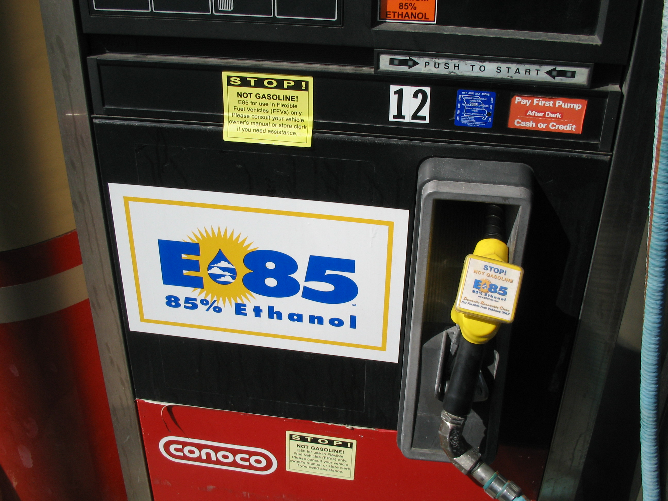

With vehicles that are designed to use gasoline and alternative fuel, such as E-85, manufacturers usually rate the horsepower, torque, and EPA fuel economy ratings separately. Select four flex-fuel vehicles and using service information locate the values for both gasoline and the alternative fuel.

Vehicle #1 Make _____________ Model _____________ Year ____ Engine __________

 | HP | Torque | City MPG | Highway MPG
Gasoline
Alternative Fuel

Vehicle #2 Make _____________ Model _____________ Year ____ Engine __________

 | HP | Torque | City MPG | Highway MPG
Gasoline
Alternative Fuel

Vehicle #3 Make _____________ Model _____________ Year ____ Engine __________

 | HP | Torque | City MPG | Highway MPG
Gasoline
Alternative Fuel

Vehicle #4 Make _____________ Model _____________ Year ____ Engine __________

 | HP | Torque | City MPG | Highway MPG
Gasoline
Alternative Fuel

