Lighting System Diagnosis
Meets ASE Task: (A6-E-1) P-1, (A6-E-2) P-1, and (A6-E-3) P-2 Diagnose lighting concerns; determine necessary action.

Name _______________________________ Date ___________ Time on Task __________

Make/Model/Year _________________ VIN ________________ Evaluation: 4 3 2 1

_____ 1. Check service information for the specified lighting diagnosis procedures and
specifications.

_________________________________________________________________

_________________________________________________________________

_____ 2. What type of headlights are used on the vehicle?

____ Sealed beam
____ Halogen replacement bulbs
____ High-intensity discharge (HID)
____ Other (describe) _______________________________________________

_____ 3. Is alignment equipment needed? ___ Yes ___ No

If yes, describe: ____________________________________________________

_____ 4. Is the headlight unit equipped with a bubble level? ___ Yes ___ No

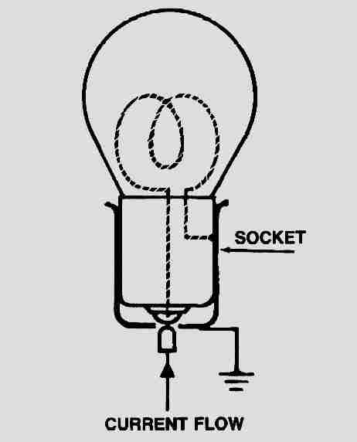
_____ 5. Is the correct bulb trade number installed? ___ Yes ___ No

_____ 6. Check for proper power and ground at the socket of the bulb.

____ OK ____ NOT OK (describe fault) ________________

____________________________________________________

_____ 7. Based on the inspection and testing, what is the necessary action?

___________________________________________________

___________________________________________________

