Starter Relays and Solenoids
Meets ASE Task: (A6-C-3) P-2 and (A6-C-5) P-2 Inspect and test starter relays, solenoids, connections, and wires; determine necessary action.

Name _______________________________ Date ___________ Time on Task __________

Make/Model/Year _________________ VIN ________________ Evaluation: 4 3 2 1

_____ 1. Clean and visually inspect the starter solenoid and/or relay for physical damage.
OK _____ NOT OK _____
_____ 2. Set a digital multimeter (DMM) to read ohms (low scale) and check the hold-in coil
and the pull-in coil.

Pull-in coil. Measure between terminals “S” and “M”:
resistance = ______ (should be 0.2 to 0.4 ohm) OK _____ NOT OK _____

Hold-in coil. Measure between terminals “S” and the solenoid housing:
resistance = _______ (should be 0.4 to 0.6 ohm) OK _____ NOT OK _____

_____ 3. Test the pull-in winding by applying 12 volts to terminal “S” and ground to terminal
“M.” Check that the plunger will be drawn into the solenoid.
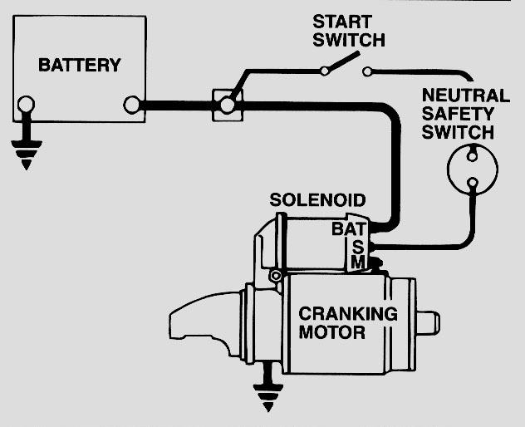
OK _____ NOT OK _____

_____ 4. Check the hold-in winding by connecting 12 volts
to terminal “S” and the other wire to ground. The
plunger should be drawn into the solenoid housing.

OK _____ NOT OK _____

_____ 5. Measure coil resistance of the relay (terminals 86 and
85).
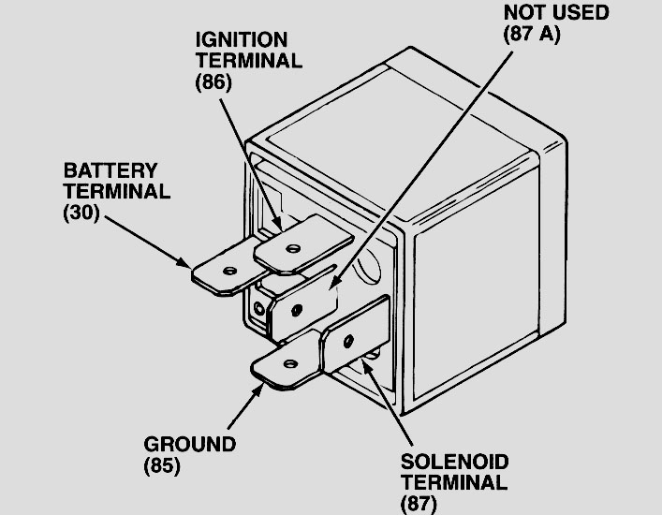
Resistance = ______ ohms
(should be 60 to 100 ohms)

OK _____ NOT OK _____

_____ 6. What is the necessary action?
_____________________________________
_____________________________________

