Battery and Capacity Tests
Meets ASE Task: (A6-B-1) P-1 and (A6-B-2) P-1 Perform battery state-of-charge test; determine necessary action.

Name _______________________________ Date ___________ Time on Task __________

Make/Model/Year _________________ VIN ________________ Evaluation: 4 3 2 1

_____ 1. Check service information for the specified method for determining the state-of-
charge of the battery.

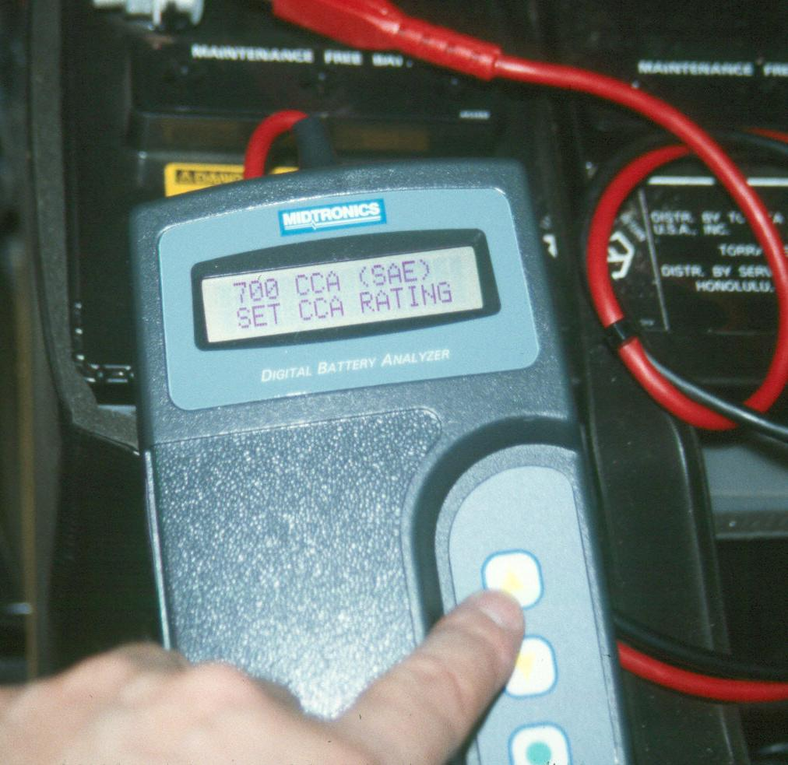
_____________________________________________________
_____________________________________________________
_____________________________________________________
_____ 2. Determine the state-of-charge using a voltmeter.
12.6 volts or higher = 100% charged
12.4 volts = 75% charged
12.2 volts = 50% charged
12.0 volts = 25% charged
10.5 volts = dead
_____ 3. Determine the state-of-charge and capacity using a conductance tester.
__________________________________________

_____ 4. Determine the capacity of the battery using a carbon pile tester.
__________________________________________

_____ 5. What is the condition of the battery? ______________________________________

_____ 6. What is the necessary action? _____________________________________________
__________________________________________________________________

