Key Off Battery Drain
Meets ASE Task: (A6-A-8) P-1 Measure and diagnose the cause(s) of excessive key-off battery drain (parasitic draw); determine the necessary action.

Name _______________________________ Date ___________ Time on Task __________

Make/Model/Year _________________ VIN ________________ Evaluation: 4 3 2 1

A battery electrical drain test should be performed if a battery is dead (discharged) to determine if a battery electrical drain was the cause of the dead battery.

_____ 1. Perform a visual inspection and check if the following are turned on:

- The glove box light (instrument panel compartment light)
- The interior light switch
- Vanity mirror(s) light(s)
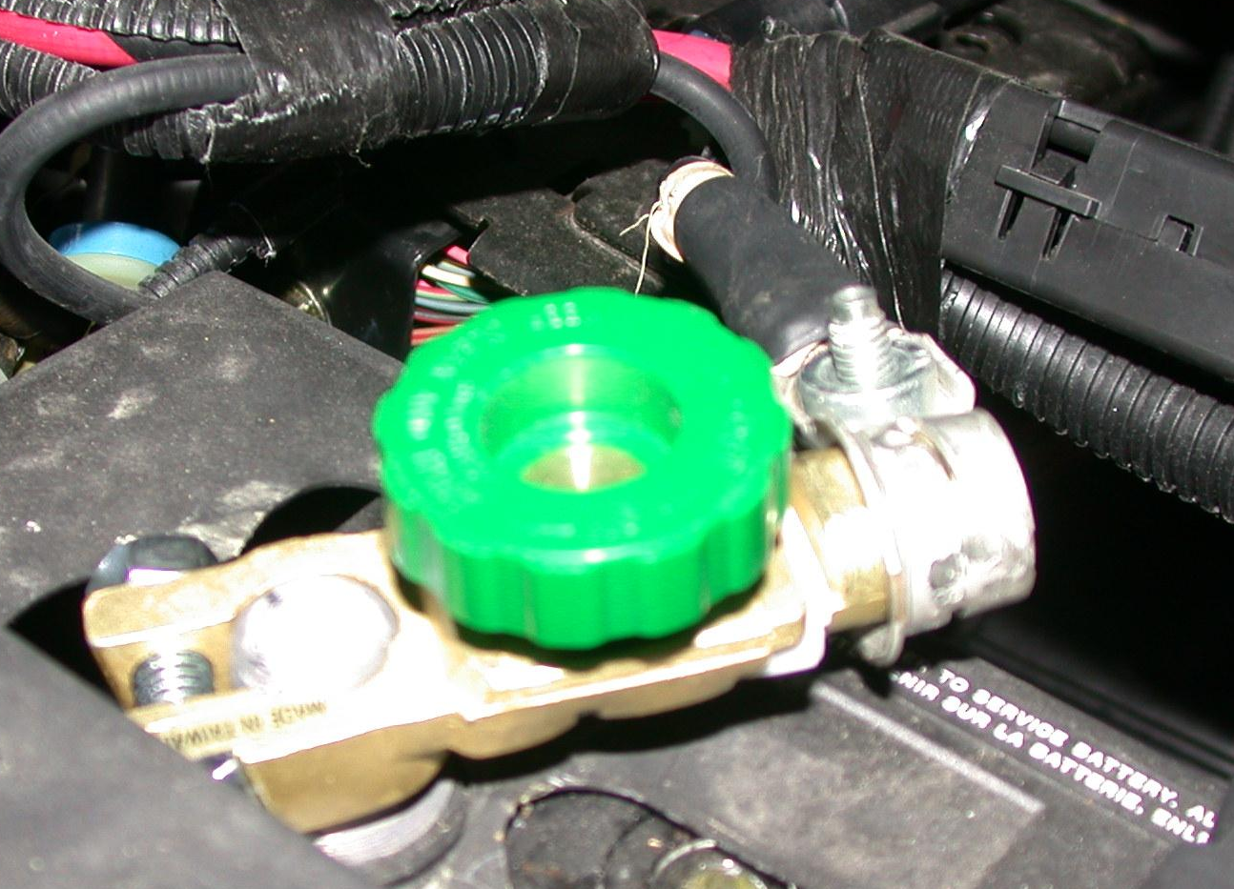
- Trunk light (look for discoloration indicating that the bulb may have been on for a long time)

_____ 2. Turn the ignition and all accessories off. Close all doors and the
trunk. Disconnect the under-the-hood lamp if equipped.

_____ 3. Disconnect the negative (-) battery cable.

_____ 4. Select DC amperes on a digital multimeter.

_____ 5. Connect the black meter lead to the negative terminal of the battery.

_____ 6. Connect the red meter lead to the disconnected cable end and read
the ammeter.

______ amps of battery electrical drain [should be less than
0.05A (50 mA)]

OK _____ NOT OK _____

_____ 7. What is the necessary action? _____________________________________________
__________________________________________________________________

_____ 8. Reconnect the battery, reset the radio presets, and set the time on the vehicle clock.

HINT: If possible, use a clip-on type digital multimeter or an amp probe to measure the battery drain. Using this equipment prevents the need to disconnect the battery cable and then have to reset the radio and the clock.

