Wire Harness and Connector Repair

Meets ASE Task: (A6-A-10) P-1 Repair wiring harnesses and connectors

Name _______________________________ Date ___________ Time on Task __________

Make/Model/Year _________________ VIN ________________ Evaluation: 4 3 2 1

_____ 1. Check service information for the specified procedures for repairing wiring harnesses
and connectors. Describe:
__________________________________________________________________
__________________________________________________________________
_____ 2. Perform a visual inspection and determine the following information regarding the
wiring harnesses in the vehicle.

a. Is the wiring harness covered with corrugated plastic conduit?
_____ Yes _____ No (If no, disregard “B”.)

b. Does the plastic corrugated conduit have a green or gray painted stripe?
_____ Yes _____ No
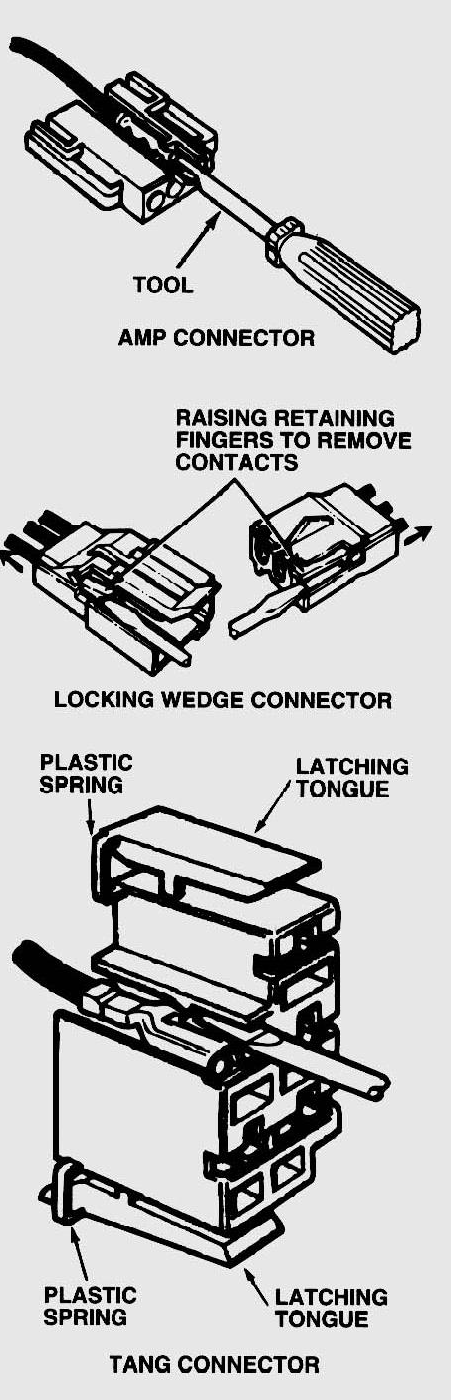
NOTE: The green or gray painted stripe indicates
that the conduit is designed to withstand high
temperatures up to about 300°F (150°C).

c. Is the wiring harness routed near any of these items?
_____ A heat source such as an EGR valve?
_____ Yes _____ No
_____ Close to moving components?
_____ Yes _____ No

_____ 3. Are the electrical connectors weather-proof?
_____ Yes _____ No
