Hybrid Vehicle HV Circuit Disconnect
Meets ASE Task: (A6-B-7) P-2 Identify location of hybrid vehicle high-voltage circuit disconnect (service plug) location and safety precautions.

Name _______________________________ Date ___________ Time on Task __________

Make/Model/Year _________________ VIN ________________ Evaluation: 4 3 2 1

_____ 1. Check service information for the location of the high-voltage disconnect (service
plug) for the following hybrid electric vehicles:
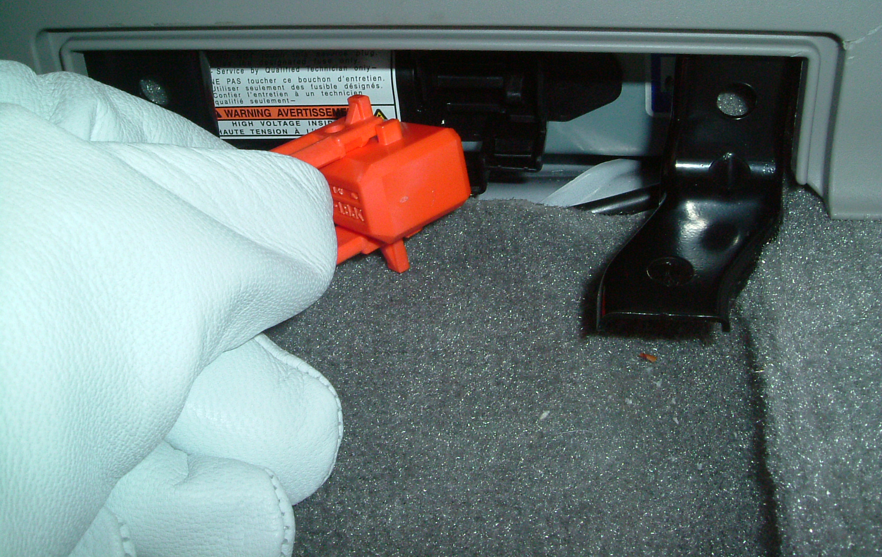
Toyota Prius _____________________

__________________________

Toyota Camry hybrid ______________

__________________________

Honda Civic and Accord hybrid ______

__________________________

Ford/Mercury hybrid ________________________________________________

General Motors PHT hybrid __________________________________________

General Motors two-mode hybrid ______________________________________

Saturn hybrid ______________________________________________________

Other (describe) ____________________________________________________
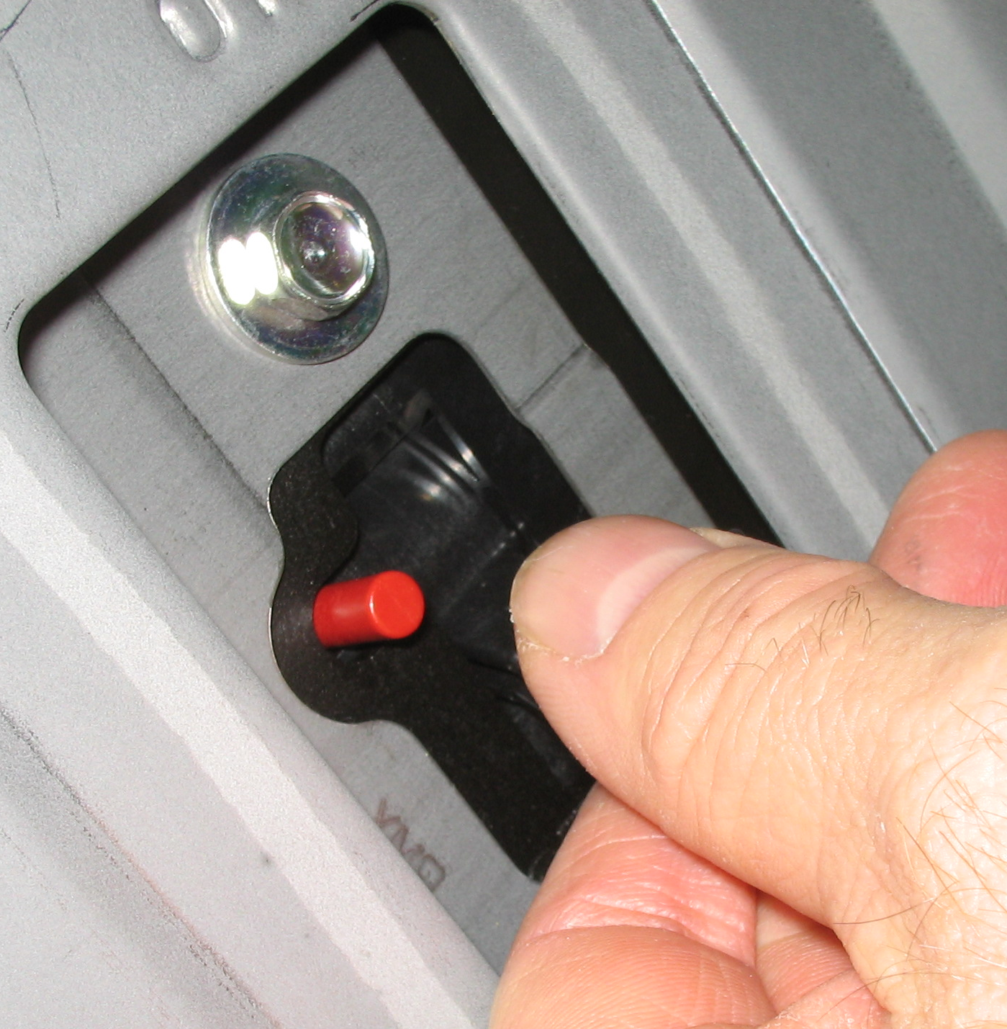
_____ 2. Check service information and list the safety
precautions specified when de-powering the high-
voltage circuits.

___________________________________

___________________________________

___________________________________

