Smoke Test of the EVAP System
Meets ASE Task: (A8-E-5) P-2 Inspect and test components and hoses of the evaporative emissions control system and DTCs; perform necessary action.

Name _______________________________ Date ___________ Time on Task __________

Make/Model/Year _________________ VIN ________________ Evaluation: 4 3 2 1

_____ 1. Check for any EVAP-related diagnostic trouble codes (DTCs).

_________________________________________________________________

_____ 2. Check service information for the procedures and pressures to follow when checking
the evaporative emission control system for leaks using smoke.

__________________________________________________________________

__________________________________________________________________

Specified maximum pressure = _________________________________

_____ 3. Connect the smoke machine to the evaporative emission control system following the
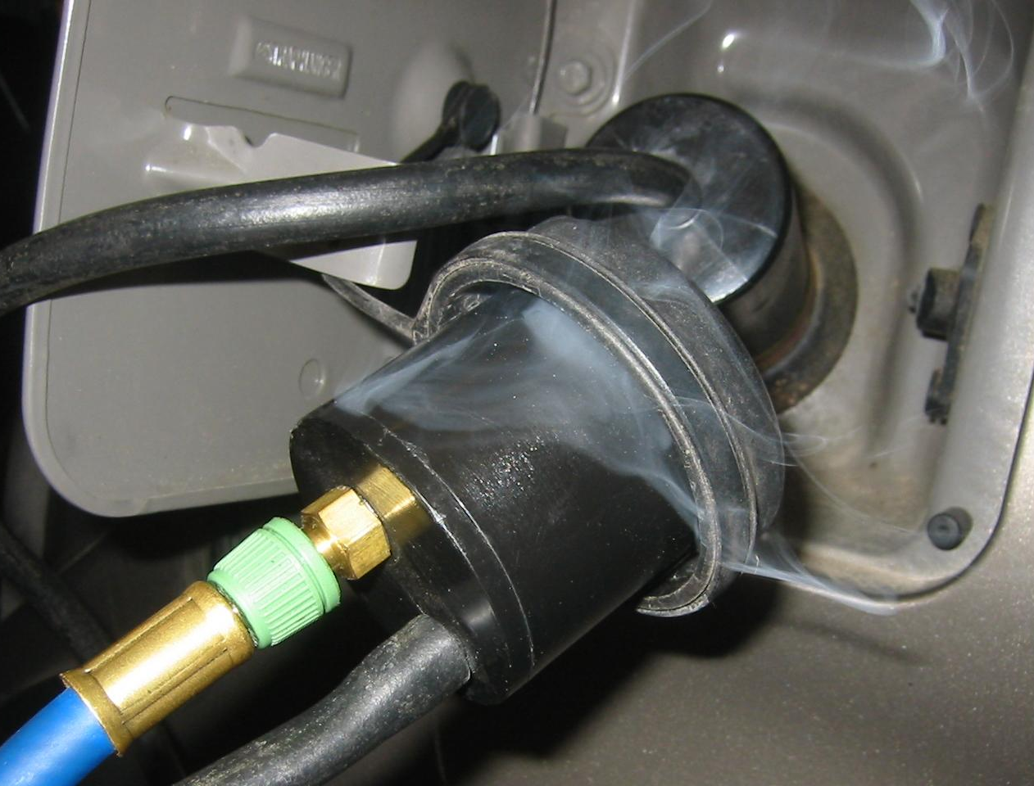
instructions supplied with the smoke machine.

____________________________________

____________________________________

____________________________________

____________________________________

_____ 4. Use a bright light and look for smoke leaking from the evaporative emission control
system. Describe the leaks, if any.

__________________________________________________________________

__________________________________________________________________

_____ 5. Based on the results of the scan tool and smoke testing, what is the necessary action?

__________________________________________________________________

