Secondary Air Injection Diagnosis
Meets ASE Task: (A8-E-4) P-2 Inspect and test mechanical components of secondary air injection systems; perform necessary action.

Name _______________________________ Date ___________ Time on Task __________

Make/Model/Year _________________ VIN ________________ Evaluation: 4 3 2 1

_____ 1. Check service information for the recommended procedures to follow when inspecting
and testing the AIR pump components.

_________________________________________________________________

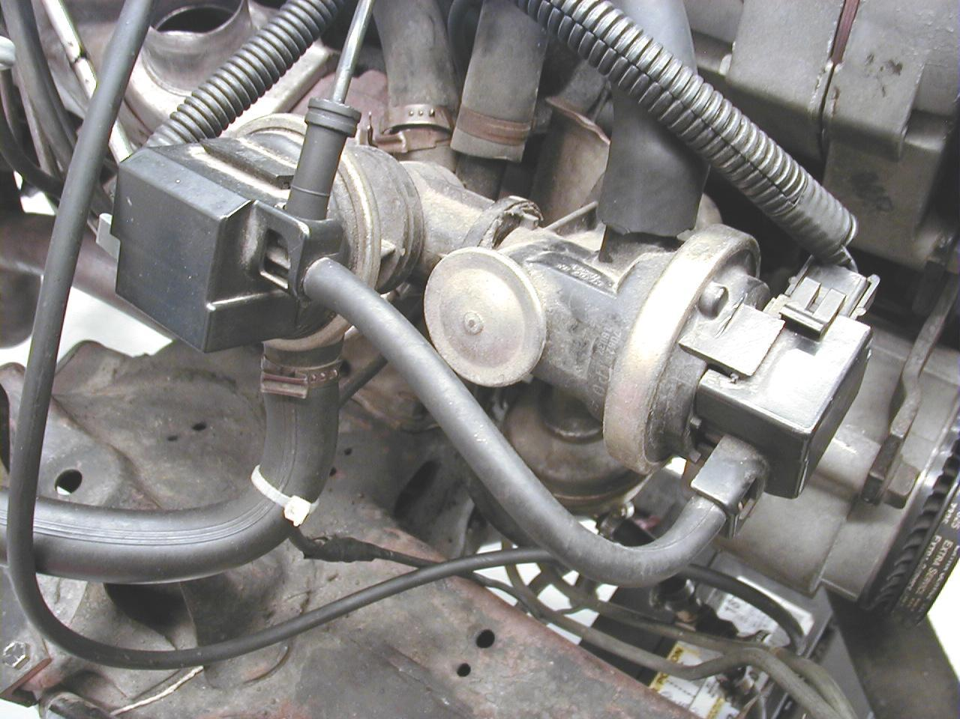
_____ 2. Carefully inspect the condition
of all of the hoses, check the valves
and the metal lines for corrosion or
damage.

_____ 3. Start the engine and feel the air pump
lines to confirm the proper air flow.

NOTE: A defective one-way check valve at the exhaust manifold can allow hot exhaust gases to flow past the check valve and cause damage to the switching valves, hoses or air pump itself. These exhaust gases can cause poor engine operation and stalling if drawn into the air intake system.

_____ 4. Inspect the air pump drive belt for cracks and proper tension.

_____ 5. Inspect the electrical/electronic components of the air injection system.

_____ 6. Based on the inspection, what is the necessary action?

________________________________________________________________

________________________________________________________________

________________________________________________________________

