Hybrid High-Voltage Disconnect
Meets ASE Task: (A6-B-7) P-2 Identify the location of hybrid vehicle safety disconnect location and safety procedures.

Name _______________________________ Date ___________ Time on Task __________

Make/Model/Year _________________ VIN ________________ Evaluation: 4 3 2 1

Hybrid electric vehicles (HEV) use a high-voltage battery pack and an electric motor(s) to help propel the vehicle. To safely work around a hybrid electric vehicle, the high-voltage (HV) battery and circuits should be shut off following these steps:

Step 1 Turn off the ignition key (if equipped) and remove the key from the
ignition switch.
Step 2 Disconnect the high-voltage circuits.
______________________________________________________________________________
CAUTION: Some vehicle manufacturers specify that rubber insulated lineman’s gloves be used whenever working around the high-voltage circuits to prevent the danger of electrical shock.
______________________________________________________________________________

Toyota Prius
The cutoff switch is located in the trunk. To gain access, remove three clips holding the upper left portion of the trunk side cover. To disconnect the high-voltage system, pull the orange handled plug while wearing insulated rubber lineman’s gloves.
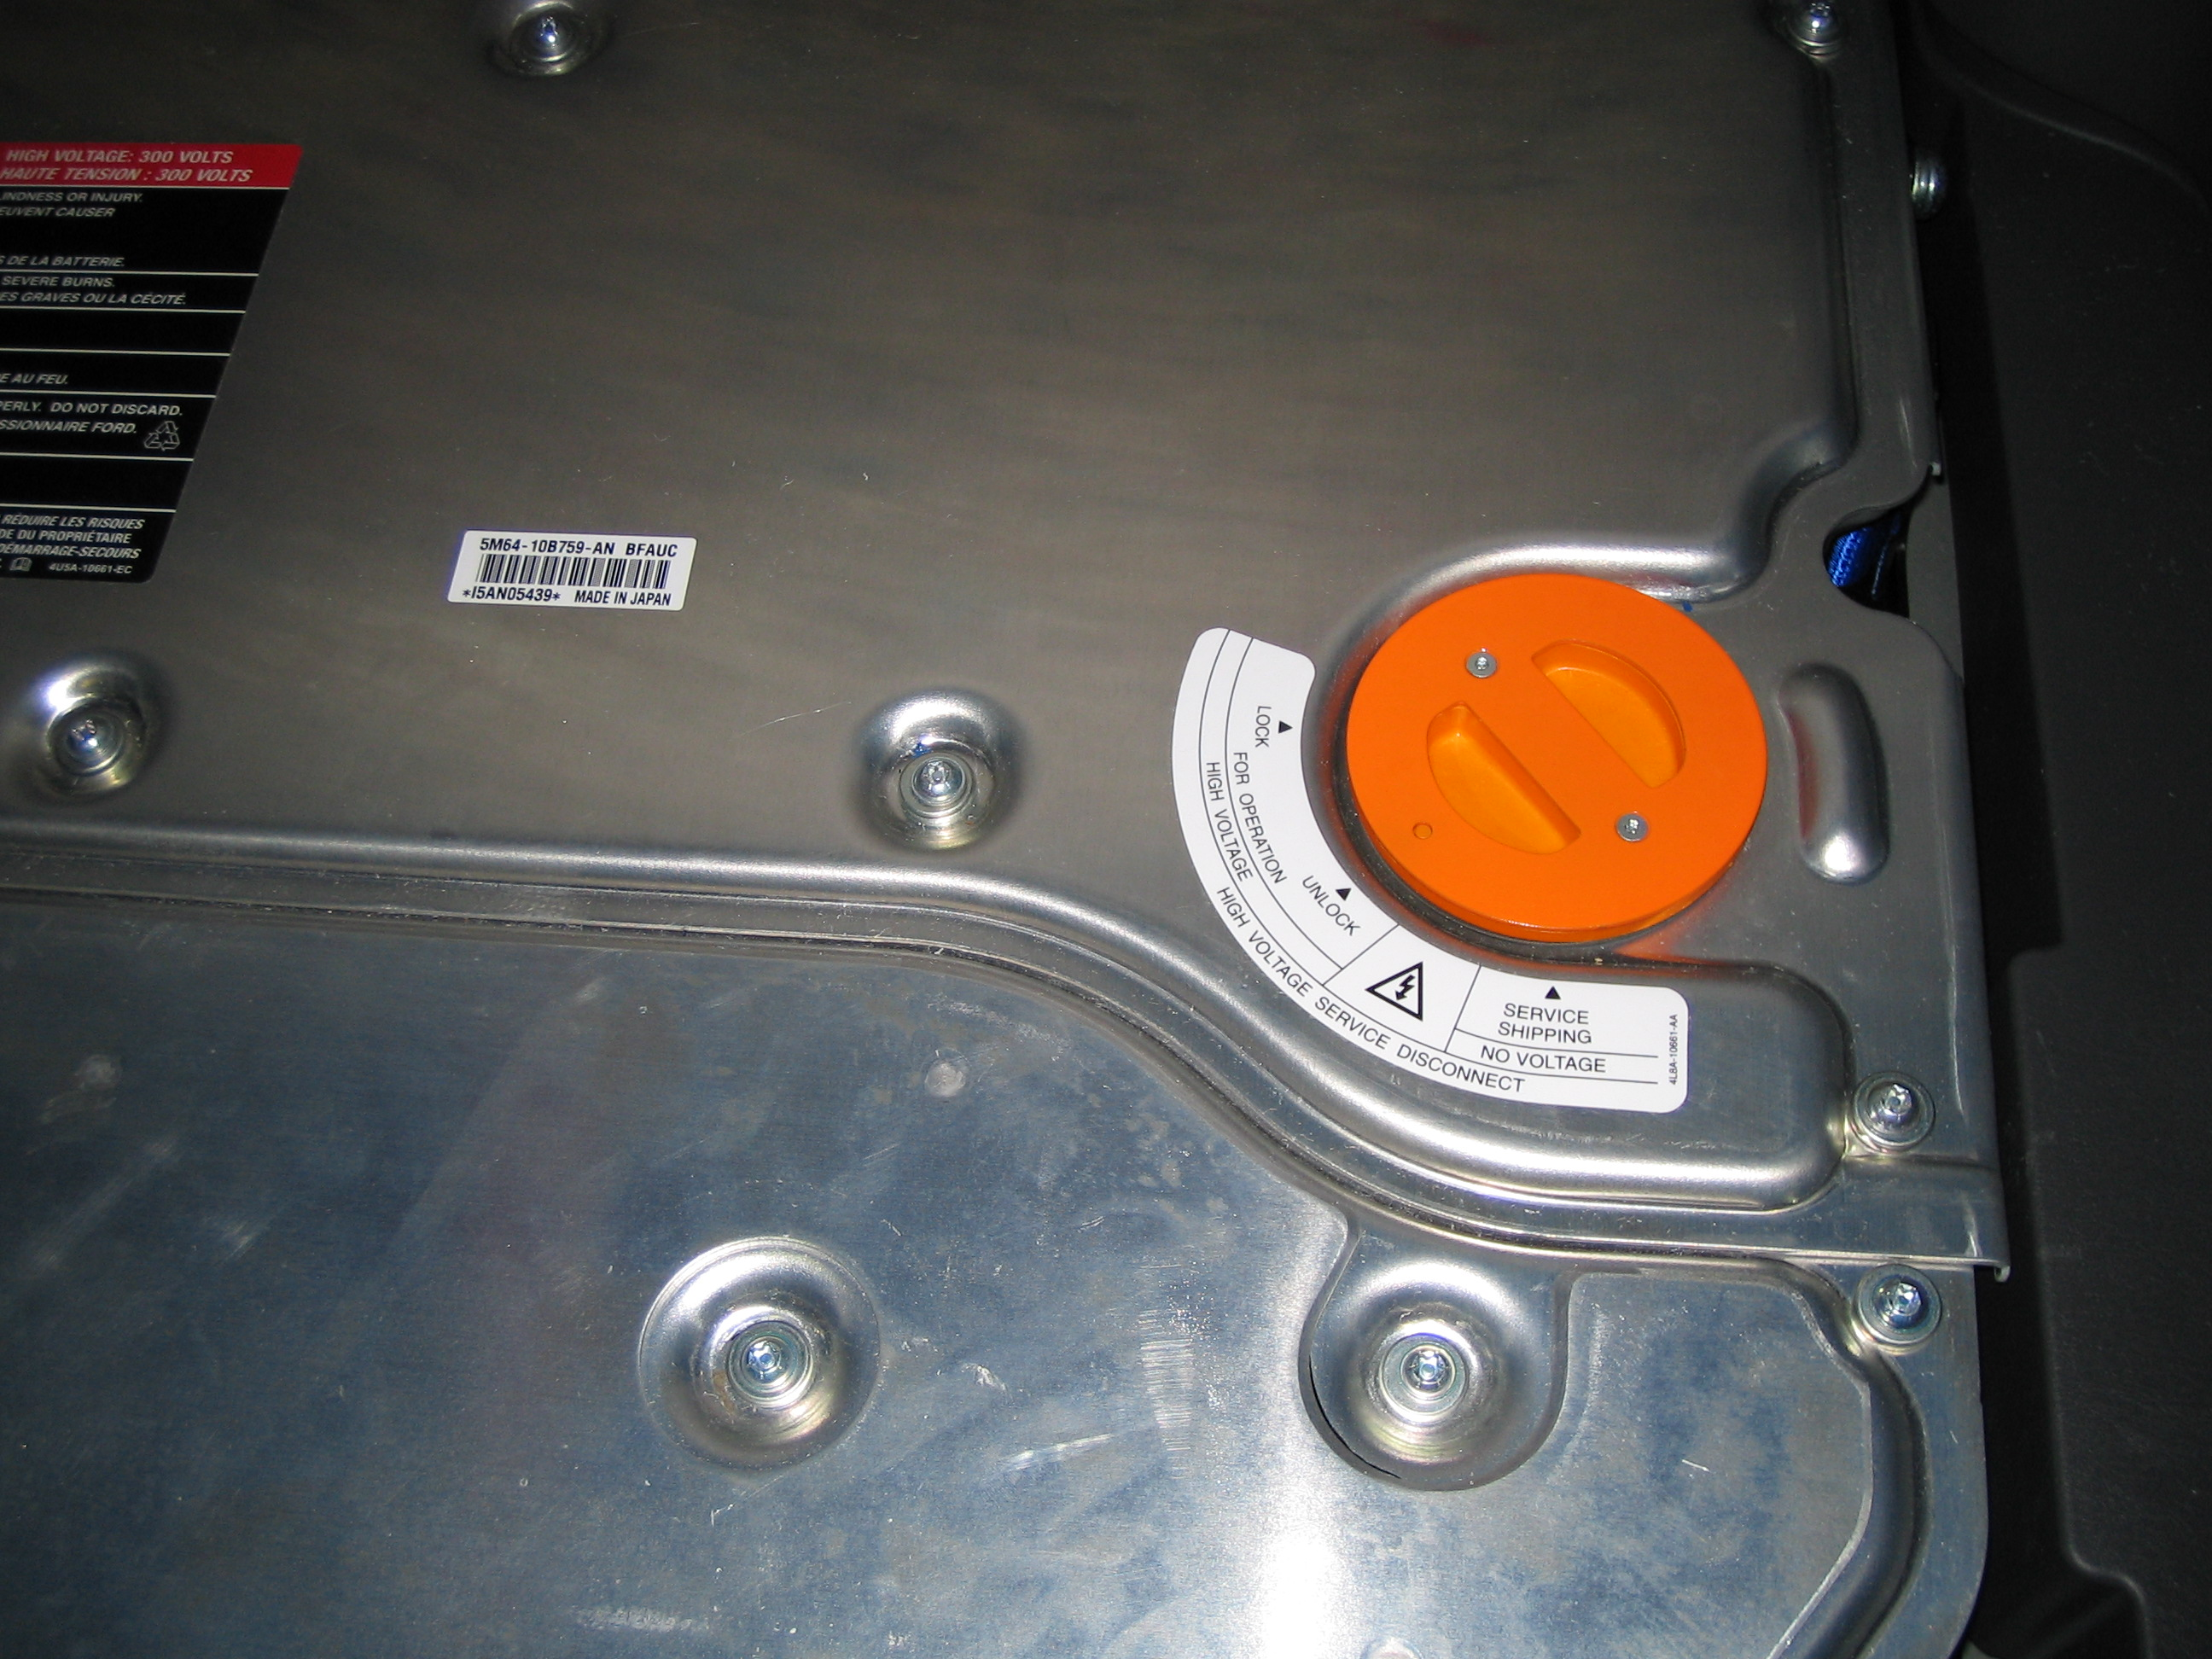

Ford Escape
The high-voltage shut off switch is located
in the rear of the vehicle under the right
side carpet.

Honda Civic
To totally disable the high-voltage system on a Honda Civic, remove the main fuse (labeled number 1) from the driver’s side underhood fuse panel.

Chevrolet/GMC Pickup Truck
The high-voltage shut off switch is located under the rear passenger seat. Remove the cover marked “energy storage box” and turn the green service disconnect switch to the horizontal position to turn off the high-voltage circuits.

