Fuel Trim Diagnosis
Meets ASE Task: (A8-B-6) P-1 Diagnose emissions or driveability concerns without stored diagnostic trouble codes; determine necessary action.

Name _______________________________ Date ___________ Time on Task __________

Make/Model/Year _________________ VIN ________________ Evaluation: 4 3 2 1

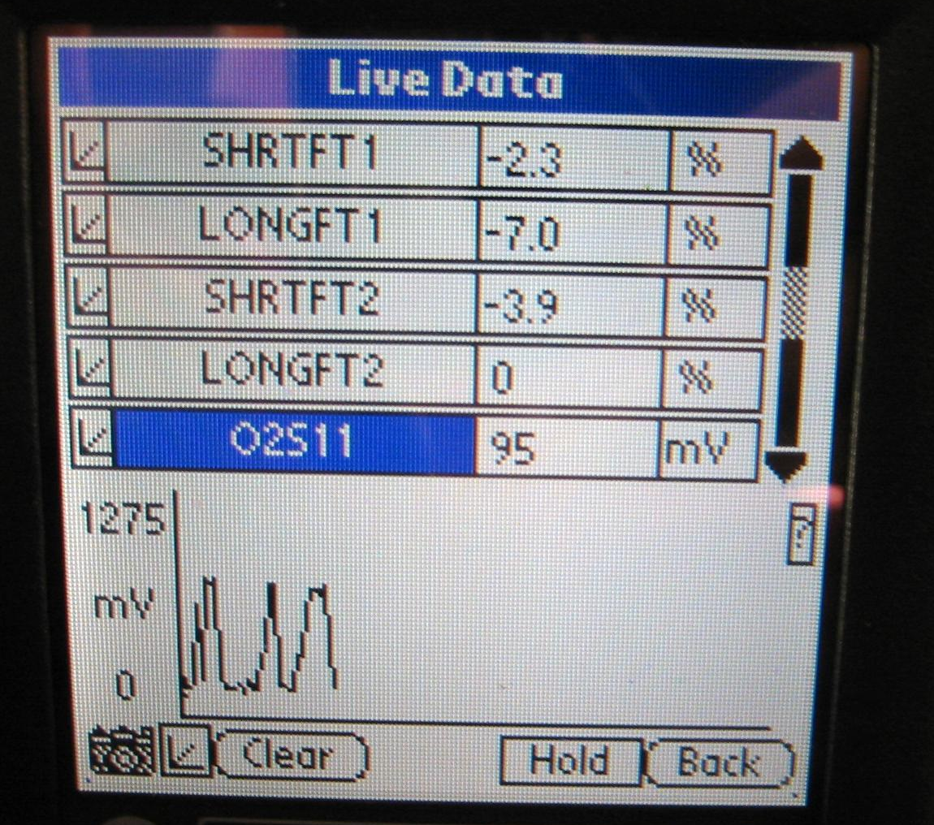
Fuel trim is the computer correction factor that uses the oxygen sensor to determine if more or less fuel needs to be delivered by the fuel injectors. Fuel trim is only available on a scan tool.

_____ 1. Connect a scan tool and select long-term
fuel trim (LTFT) (block learn) and short-
term fuel trim (STFT).

_____ 2. Start the engine and operate until normal
operating temperature and closed loop
status is achieved.

_____ 3. Record the following cell number and
LTFT amount:

Cell LTFT STFT

Idle in Drive (if automatic transmission only) ________ ________ ________

Idle in Park A/C off ________ ________ ________

Idle in Park A/C on ________ ________ ________

3000 RPM in Park ________ ________ ________

Results: Fuel trim should be within plus or minus 10% or within 118-138 if the
block/integration is displayed as a binary number.

_____ 4. Based on the test results, what is the necessary action? ________________________

________________________________________________________________

