Fuel Filter Replacement

Meets ASE Task: (A8-D-4) P-2 Replace fuel filters.

Name _______________________________ Date ___________ Time on Task __________

Make/Model/Year _________________ VIN ________________ Evaluation: 4 3 2 1

_____ 1. Check service information for the recommended part number and fuel filter
replacement procedure.

a. Fuel filter part number = __________________

b. Recommended procedure: _________________________________________

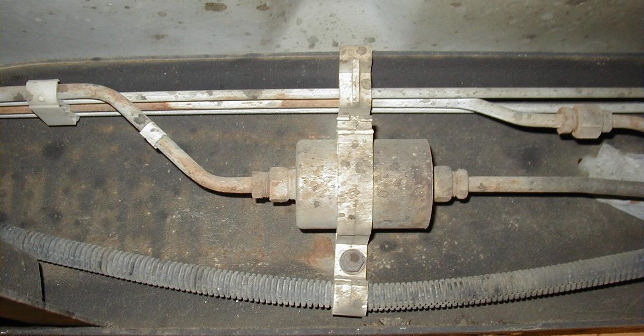
___________________________________________________________

_____ 2. Check all that apply:

____ Fuel system pressure should be relieved before removing the old filter

____ Special tools required to remove filter (describe): _____________________

____________________________________________________________

____ Direction of fuel flow labeled on the filter? __________________________

____ Other (describe) _______________________________________________

____________________________________________________________

