Oxygen Sensor Diagnosis
Meets ASE Task: (A8-B-7) P-2 Inspect and test sensors, actuators, and circuits using a graphing multimeter (GMM)/digital storage oscilloscope (DSO); perform necessary action.

Name _______________________________ Date ___________ Time on Task __________

Make/Model/Year _________________ VIN ________________ Evaluation: 4 3 2 1
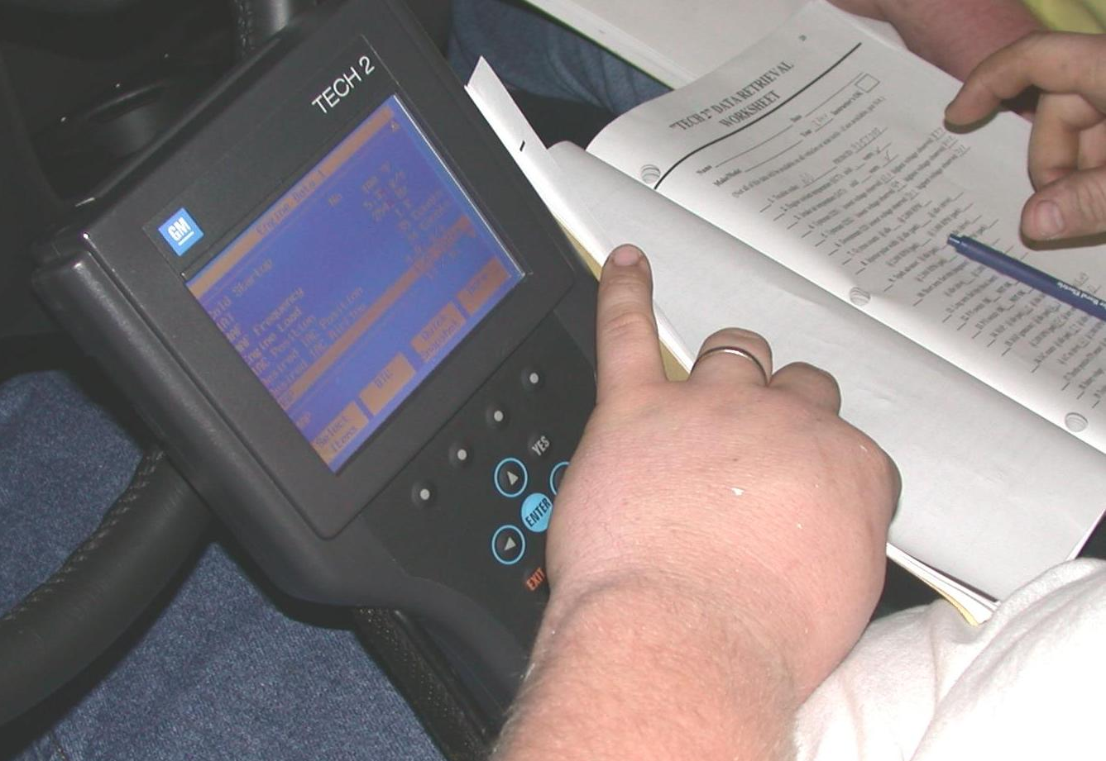

_____ 1. Connect the scan tool to the DLC and start the engine.

_____ 2. Operate the engine at a fast idle (2500 RPM) for
2 minutes to allow time for the oxygen sensor to
warm to operating temperature.

_____ 3. Observe the oxygen sensor activity on the scan tool
to verify closed loop operation.

_____ 4. Select “snap shot” mode and hold the engine speed steady and start recording.

_____ 5. Play back snap shot and place a mark beside each range of oxygen sensor voltage for
each frame of the snap shot.

Between 0 and 300 mV Between 300 and 600 mV Between 600 and 1000 mV

____________________ ______________________ _______________________
(record # of times) (record # of times) (record # of times)

_____ 6. Results: A good oxygen sensor and computer system should result in most snap shot
values at both ends (0 to 300 and 600 to 1000 mV). If most of the readings are in the
middle, the oxygen sensor is not working correctly.

OK ________ NOT OK ________

_____ 7. Based on the test results, what is the necessary action? _________________________

_________________________________________________________________

