Coolant Flush
Meets ASE Task: (A1-D-4) P-1 Flush cooling system; refill and bleed the system.

Name _______________________________ Date ___________ Time on Task __________

Make/Model/Year _________________ VIN ________________ Evaluation: 4 3 2 1

_____ 1. Check service information and/or the coolant flush machine instructions for the
specified procedure to follow. Describe the procedure: ________________________
_____________________________________________________________________
_____________________________________________________________________
_____ 2. Is a coolant flush machine being used? Yes ____ No ____ (describe) ____________
_____________________________________________________________________
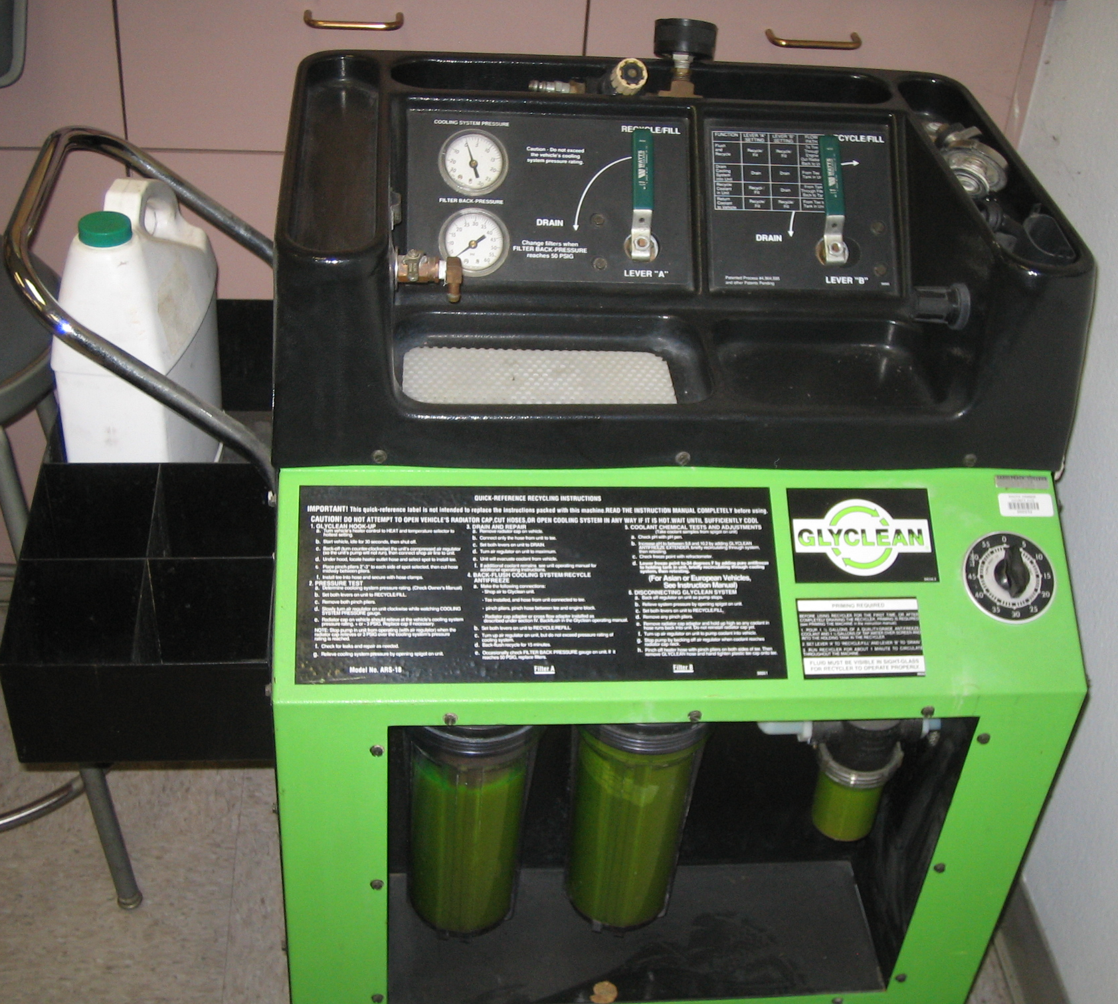

_____ 3. What is the specified coolant? ____________________________________________
_____ 4. What is the specified procedure for bleeding air from the cooling system?
__________________________________________________________________
__________________________________________________________________
__________________________________________________________________

