Bushing Inspection

Meets ASE Task: (A2-C-14) P-2 Inspect bushings; determine needed action.

Name _______________________________ Date ___________ Time on Task __________

Make/Model/Year _________________ VIN ________________ Evaluation: 4 3 2 1

_____ 1. Check service information on the exact procedures to follow when inspecting bushings.
Describe the specified procedures. ___________________________________________
____________________________________________________________________
____________________________________________________________________
____________________________________________________________________
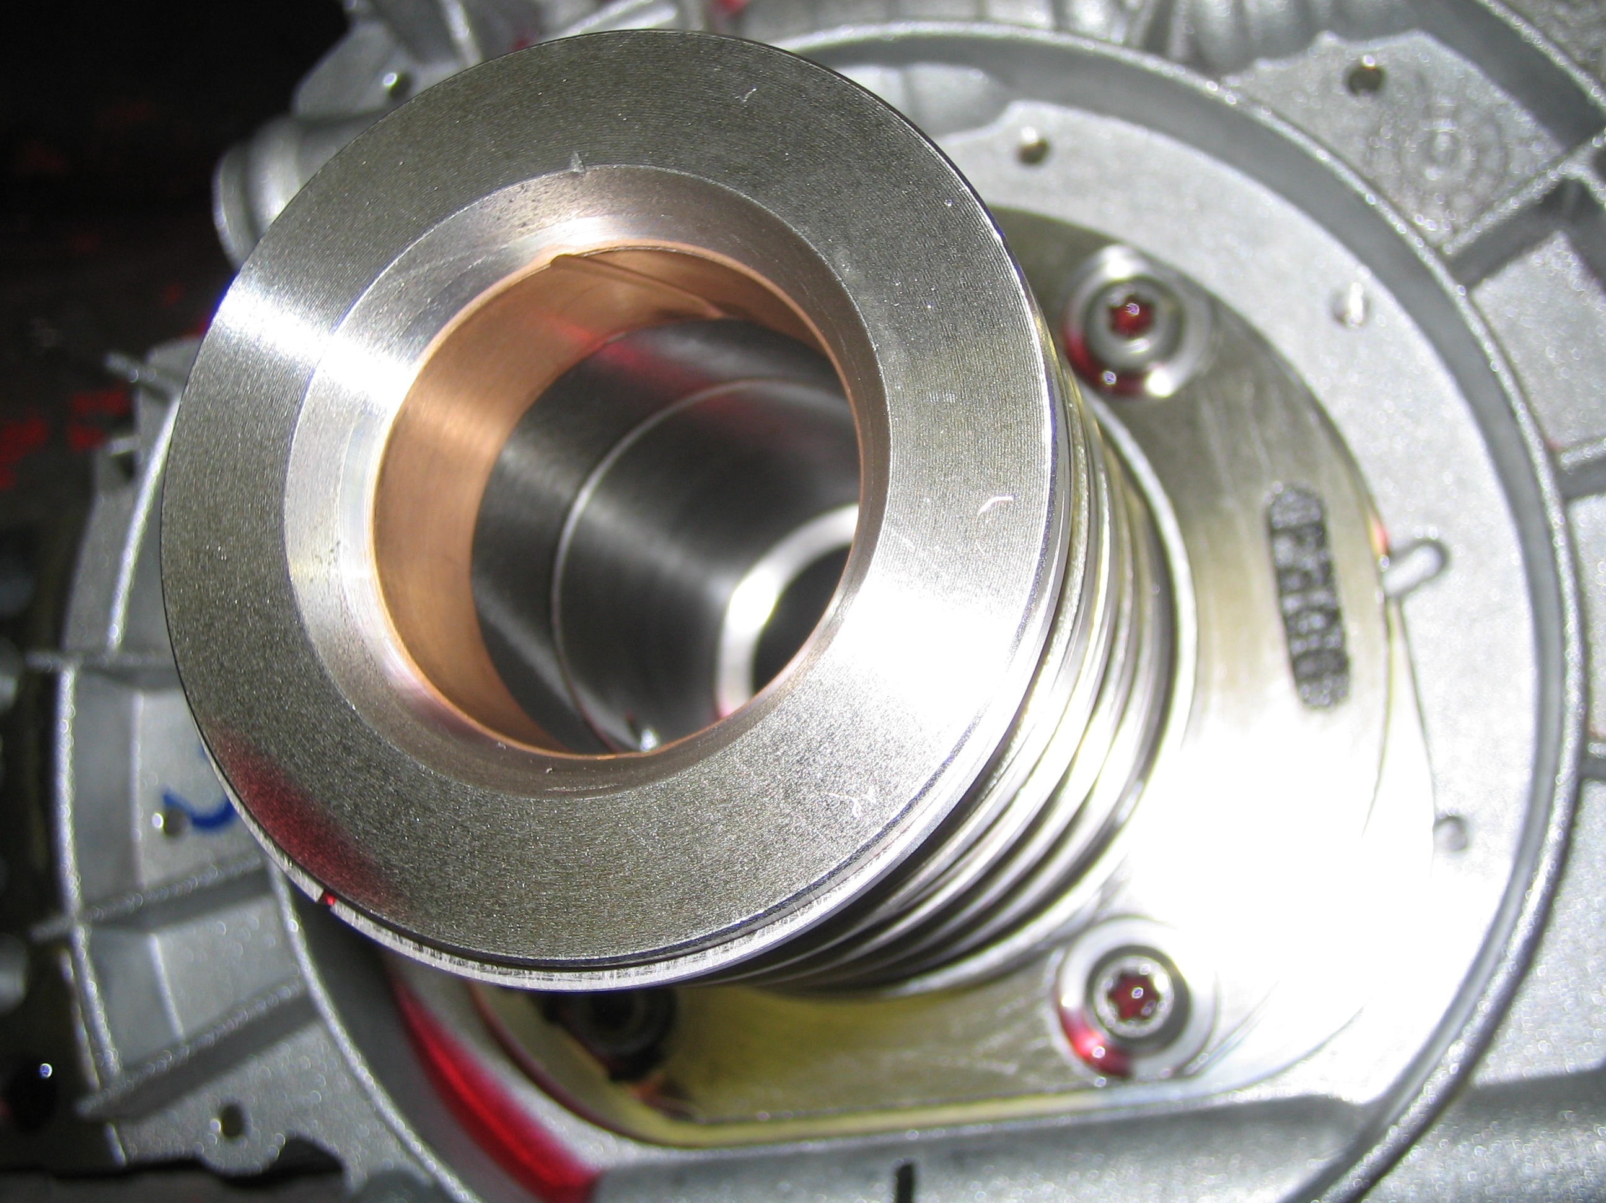

_____ 2. Based on the inspection results, what is the needed action? ______________________
___________________________________________________________________
___________________________________________________________________
___________________________________________________________________

