Identify Drivetrain Components

Meets ASE Task: (A2-A-5) P-1 (MLR only) Identify drivetrain components and configuration.

Name _______________________________ Date ___________ Time on Task __________

Make/Model/Year _________________ VIN ________________ Evaluation: 4 3 2 1

_____ 1. What is the difference between an automatic transmission and an automatic transaxle?
Describe the differences. _________________________________________________
__________________________________________________________________
__________________________________________________________________
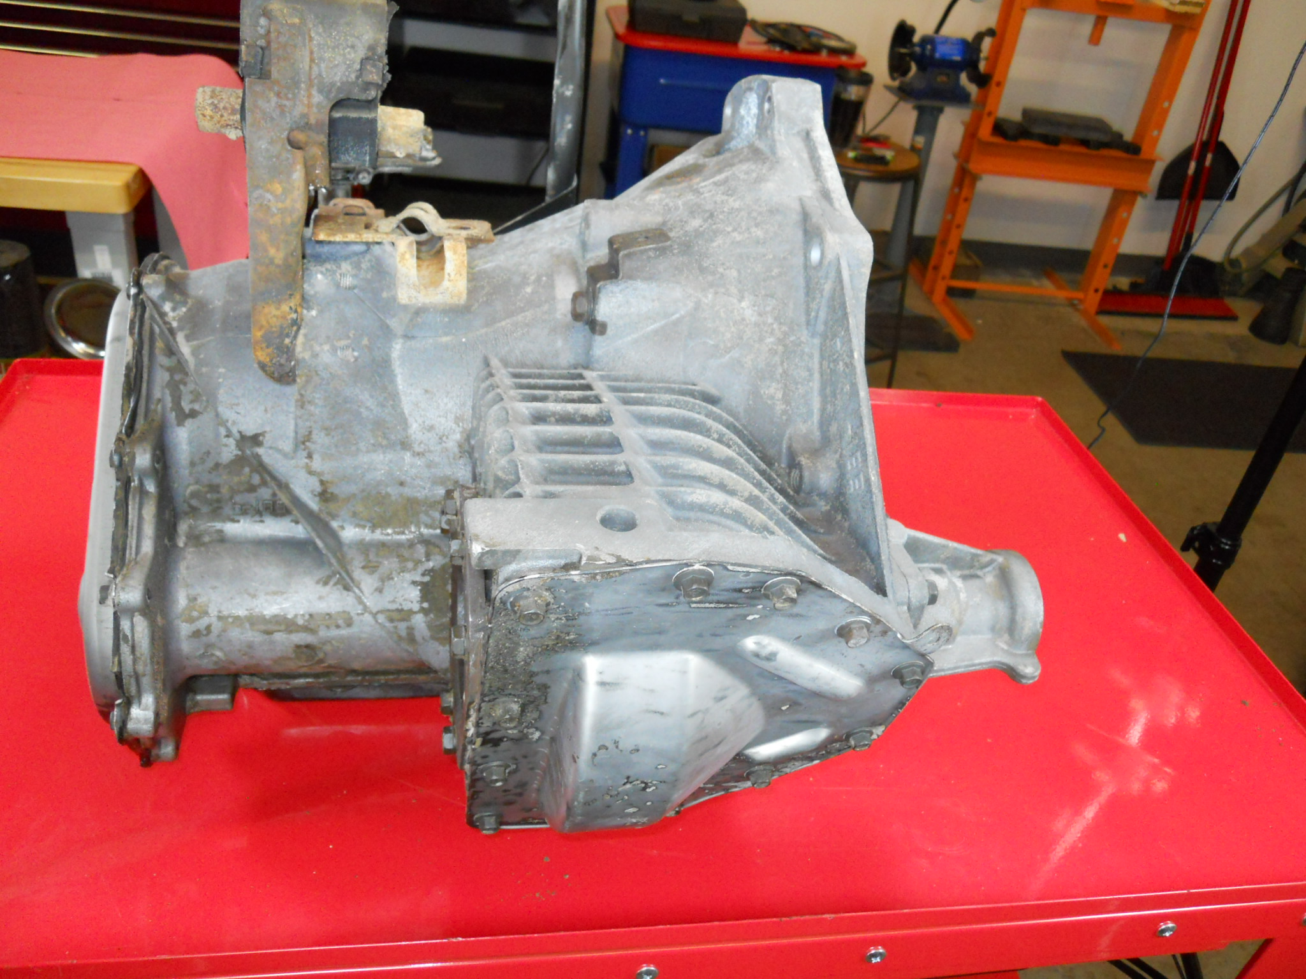
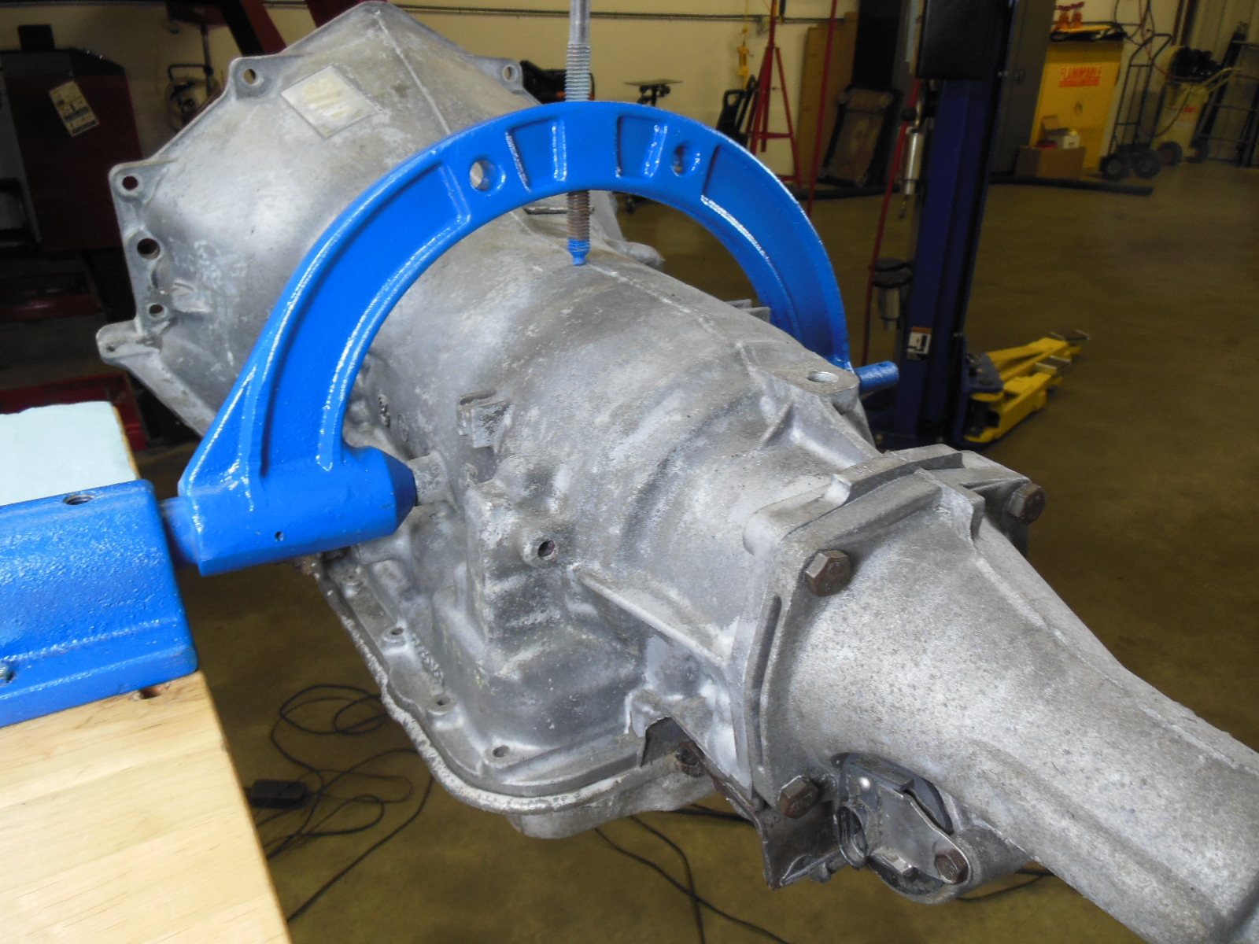
_____ 2. What components are the same between an automatic transmission and an automatic
transaxle? ____________________________________________________________
_________________________________________________________________
_________________________________________________________________
_____ 3. What components are difference between an automatic transmission and an automatic
transaxle? ____________________________________________________________
_________________________________________________________________
_________________________________________________________________

