Transfer Case Disassembly and Reassembly

Meets ASE Task: (A3-F-7) P-2 Disassemble and reassemble transfer case.

Name _______________________________ Date ___________ Time on Task __________

Make/Model/Year _________________ VIN ________________ Evaluation: 4 3 2 1

_____ 1. Check service information for the recommended procedures to follow when
disassembling and reassembling a transfer case. Describe the procedure. ____________
____________________________________________________________________
____________________________________________________________________
____________________________________________________________________
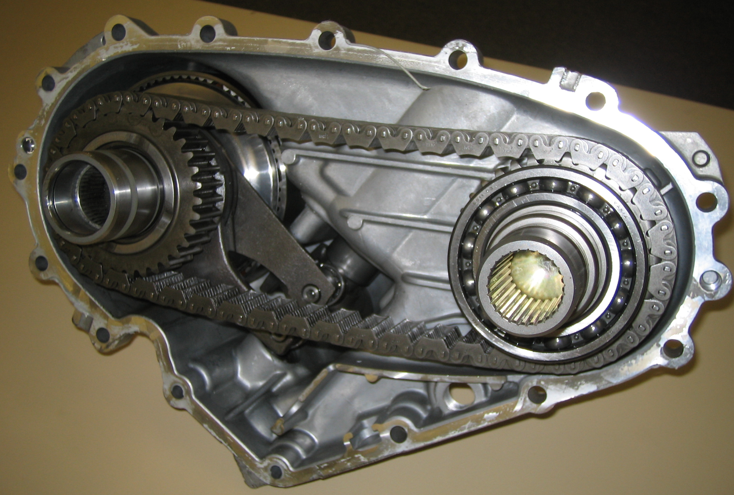

_____ 2. List the tools recommended to be used to disassemble and reassemble the transfer case.
____________________________________________________________________
____________________________________________________________________
_____ 3. List all faults or concerns found. ____________________________________________
____________________________________________________________________

