Transfer Case Lube Level Check

Meets ASE Task: (A3-A-2) P-1, (A3-F-3) P-3 Check transfer case lube level and vents/seals.

Name _______________________________ Date ___________ Time on Task __________

Make/Model/Year _________________ VIN ________________ Evaluation: 4 3 2 1

_____ 1. Check service information for the specified methods to follow to check the seals, vents,
and lube level (describe). __________________________________________________
____________________________________________________________________
____________________________________________________________________
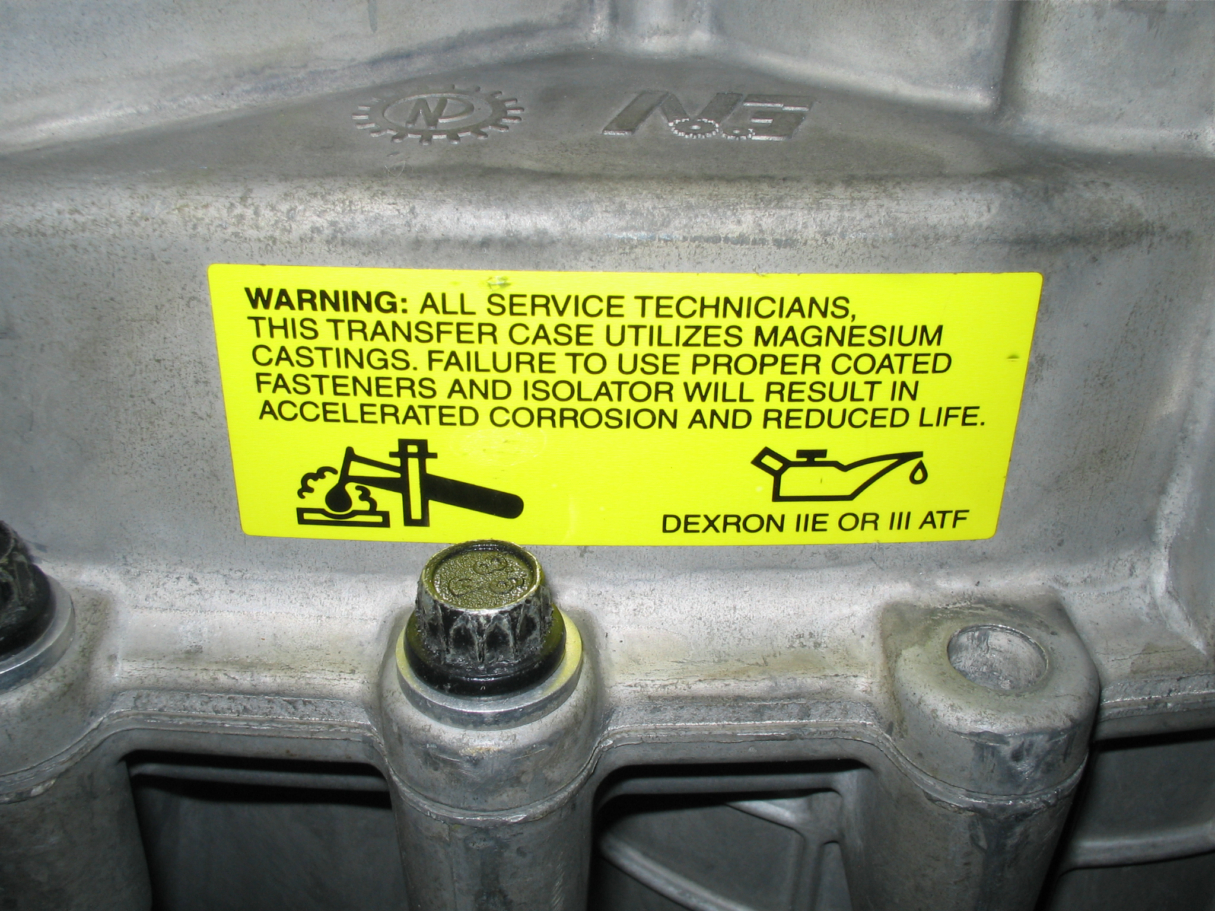
____________________________________________________________________

_____ 2. What is the specified lube? ___________________________________
_____ 3. Were the vents clear? Yes ____ No ____ If no, describe why they were clogged.
____________________________________________________________________
____________________________________________________________________
_____ 4. Were the seals okay? Yes ____ No ____ If no, describe which seals were leaking.
____________________________________________________________________
____________________________________________________________________

