Disassemble and Reassemble Transmission/Transaxle

Meets ASE Task: (A3-C-6) P-2 Disassemble and reassemble transmission/transaxle components.

Name _______________________________ Date ___________ Time on Task __________

Make/Model/Year _________________ VIN ________________ Evaluation: 4 3 2 1

_____ 1. Check service information for the exact procedures to follow when disassembling the
manual transmission/transaxle (describe procedures). ____________________________
____________________________________________________________________
____________________________________________________________________
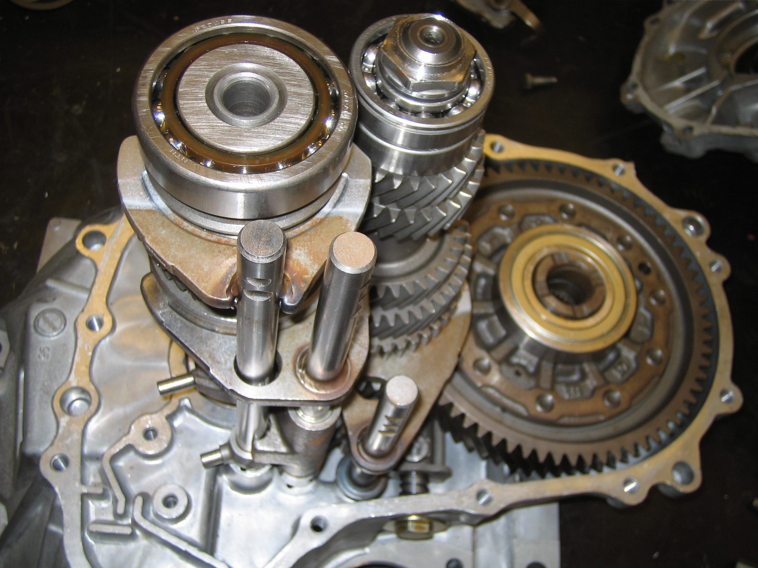

_____ 2. List all tools needed.
a. _______________ d. _______________ g. _______________
b. _______________ e. _______________ h. _______________
c. _______________ f. _______________ i. _______________
_____ 3. Check service information for the specified assembly procedures, including the
measurements and clearances that should be checked (describe procedure).
____________________________________________________________________
____________________________________________________________________
_____ 4. List the measurements and clearances. ________________________________________
____________________________________________________________________
____________________________________________________________________

