Inspect/Replace Clutch Components
Meets ASE Task: (A3-B-3) P-1 Inspect, release, and replace (throw out) bearing, pressure plate and clutch disc; determine needed action.

Name _______________________________ Date ___________ Time on Task __________

Make/Model/Year _________________ VIN ________________ Evaluation: 4 3 2 1

_____ 1. Check service information and determine the specified tests and inspections
recommended to be performed (describe). _____________________________________
____________________________________________________________________
____________________________________________________________________
____________________________________________________________________
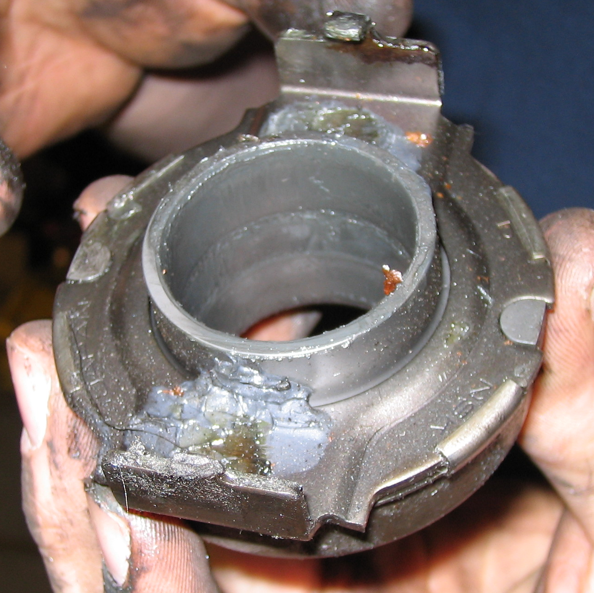
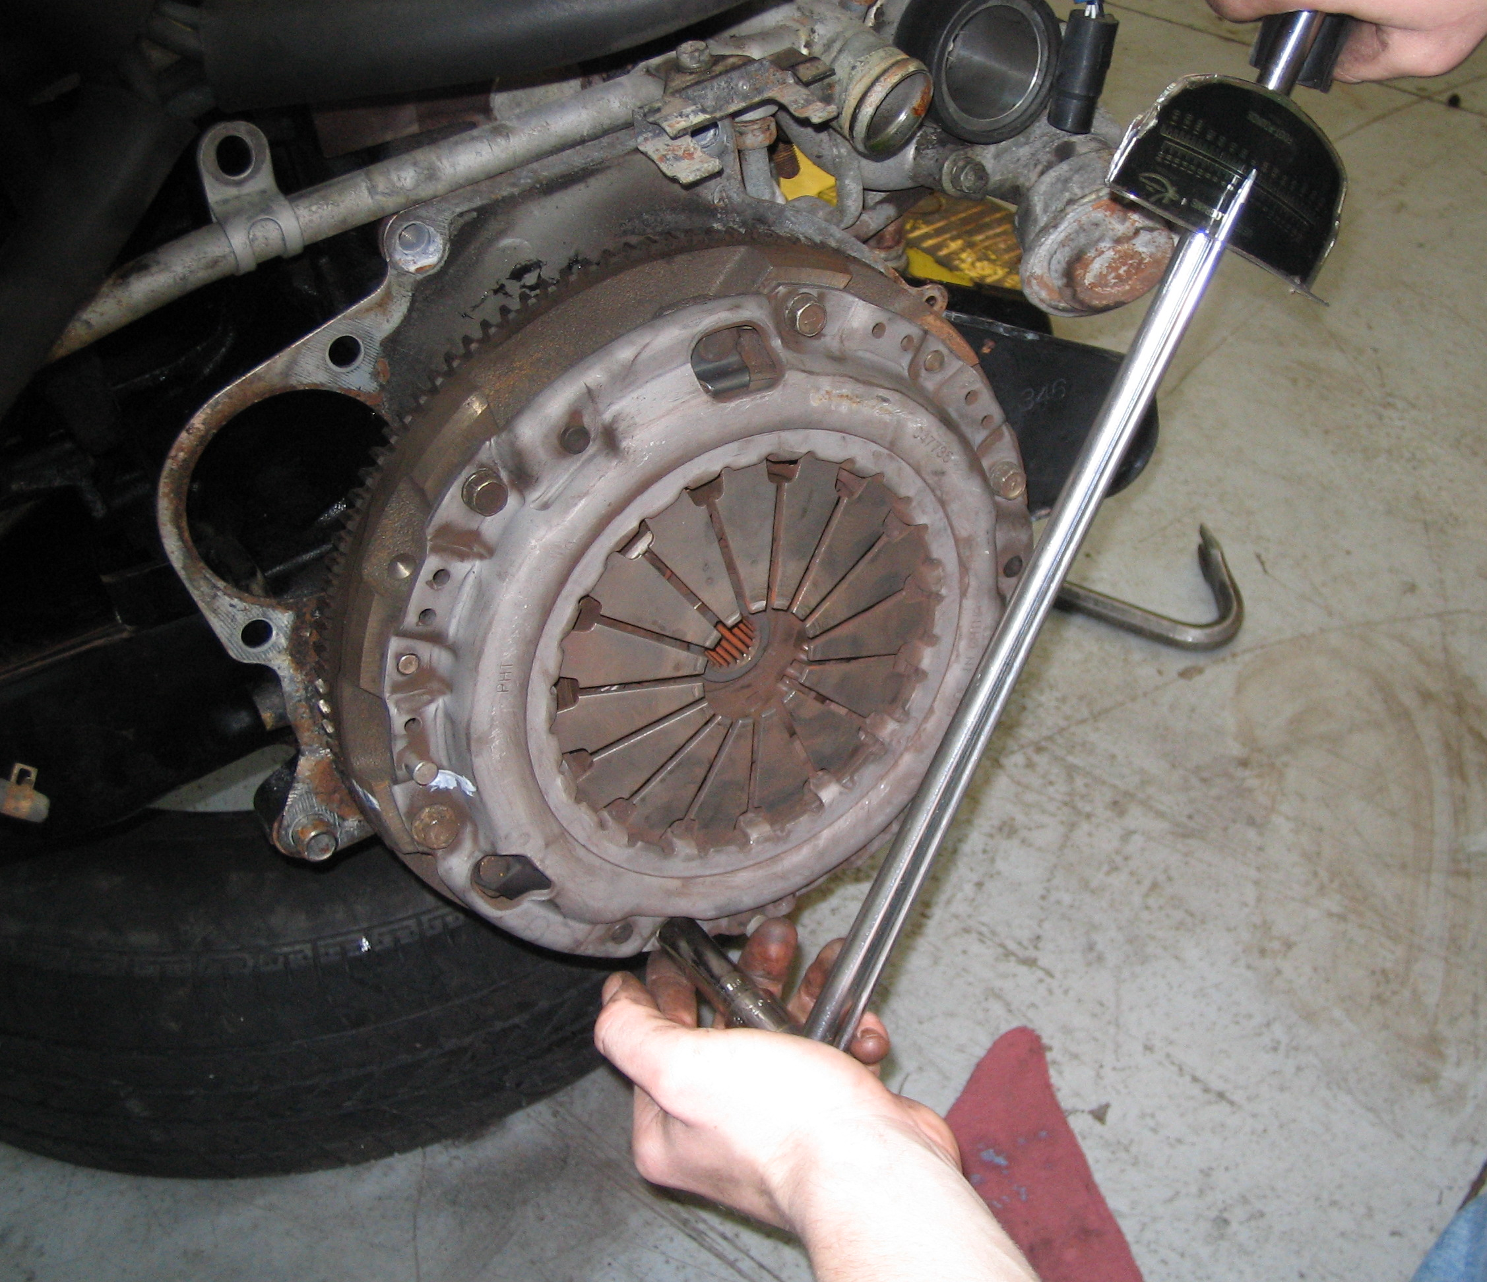

_____ 2. Based on the inspection, what is the needed action? _____________________________
____________________________________________________________________
____________________________________________________________________
____________________________________________________________________

