Vehicle Emission Control Information

Meets ASE Task: (A1 through A8-A-2) P-1 Research vehicle and service information.

Name _______________________________ Date ___________ Time on Task __________

Make/Model/Year _________________ VIN ________________ Evaluation: 4 3 2 1

_____ 1. Locate the vehicle emission control information (VECI) sticker and describe its
location: _____________________________________________________________
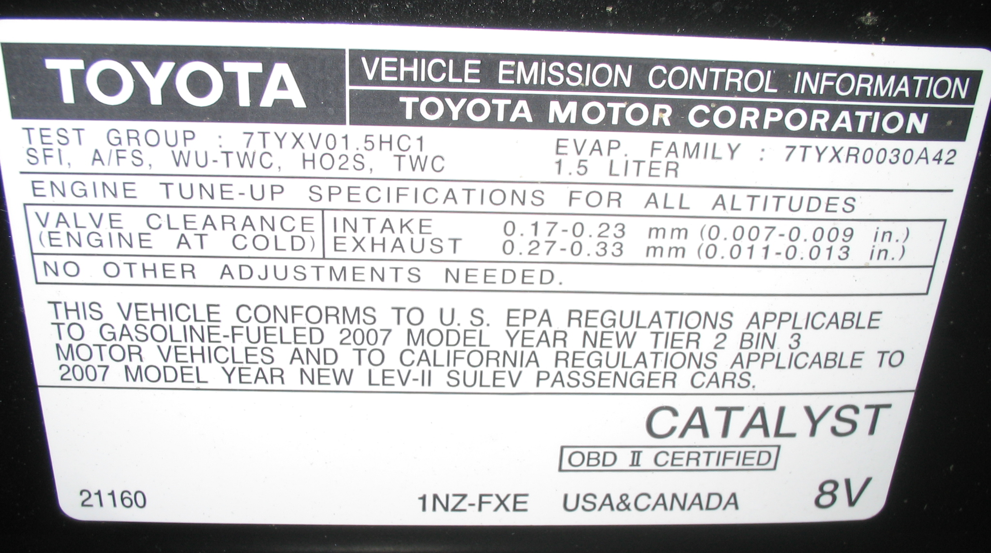

_____ 2. List what service information is included on the sticker: _______________________
_________________________________________________________________
_________________________________________________________________
_____ 3. List emission control devices on the vehicle: _________________________________
__________________________________________________________________
__________________________________________________________________
_____ 4. What is the U.S. Federal emission rating of the vehicle? _______________________
_____ 5. What is the California emission rating of the vehicle? __________________________

