Brake Hoses and Lines
Meets ASE Task: (A5-B-6) P-1, (A5-B-7) P-2, (A5-B-8) P-2 Brake hose and line inspection and replacement.

Name _______________________________ Date ___________ Time on Task __________

Make/Model/Year _________________ VIN ________________ Evaluation: 4 3 2 1

_____ 1. Check service information for the specified procedure to follow when inspecting
and/or replacing brake hoses and lines. Describe the recommended procedures.
__________________________________________________________________
__________________________________________________________________
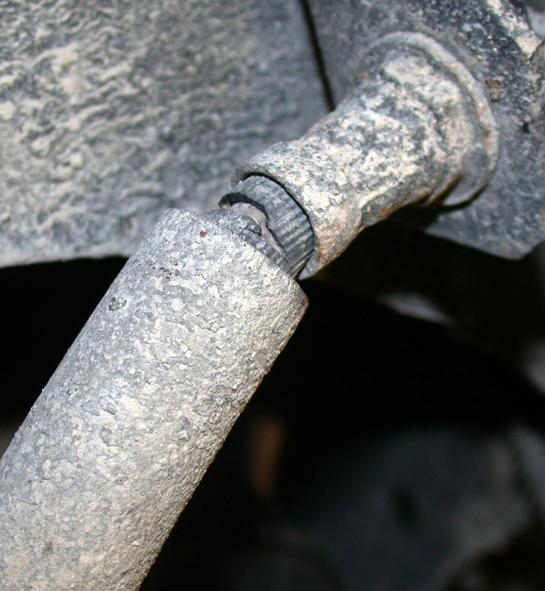
_____ 2. Based on the inspection of the brake lines and hoses,
what is the needed action?

________________________________________
________________________________________
________________________________________
________________________________________

_____ 3. Using the specified diameter of brake line, perform the two brake line flaring procedure.

_____ Double flare Instructor’s check ___________
_____ ISO (bubble) flare Instructor’s check ___________
_____ 4. Bend brake line as needed. Instructor’s check ___________
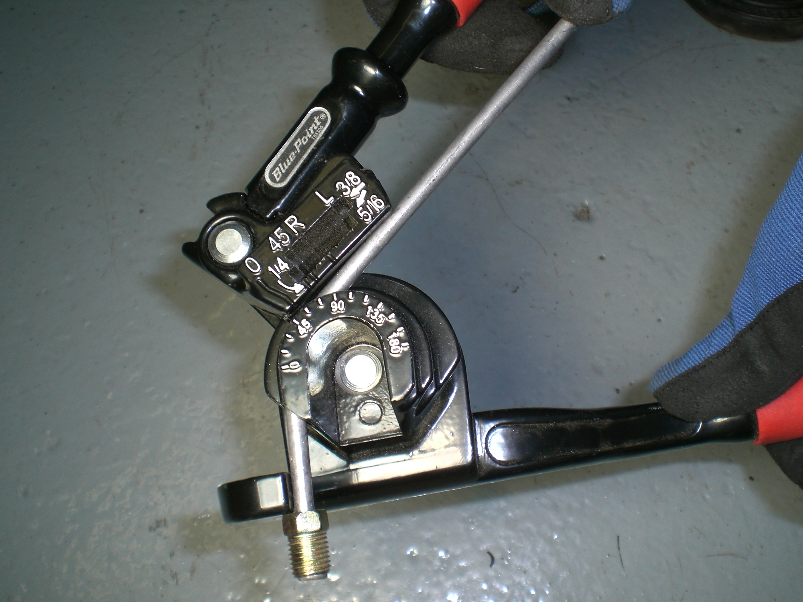

_____ 5. List the trade number of the brake light bulbs, including the center high-mounted stop
light.
Rear brake light trade number = _______________
Center high-mounted stop light trade number = ______________

_____ 6. Based on the test results, what is the needed action? ___________________________

