Fuel Pump Volume
Meets NATEF Task: (A8-D-3) P-1 Inspect and test fuel pumps and pump control systems for pressure, regulation, and volume; perform necessary action.

Name _______________________________ Date ___________ Time on Task __________

Make/Model/Year _________________ VIN ________________ Evaluation: 4 3 2 1

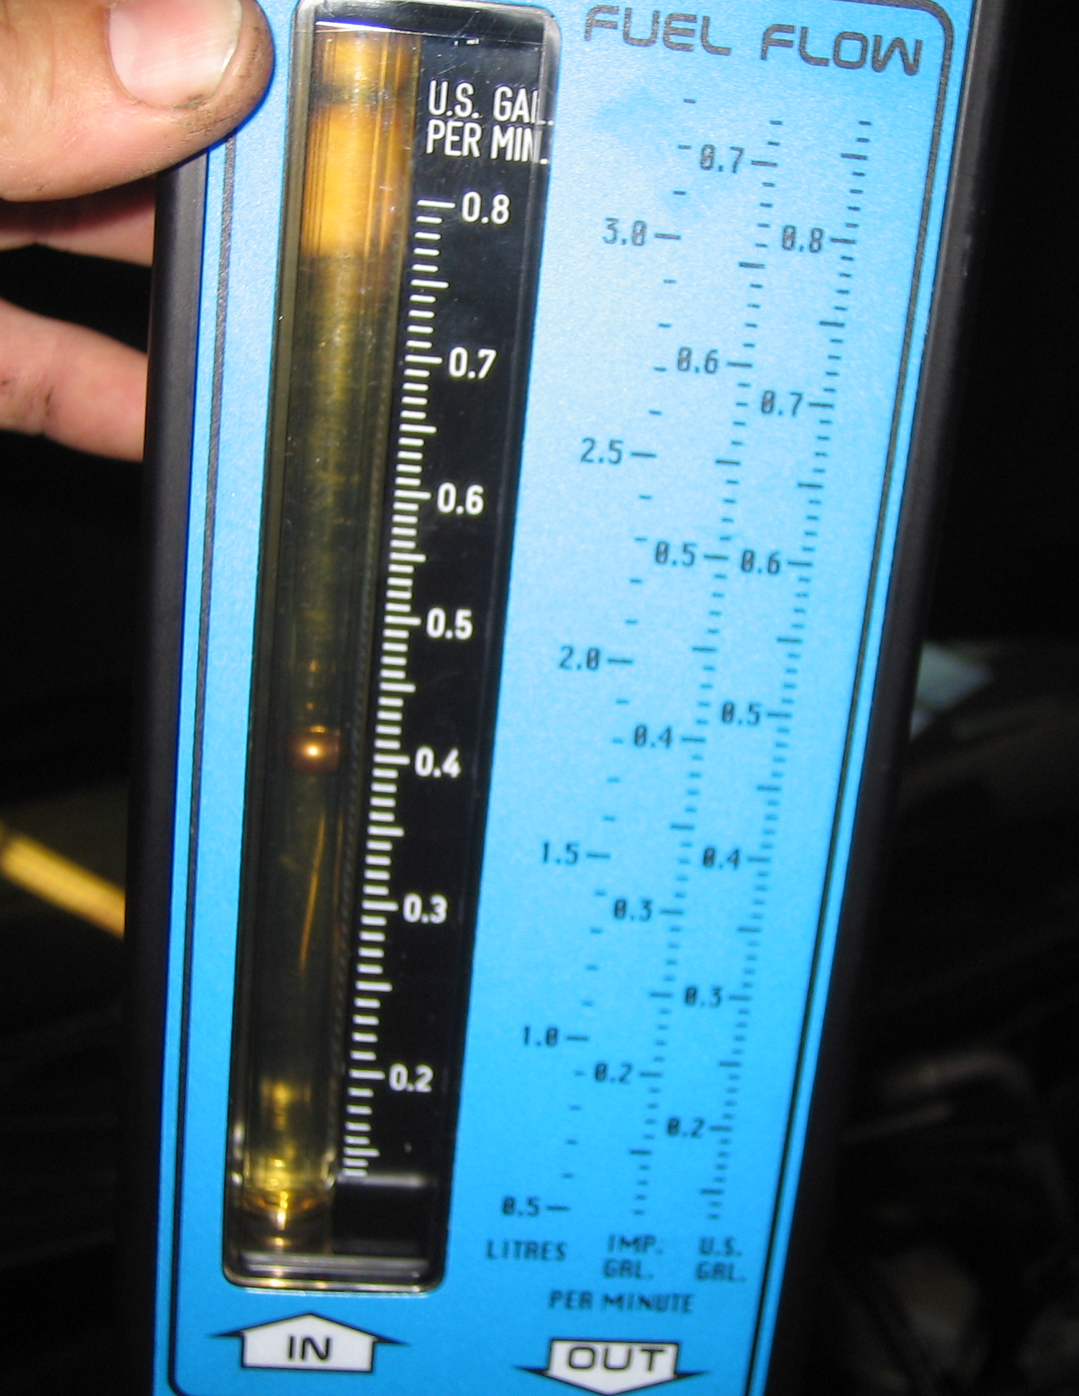
_____ 1. Check service information for the recommended procedure to
follow to determine fuel pump volume.

_____________________________________________________

_____________________________________________________

_____ 2. What is the specified volume?

_________ (usually between 0.5 and 0.8 gallons per minute)

_____ 3. What procedure was performed to determine fuel pump volume?

___________________________________________

_____ 4. What was the fuel pump volume?

___________________

_____ 5. Based on the test results, what is the necessary action?

_______________________________________________________________

_______________________________________________________________

_______________________________________________________________

