Digital Multimeter Use for Electrical Problems
Meets NATEF Task: (A6-A-3) Demonstrate the proper use of a digital multimeter (DMM)
during diagnosis of electrical circuit problems. (P-1)

Name _______________________________ Date ___________ Time on Task __________

Make/Model/Year _________________ VIN ________________ Evaluation: 4 3 2 1

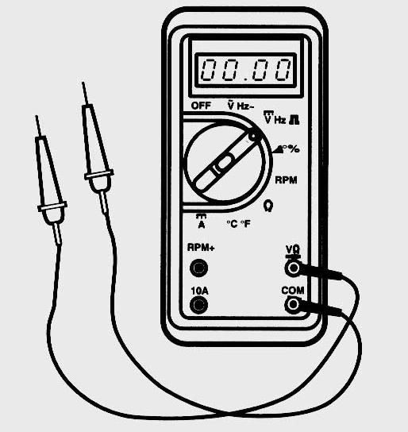
_____ 1. Check service information on the correct procedure for
checking charging system voltage.

_________________________________________________

_________________________________________________

a. Which position on the digital multimeter should be
selected to check charging system voltage?
__________________
What is the specified voltage? _________
What is the actual voltage? _________

b. Which position should selected to check the voltage drop of the charging
system? ___________________
What is the specified voltage drop? _________
What is the actual voltage drop? __________

_____ 2. Check service information regarding the specified resistance for spark plug wires.

__________________________________________________________________

Which position on the DMM should be selected to measure spark plug wire
resistance? ___________________
What is the specified resistance? ____________
What is the actual (measured) resistance? ___________

_____ 3. Check service information regarding the specified battery drain test (parasitic draw)
test procedures.

__________________________________________________________________

Which position on the DMM should be selected to measure battery electrical
drain? _________________
What is the specified maximum battery electrical drain? __________
What is the actual (measured) battery electrical drain? ____________

