Ignition Coil Testing
Meets NATEF Task: (A8-C-4) P-1 Inspect and test ignition primary and secondary circuit wiring and solid state components; test ignition coil(s); perform necessary action.

Name _______________________________ Date ___________ Time on Task __________

Make/Model/Year _________________ VIN ________________ Evaluation: 4 3 2 1

_____ 1. Check service information for the specified ignition coil testing procedure.

_________________________________________________________________

_____ 2. Visually inspect the coil(s) for carbon track and other faults. OK ___ NOT OK ___
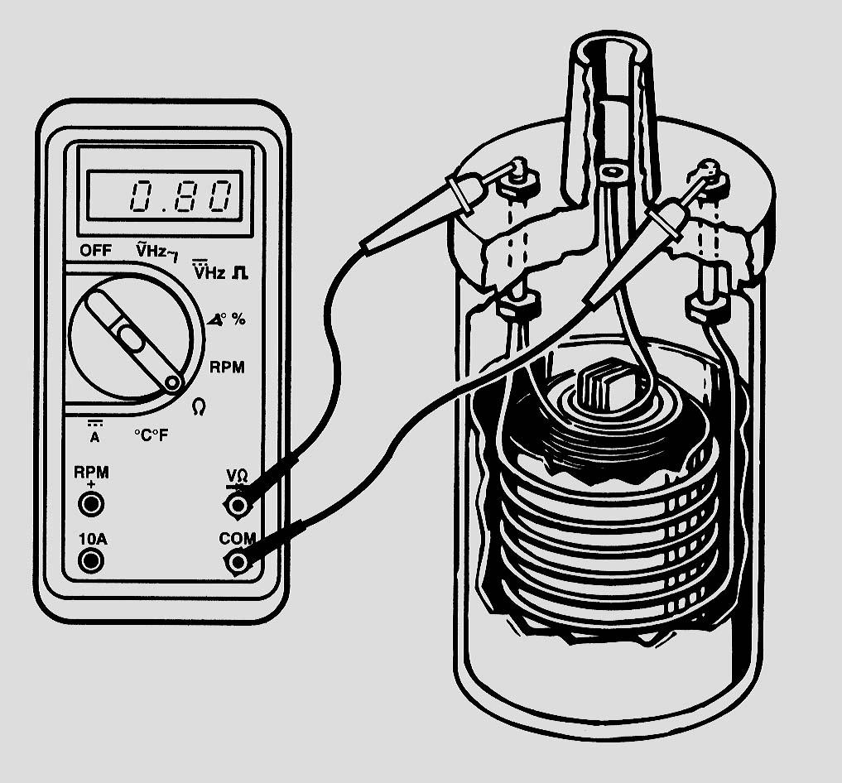
_____ 3. Check the primary winding resistance.

Specification: ______________________

Actual: ___________________________

OK ____ NOT OK ____
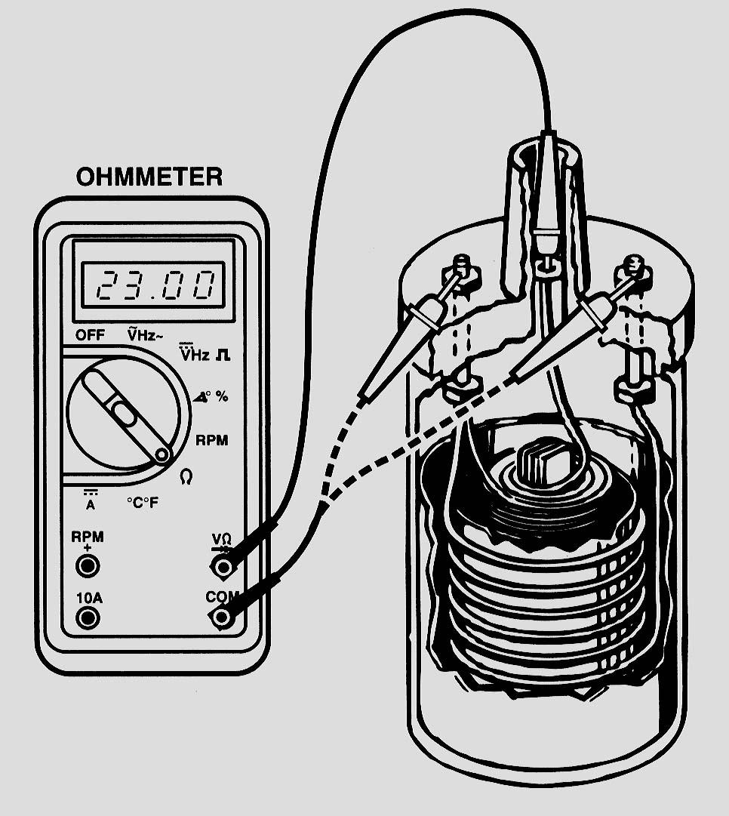
_____ 4. Check the secondary winding resistance.

Specification: ______________________

Actual: ___________________________

OK ____ NOT OK ____

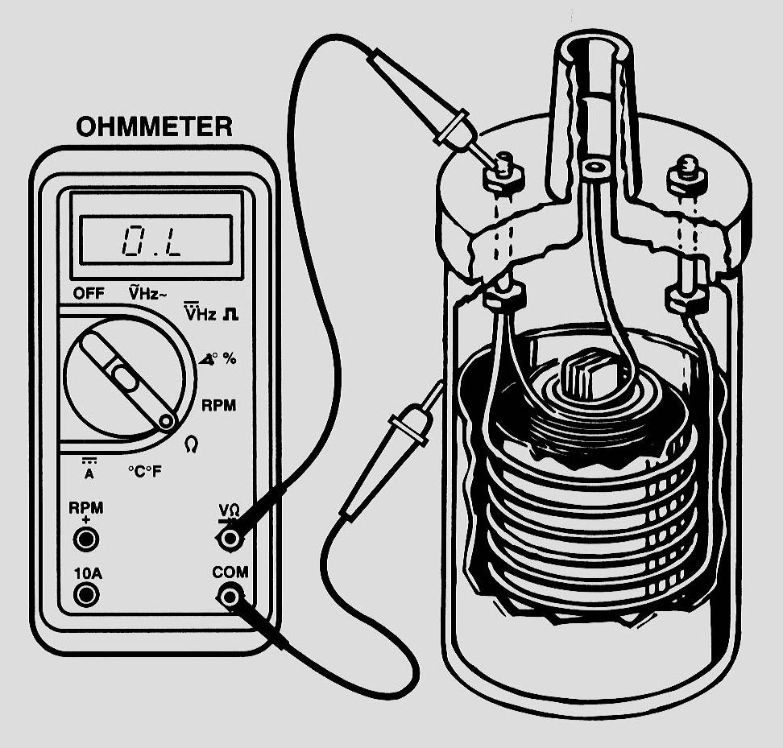
_____ 5. Perform resistance checks for short-to-ground.

OK ____ NOT OK ____

_____ 6. Based on the inspection and tests, what is the necessary action? _________________

_________________________________________________________________

